The Universe Has No Now
Book 1: No Now, No Centre
Time, Origins, and Whether We Can Get Somewhere Else
Lothar J. Musiol

Copyright
The Universe Has No Now, Book 1: No Now, No Centre. Time, Origins, and Whether We Can Get Somewhere Else
Copyright © 2026 Lothar J. Musiol. All rights reserved.
Look First, Volume 1, Book 1 of 2.
Photograph credits are not printed under the figures. They are in this file, so a copy that never sees the store page still names its sources.
Photographs. Fig 3: NASA/SDO. Fig 4: NASA/ESA/Hubble. Fig 8: NASA/ESA/STScI. Fig 9: ESA and the Planck Collaboration, CC BY 4.0. Fig 14: NASA/ESA/Hubble Heritage Team (STScI/AURA). Fig 16: NASA/JPL-Caltech/IPAC (2MASS, T. Jarrett). Fig 17: NASA/CXC/CfA/M. Markevitch et al.; NASA/STScI; ESO WFI. Fig 18: NASA/ESA/J. Hester and A. Loll (Arizona State University). Fig 20: Event Horizon Telescope Collaboration, CC BY 4.0. Fig 24: NASA/Hubble Heritage Team (STScI/AURA). Diagrams are original line art for this book. Figures 0, 1 are simple drawings made for this edition.

How to Read This Book
Every claim in these pages wears one of three temperatures. The difference matters more than any formula.
Hot — established. Measured, repeated, and used to predict new measurements. The universe is expanding. Space is filled with a 2.7-degree glow left over from a hot past. Ordinary matter is a minority ingredient. Black holes exist. There is no single “now” shared by observers who move differently.
Warm — working theory. The best account we have, with real gaps. A burst of extremely fast expansion in the first sliver of a second (inflation) explains several facts at once, but we have not identified the field that did it. Most of the mass that pulls on galaxies does not emit light; we do not know what particle, if any, it is. Empty space behaves as if it has a faint energy of its own; we do not know why that energy is the size it is.
Cold — speculation. Allowed by the equations, not selected by the data. Traversable wormholes. A required final state in which life computes forever (the Omega Point). A stack of universes with different laws. Extra dimensions from string theory.
On that last item, a standing rule. String theory, whenever it appears in this book, cannot currently be tested. It is a large, ingenious mathematical framework. It has not produced a unique, risky prediction — a number or a signature that would kill the whole idea if the experiment came out otherwise. Extra dimensions and a “landscape” of possible laws inherit that status. They may be mentioned because popular physics mentions them. They are not results.
A few scenes in this book are stories: a greenhouse on a dead planet, a radio that answers a quarter-hour late, a clock that runs slow beside a black hole, a melt-probe chewing through kilometers of ice into a sea that has never seen the Sun. They are thought experiments with dirt on them. The numbers in them are real. The people are invented. They are here so the geometry has somewhere to sit besides a diagram.
The main chapters keep the math in the sentence, the way a good explainer talks at a table. A handful of relations are important enough to number. Those numbered equations live in the Appendix, where the treatment is actually technical: the Friedmann equation, the spacetime interval, the helium calculation, the Bekenstein bound, the energy condition a wormhole has to break. If you want the scaffolding, it is there. If you want the story, you can finish the book without opening the back.
This edition is longer than a Barrow pamphlet on purpose — a few hundred Kindle pages of teaching, not an outline. The extra is not padding. It is the second trunk, the leftover in the air, the crew that does not sleep, the loop that calls itself I, and a path that refuses a last chapel. The sentences stay short. The inventory grew.
You do not need a physics degree. You need curiosity and a willingness to let “now” come apart.

An Epistemic Map
Before the first chapter, here is the whole book’s method on two pages. Every sentence in it is one of six kinds of claim. The kinds differ in what would have to happen for the claim to be wrong.
Kind of claim | What makes it that kind | Temperature | Examples in this book
Measurement | A number read off an instrument, repeated by others | Hot | GPS clocks gain about 38 microseconds a day without correction; the leftover glow is 2.725 K; the ring around M87*
Tested theory | A theory that predicted measurements before they were made, in the regime where it was tested | Hot | Special and general relativity in tested regimes; the hot, expanding past; the helium made in the first minutes
Theoretical extrapolation | A tested theory pushed into regimes no one has measured | Warm | Black-hole interiors; inflation; the far future of heat death
Interpretation | A reading of what a tested theory says exists, which no experiment can yet separate from its rivals | Labeled separately | The block universe; Everett’s branches; Bohm; QBism; presentism
Open research | A question being actively measured, where the answer may change soon | Warm, dated | Whether dark energy changes with time; the Hubble tension; what dark matter is; quantum gravity and emergent time
Speculation | Allowed by some equations, not selected by any data | Cold | Time machines; hopping between branches; other bubbles; continuity through uploading

How hot, warm, and cold map onto it. Hot covers the first two rows: measurements and theories that have survived the tests they could have failed. Warm covers the third and the fifth: extrapolations of good theories, and open research that the next survey may settle. Cold is the last row. Interpretations sit to one side, because their temperature is not about evidence at all. The block universe, for instance, is not warmer or colder than a hidden “now”; both fit every measurement. This book prefers the block for reasons of economy and says so. Whenever the text crosses from physics into interpretation, a shaded box marked Physics vs philosophy shows where the line falls: what the evidence establishes, what this book infers, and what would change the verdict.
Dated claims. Open research moves. Boxes marked Status as of October 2026 give the numbers for dark energy, the Hubble tension, dark-matter searches, and string theory as they stood when this edition was finished. If you are reading much later, check those boxes first.
Where rivals get heard. When the book declines a view (presentism, Copenhagen, QBism, Bohm, collapse models, the strong anthropic principle, multiverse arguments, survival by uploading), it first gives the view’s strongest case, then what the view gets right, then why the book still declines it.
Notes. Superscript numbers link to the Notes and Sources at the back, which give the primary paper or an authoritative review for each key claim, with links, followed by a bibliography arranged by chapter. Tap the number at the start of a note to return to the page you came from.

Four Reading Paths
The general reader. Read straight through. Skip the shaded boxes on a first pass if you like; the chapters make sense without them. Seven spacetime diagrams carry the geometry: start with Spacetime Diagram 1 in Chapter 1 and Spacetime Diagram 2 in Chapter 3, and the rest will read easily.
The physics reader. Read Part I quickly, then Parts II to V with the Appendix open beside them; each chapter has a matching appendix note (Chapter 9 with A9, and so on) where the equations live. The status boxes in Chapters 8, 17, 18, and 40 and the Notes give the current numbers and sources.
The philosophy reader. Read Chapters 1 to 6, then 36 to 38, 41 to 43, and 45 to 46. The Physics vs philosophy boxes in Chapters 6, 15, 36, 41, 42, and 45 mark each step from a physical result to an interpretation, and the rival views are stated in their strongest form before they are declined.
The skeptical reader. Start with this map and the status boxes. Then read the hot/warm/cold summaries at the end of each chapter, and check any claim that matters to you against its note. Where this book takes a side (the block, Everett, a filter rather than a purpose), it says that it is taking a side.

A Note on the Series
This book is Volume 1 of Look First. It comes in two books. This is Book 1, No Now, No Centre: Parts I to V, from the missing universal now to the one-way membranes. Book 2, Getting There Anyway, carries Parts VI to X: the crew that can wait, the library that crew would carry, loops, copies, the filter, and what the future is allowed to be.
If you liked the greenhouse and wanted a downtown, or a fountain, that want has one later kitchen: A Trip Is Not a New Life — camps, the body, and the Earth you do not abandon. A trip is not a settlement. A longer life is not a new body. They are the same invoice. That kitchen is optional. It is not the missing half of this one.
That book stands alone. It reuses a woman, three temperatures, and a habit of looking first. It does not reopen this spine. You can stop here. The leftover glow will still be late tomorrow.

Author’s Note
Most people meet the universe in the wrong order.
First comes the solar system, then stars, then a chapter that says the galaxies are flying apart, then — if the book has nerve — a sentence about the Big Bang. Time is treated as the thing the story runs in, the way a clock is assumed to run on a wall. Black holes arrive as monsters. Dark matter arrives as a rumor. Wormholes arrive as promised shortcuts. String theory arrives as the thing “they’re working on,” which the listener is invited to treat as almost done.
That order is historically understandable. It is roughly the order we discovered these things. It is not the order that makes the structure easiest to see.
This book runs a different sequence on purpose. It starts with events, because that is what relativity actually talks about, and with the fact that two people can disagree about which events are simultaneous without either of them being wrong. Only after “now” has been retired as a universal fact does it turn to the hot past, the leftover light, the missing mass, the missing energy, the one-way membranes we call black holes, and the shortcuts that probably do not exist. The questions people actually want — Can we get somewhere else? Is there a multiverse? Was the universe made for us? Does time exist? — are delayed until the words have meanings.
John D. Barrow’s short book The Origin of the Universe is the formal model: brief chapters, no swagger, a clean line between a measurement and an idea. Steven Weinberg’s The First Three Minutes is the model for the thermal past — a reconstruction, minute by minute, that anyone can follow and that happens to be right. Sean Carroll’s work on the arrow of time, Alan Guth’s and Andrei Linde’s inflation, Roger Penrose’s singularity theorems, P. J. E. Peebles’s insistence that structure is a physical problem, Katie Mack’s tour of cosmic endings — these are the sources. They are used. They are not copied. Where they disagree, the disagreement is the point.
A book like this should succeed if those recognitions arrive in the chapters, not in this note. If meaning is not scheduled for the end of time, it has to be made in the middle: this copy, this planet, this launch window.
Readers of The Quantum Conversation, a book of mine outside this series, will notice a family resemblance: start with the variable that makes the physics simple, not the variable that got discovered first. There, the variable was phase. Here, it is the event.

Contents
Copyright
How to Read This Book
An Epistemic Map
Four Reading Paths
A Note on the Series
Author’s Note
Prologue: The Clock That Does Not Agree
PART I — There Is No Now
1. The Argument in the Kitchen
2. An Event Is a Happening, Not a Thing
3. Light Is Late on Purpose
4. Andromeda’s Navy
5. You Are a Path
6. The Block
PART II — The Past We Can Rebuild
7. The Explosion That Happened Everywhere
8. Everything Is Stretching
9. A Baby Picture in Microwaves
10. The First Three Minutes
11. Almost Nothing, Almost Everywhere
PART III — A Burst, Then Seeds
12. Three Puzzles the Hot Bang Cannot Solve
13. Inflation, Without the Hype
14. How a Quantum Twitch Became a Galaxy
15. Bubbles That May Never Stop
16. Chaos Is an Engine
PART IV — The Missing Most
17. The Extra Pull
18. The Shove
19. Why Forever-Mind Does Not Follow
PART V — One-Way Membranes
20. A Horizon Is a Fact About Events
21. An Hour Beside the Edge
22. The Hole That Runs Backward
23. The Skin and the Leak
24. Not a Door
APPENDIX — The Scientific Detail
How to Read These Notes
A0. Three Temperatures of Claim
A1. Relativity of Simultaneity
A2. Minkowski Coordinates and the Interval
A3. Light Cones and Lookback Time
A4. Tilting the Simultaneity Slice
A5. Proper Time and the Twin Effect
A6. Causal Structure: Past, Future, Elsewhere
A7. FLRW: No Center, No Edge
A8. Hubble–Lemaître Law and Redshift
A9. The CMB as a Blackbody
A10. Thermal History, Minute by Minute
A11. Critical Density and the Cosmic Inventory
A12. Horizon, Flatness, and Relic Problems
A13. Slow-Roll and E-Folds
A14. The Primordial Spectrum
A15. Eternal Inflation and the Measure Problem
A16. Sensitivity: From Quantum Noise to BKL Chaos
A17. What “Non-Baryonic” Means
A18. Vacuum Energy and the Cosmological Constant
A19. Why Recollapse Is Not in the Data
A20. The Schwarzschild Radius
A21. Gravitational Time Dilation and Kerr Orbits
A22. White Holes and the Kruskal Diagram
A23. The Bekenstein–Hawking Bound
A24. Geodesics, Singularities, and Why You Do Not Come Out
A46. Inventory of Claims, by Temperature
Equations at a Glance
Further Reading (tiered)
Glossary
NOTES AND SOURCES
Notes
Bibliography by Chapter
ABOUT THE AUTHOR
ALSO BY LOTHAR J. MUSIOL

Prologue: The Clock That Does Not Agree
There is a clock on the kitchen wall, and it is lying to you — not by being fast or slow, but by pretending that “now” is a thing the universe shares.
You glance at it. Somewhere, at what that clock would like to call the same moment, a star in Andromeda finishes a flare. A neutrino left the Sun eight minutes ago and is about to pass through your hand without asking. A galaxy so far away that its light began traveling before Earth had multicellular life is, at this instant — if the word still means anything — already receding so fast that no message you send will ever arrive.
The clock cannot hold those facts together. It was built for a kitchen.
This book is about what replaces the kitchen clock once you take Einstein seriously, and then take the sky seriously after that. It is a scientific book. It is also meant to be a good time. Those two aims are not at war. The universe is allowed to be precise and still be the strangest story anyone ever told.
If you have ever stood outside at night and felt, for a second, that the dark was not empty but late — that you were looking into travel time — you already have the instinct this book is going to use.
The kitchen already contains a proof, if you will let a phone be a proof. GPS clocks in orbit run fast compared with clocks on the ground, once you have subtracted the special-relativistic slowing that comes from their speed. The two corrections are tens of microseconds a day, opposite in sign, and if you skip them your map slides into a ditch.¹ Those microseconds are the same mathematics that refuses a shared now on Andromeda. The casserole still comes out on time. The cosmos does not share the timer.
Here is the whole argument in three sentences, so you can hold the book to it:
Relativity gives us events, intervals, worldlines, and causal limits, not a universal present. Cosmology gives us evidence and open problems, not destiny. Meaning remains local, optional, and real.
Mara will leave that kitchen. Eli will keep the clock. The dark, if you have stood outside and felt it, is not empty. It is late.

Figure 0. A kitchen clock on a bright wall. It is an excellent local tool; it says nothing about what is happening on Andromeda.

PART I — There Is No Now

1. The Argument in the Kitchen
Imagine two people in a kitchen arguing about whether the casserole is done. One is standing still, pot holders ready. The other is walking toward the table. They agree on the recipe. They agree on the oven. They do not, if you take them seriously as physicists, agree on which distant events are happening “right now.”
That sounds like a joke. It is the opening move of twentieth-century physics.
Call the woman with the pot holders Mara. Call the walker Eli. They are invented. The casserole is invented. The disagreement is not. It is what falls out of a speed that refuses to change when you do.
In Newton’s world the joke would be on the physicist. Space was a box. Time was a universal tick, the same in London and on Jupiter. You could, in principle, freeze the universe and take a photograph of “everything at this instant.” The casserole, the moons of Saturn, and a supernova in a galaxy we have not named yet would all sit in one frame, labeled NOW.
Newton wrote that camera into law in 1687. The Principia treats time as something that “flows equably without relation to anything external.” Space is a stage that does not care who is walking on it. A second in Cambridge is a second on Jupiter because the second is a property of the universe, not a property of a clock. It let him predict the Moon. It is also, as a claim about the furniture of the world, wrong.
Hot: the Moon’s orbit yields to Newton’s arithmetic. Cold: there is a single river of time that every event sits in at once. The river was a convenience. The convenience survived two centuries because nothing in the kitchen, or in the solar system as Newton could time it, was fast enough to notice the lie.
Einstein broke the camera.
He broke it in 1905, in a paper that does not mention casseroles and barely mentions philosophy. The paper is about electrodynamics: what Maxwell’s equations look like if you are allowed to move. The speed that falls out of those equations is not a property of the air, or of a luminiferous ether that the Earth is swimming through. It is a property of the pairing of space and time. In 1983 the meter itself was redefined so that this speed is exact: 299,792,458 meters per second. That is a definition, not a measurement: the second comes from cesium, and the meter is whatever length light covers in 1/299,792,458 of it.²
People had already tried to catch the ether. In 1887 an interferometer in Cleveland sent light up and down, expecting the Earth’s motion around the Sun to change the time of the trip. The change was not there. Others patched the books: lengths contract, clocks disagree, the ether becomes a ghost that cannot be found. Their algebra is close to Einstein’s. Their ontology is not. They were saving a stage. Einstein threw the stage out. There is no ether to be at rest in. There are events, and a speed that every honest observer assigns to light.
That is a hot claim. The null result is a century of repeated measurements. The reading — no privileged rest, no universal now — is the one that has survived every later test. Some treated the relativity of simultaneity as a convention about how to set distant clocks. Einstein treated the convention as a fact about the world. The difference is not a footnote. It is why this kitchen argument is physics and not manners.
He did it because the speed of light refused to play along. Measure that speed while you are standing still; then measure it while you are on a train. You get the same number. Not almost the same — the same. The only way that can be true, if space and time are allowed to share the job of keeping accounts, is if people who move relative to each other slice the world into “now” differently.
Here is why, at the scale of a countertop.
The oven has a window in the door and a second lamp over the stove, a couple of meters apart. A circuit is wired so that both lamps flash at what Mara, standing midway between them, will call the same instant. Light from the left lamp and light from the right lamp reach her face together. She is entitled to say: the two flashes were simultaneous. That is Einstein’s own popular example from 1916 — a train, an embankment, lightning at both ends — shrunk to fit between a sink and a fridge.³
Eli is walking toward the right-hand lamp, and the books only close if we put him where Mara was: midway, in his own accounting, at the moment the lamps fire. In that accounting the two lamps are still the same distance from him. The light from the right-hand lamp meets him sooner because he is walking into it. The light from the left has farther to run and is chasing him. He subtracts those travel times and still cannot call the flashes one instant. A person merely standing closer to one lamp is a different mistake: unequal arrival, equal emission, once the distances are put back in. Eli has already put the distances back in. What remains is a disagreement about the emissions. Neither of them has made a mistake. They have different slices.
If the speed of those flashes were infinite, Mara’s “same time” and Eli’s “same time” would collapse into one stamp. An infinite courier can update every clock at once. A finite courier cannot. The same c that makes the Cleveland interferometer come up empty is the c that forbids a shared now. You do not get to keep Newton’s photograph and the Cleveland null result. One of them has to go. The photograph went.
Standing still, in this kitchen, does not mean “the true rest of the universe.” It means Mara is not walking relative to the floor. Eli is. Newton would have asked which of them is really moving relative to absolute space. There is no such question left to ask. Each is entitled to treat themselves as at rest and the other as moving. Each is entitled to a now. Those nows agree at the stove. They do not have to agree at Andromeda.
The kitchen clock is an excellent local tool. It does not tell you what is happening on Andromeda. Nothing does, instantly. Light from Andromeda takes about two and a half million years to arrive. Any claim about what is “now” happening there is a claim about how you choose to extend your kitchen instant across empty space. Different motions, different extensions, different nows. If Mara and Eli already disagree about two lamps a walk apart, they will disagree — after a tilt too small to feel in the hips — about events two and a half million light-years away. Chapter 4 does the arithmetic, and Spacetime Diagram 1 draws it. Here it is enough to feel the lever: a tiny disagreement about “same time,” multiplied by a huge distance, is not tiny.
This is not mysticism. It is not “everything is relative” in the freshman-poster sense. The speed of light is not relative. The order of cause and effect, for events that can actually influence each other, is not relative. What is relative is a luxury we never noticed we were taking: a single present tense for the whole universe.
Mara takes the casserole out. That event can be a cause of Eli smelling dinner. Everyone who can be reached by the smell, or by a shout, will agree on the order: out first, smell second. That order is not a slice. It is a cone. The luxury we lost is only the luxury of stamping Andromeda with the same second. We did not lose before and after where they earn their keep. It just will not let the kitchen timer annex a galaxy.
Keep the temperatures honest. Hot: light’s speed in vacuum is the same in every inertial lab we have built. Hot: no signal we have ever sent outruns it. Hot: two people in relative motion do not share a distant present. Warm: the cleanest reading is that the universe is a four-dimensional spread of events, not a box with a moving stamp. Cold: that this makes your choices unreal. It does not. A choice is an event with a past cone and a future cone. Chapter 6 will spend that coin. Do not spend it in the kitchen as despair.
Once that luxury is gone, several other ideas have to be rebuilt. The past is not a country that has vanished. The future is not a country that has not yet been founded. Both are regions of a four-dimensional object that physicists call spacetime. Your life is a path through it. The path has a beginning and, for you, an end. The object does not have a glowing edge labeled NOW that advances like a weather front.
That is the claim of Part I. The rest of the book spends it on the sky, and none of that works if the kitchen clock stays the official time of the cosmos.
Take the casserole out when your clock says so. Then look up, and notice that the dark is late.
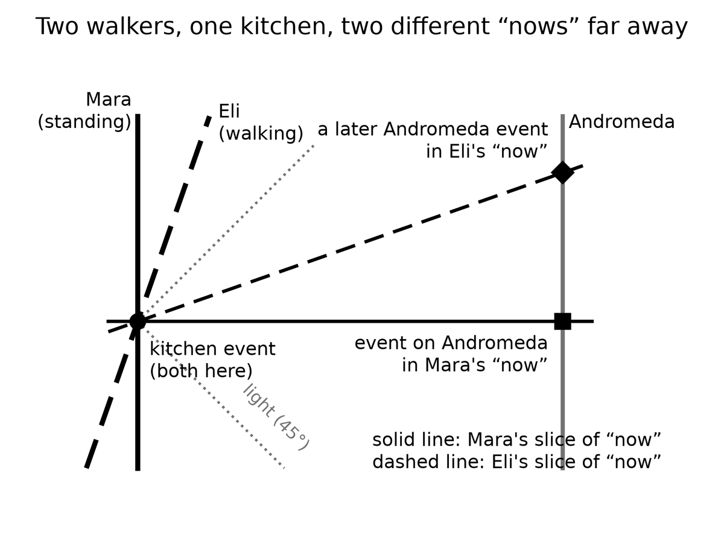
Spacetime Diagram 1. Relativity of simultaneity. Time runs up the page, space across it, and light travels at 45 degrees. Mara’s slice of “now” is level; Eli’s, because he is walking, tilts. Across a kitchen the tilt is nothing. At Andromeda it picks out a different event.
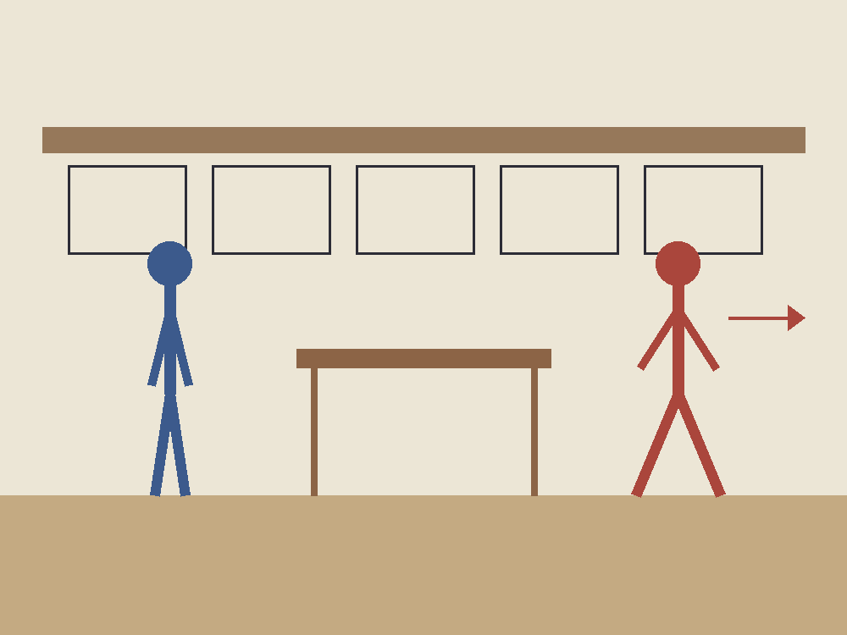
Figure 1. One kitchen. Put two people in it, one walking and one standing still: they agree on the casserole; they do not share Andromeda’s now.

2. An Event Is a Happening, Not a Thing
Physics, at this level, does not start with objects. It starts with events.
An event is a happening with a location and a time — or, more carefully, a happening that can be given four numbers once you have chosen a way to measure. A firecracker goes off. A photon hits a detector on a satellite. Two black holes finish colliding and ring down. You finish this sentence. Each of those is an event. A person is not an event. A person is a long, messy chain of them.
This sounds like bookkeeping. It is the opposite of bookkeeping. It is a decision about what the universe is made of.
Hold the firecracker a moment. It is not a red tube that “is” in the drawer and then “is” in the air. The lighting, the bang, the smoke that reaches a neighbor’s window — those are events. The tube is a habit we form when a bundle of events stays in step long enough for a hand to close on it. A marriage is an event, or a short braid of them: two people in a room, a sentence said, a register signed. The marriage-as-object, the thing you point at twenty years later and call “us,” is the trail. A death is an event. The person who died is not an event that has finished. The person was the trail. Confusing the trail with a crumb is how you end up asking where the rock “goes” when time “passes.” The rock does not go. The rock is a worldline. The crumb is a happening on it.
The loss is not verbal. Start with the rock and you will want a universal tick that tells you when the rock is “the same rock, later.” You will want a photograph of all the rocks at once. You will rebuild Newton’s camera because the camera is what objects demand. Start with events and the camera is optional. The rock is still there, as a braid. You can weigh it. You can throw it. You just cannot promote it into the atom of the inventory. Hot: detectors click at places and times. Warm: calling the click-cluster a muon, or a person, is the right habit for daily work. Cold: that the habit is what the universe is made of.
Give each event four coordinates. Three of them are the ones you already use to find a restaurant: a grid on the Earth, or a grid in the sky. The fourth is a clock reading. The set of all events, related by which ones can influence which others, is spacetime. The geometry of this got a line that still startles.
Hermann Minkowski, who had taught Einstein and had not at first been impressed by him, said it in Cologne on 21 September 1908: henceforth space by itself, and time by itself, are doomed to fade into mere shadows.⁴ He said it to a room of natural scientists who had grown up inside Newton’s box. Then the 1905 paper stopped looking like a trick with clocks. It was a geometry. Space by itself is a shadow because a length you measure depends on your motion. Time by itself is a shadow because a duration you measure depends on your motion. What is not a shadow is the pairing. Four numbers, glued by a rule that does not care who is walking. That sentence is warm as poetry and hot as a classification: every later test that has distinguished “space plus time” from spacetime has come down on that side.
Unpack the shadows without reciting the whole lecture. A meter stick moving past you is shorter along the direction of the motion than the same stick at rest in your kitchen. A clock moving past you ticks through fewer of its own seconds between two of your marks than a clock on the wall. Those are not optical tricks. They are what “space by itself” and “time by itself” become once c is the same for everyone. The point was that the two tricks are one trick. Shorten a length and you have borrowed from time. Stretch a duration and you have borrowed from space. The loan is exact. The leftover, the thing that does not change when you change walkers, is the interval.
Mara books a table. The booking already has almost everything physics will ask for. A street and a number. A floor. A clock time — half past seven, not “evening” in the abstract. If you like, a calendar date. Those are four coordinates for an event: Mara sits, the bread arrives. You can change the grid. You can measure the restaurant from a church steeple or from a satellite. You can run Mara’s watch fast or slow. You cannot turn the dinner into a rock that exists “at all times” and then ask time to happen to it. The dinner is a happening. Miss the hour and the table is a different event, or no event at all.
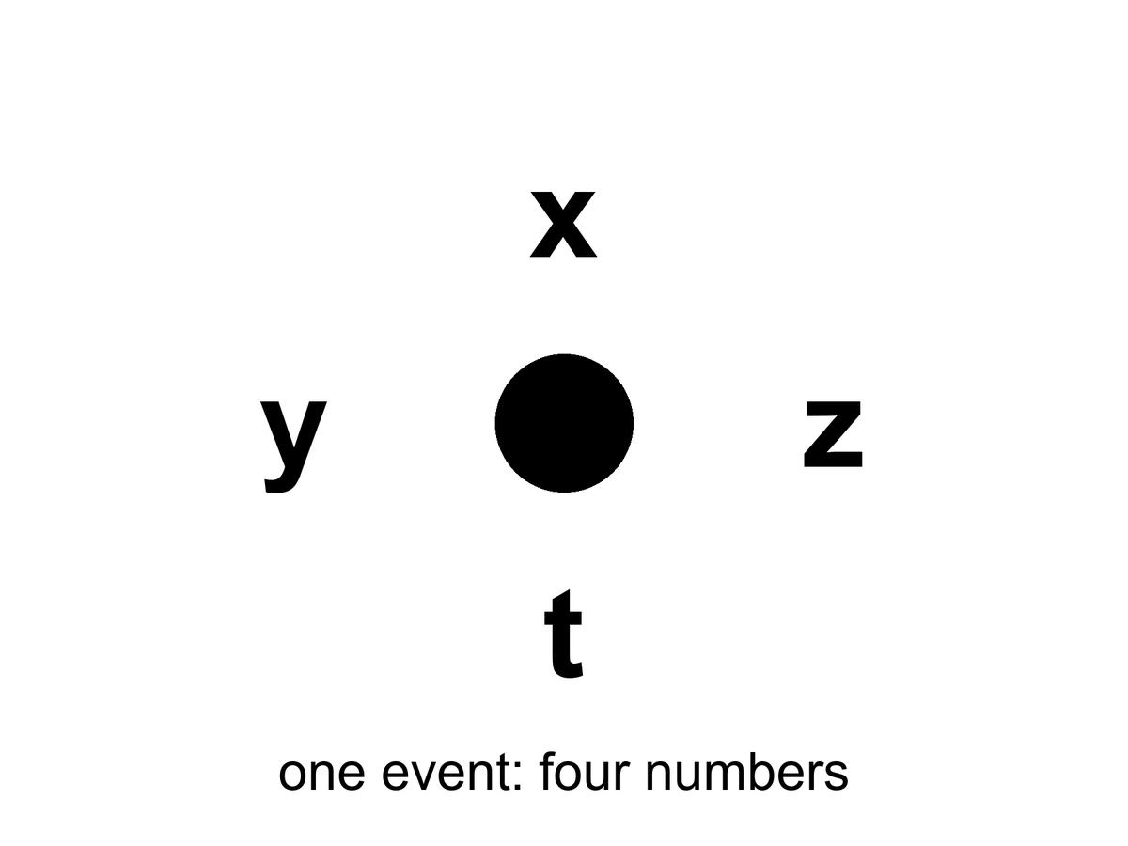
Figure 2. One event: a happening with four numbers, x, y, z and t. An event is not a rock.
The useful picture is not a box of space with a clock hanging on the wall. The useful picture is a loaf. Each event is a crumb. A worldline is the trail of crumbs that is you — or the Earth, or a photon. A photograph of “the world at a given time” is a slice through the loaf. The slice is not unique. Tilt your knife — which is what changing your motion does — and you cut a different set of crumbs.
The tilt is tiny at walking speed. That is why Newton never saw it in a kitchen. Over a table, Eli’s knife and Mara’s knife cut almost the same crumbs. Over a galaxy, they do not. The loaf does not change when the knife tilts. The membership of the slice does. Cuts are useful. They are how you say “when I was twenty” without listing a million events. They are not a feature the bakery stamped on the crust.
Two events can stand in only a few relations that matter.
They can be close enough, in the right combination of space and time, that a light signal or something slower could pass from one to the other. Then one can be a cause of the other. Everyone agrees on the order. This is a timelike or lightlike separation, and it is the part of physics that still has a before and an after.
Lightlike is the edge of that permission. A photon leaving the oven lamp and hitting Mara’s eye is a lightlike pairing: no slower courier could have made the trip, and no faster one exists. Timelike is everything inside the edge — a shout, a smell, a walk from stove to table. Those pairings keep a before and an after for every honest observer. That is why the casserole can still be a cause of dinner. The order is not a courtesy. It is the interval advertising its sign.
Or they can be so far apart, compared with the time between them, that not even light can connect them. Then neither is the cause of the other. Different observers can disagree about which happened first. This is a spacelike separation. The casserole and a flare on Andromeda, “at the same kitchen instant,” are almost certainly spacelike. There is no fact of the matter about which was first that the universe is required to honor.
Appendix A2 writes this as a single formula: the spacetime interval. The interval is the same for every observer. The split of that interval into “so much space” and “so much time” is not. That is the entire trick. The loaf has a real geometry. The slices are ours.
The kitchen analog is a cutting board. Draw a right triangle from the corner of the board to a knife. The hypotenuse is a length. You can call one leg “along the counter” and one “toward the sink.” Rotate the board — you relabel the legs. The hypotenuse does not care. The interval is that kind of stubborn length, except one of the legs is time and comes in with a minus sign.
The minus sign is why the analog is not perfect. Rotate a cutting board and both legs stay lengths. In spacetime one leg is a duration, and it enters with the opposite sign to a length. That is why a small change of motion can trade a little space for a little time without changing the interval, and why a large enough distance makes “who was first” a question the interval refuses to answer. That invariance is hot: every particle detector that reconstructs a collision and every GPS receiver that solves for a position uses it. The split is ours. The pairing is not.
If you take nothing else from this chapter, take this: when a physicist says spacetime, they are not being fancy about the word background. They are telling you that the raw inventory of the world is events, and that time is one of the ways events can be separated — not a river the events float in.

3. Light Is Late on Purpose
We talk about looking into space. We are always looking into the past.
The Sun you see is eight minutes old. Jupiter, tonight, is about forty minutes old. The Andromeda Galaxy is two and a half million years old in your sky. The leftover glow this book will spend Part II on is a picture of the universe as it was when it was 380,000 years old — a baby picture with the baby long gone.
Eight minutes is the rounded kitchen number. The honest one is 499 seconds. That is how long light takes to cross one astronomical unit, the mean Earth–Sun distance, 149,597,870.7 kilometers, at 299,792,458 meters per second. The light that heats the back of your hand left the photosphere before you put the kettle on. You are not in touch with the Sun. You are in touch with a star that has already moved on.
The Moon is closer, which is why it fools people. Light from the near face takes about 1.3 seconds to finish the trip. During Apollo, Houston learned that number as a manner. A question went up. An answer came down. In the middle sat a hole you can hear on the tapes if you listen for the gap. It is not drama. It is 384,000 kilometers divided by the same c that emptied the Cleveland interferometer. The men in the room called it lag. The geometry called it a past cone.
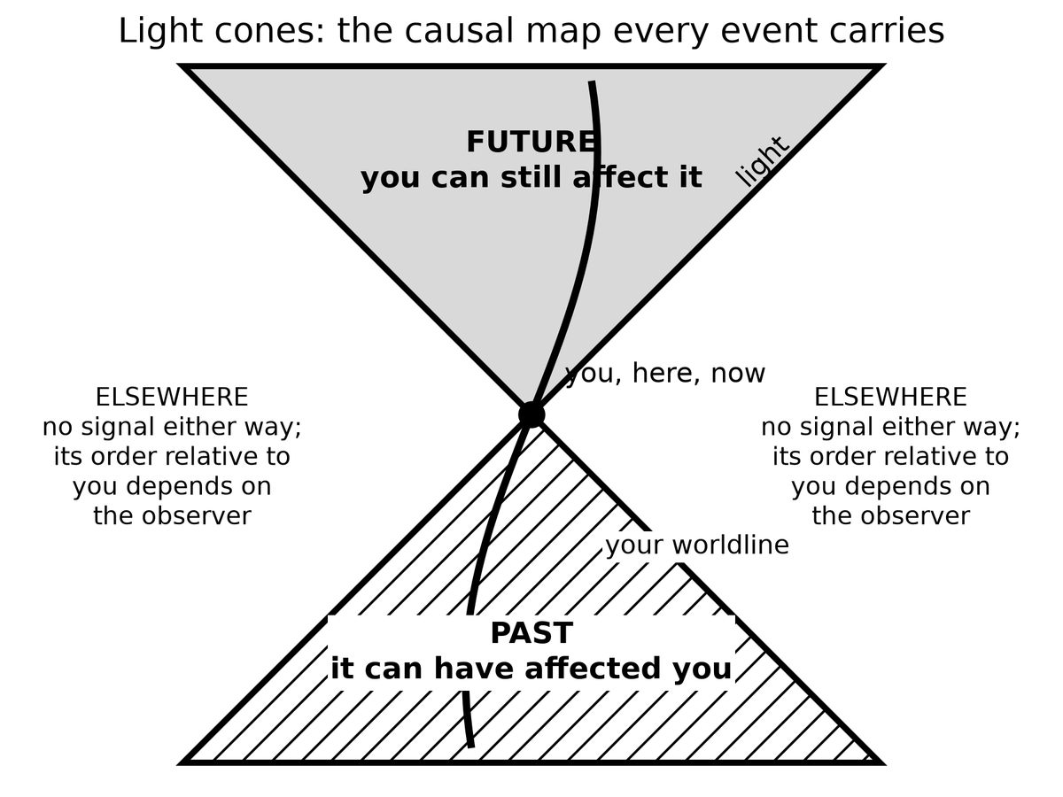
Spacetime Diagram 2. Light cones. Every event carries a future cone it can still affect and a past cone that can have affected it. Everything else is elsewhere: no signal either way, and its time order relative to you depends on the observer.
Jupiter does not have a single number. The planet runs from about 3.9 to 6.5 astronomical units from the Earth, depending on where the two worlds sit in their orbits. Light one way is then about 33 minutes on a close night and about 54 minutes on a far one. “Forty minutes” is a typical Tuesday. A flare on Io is not news. It is a letter.
Voyager 1, as of October 2026, sits about 172 astronomical units out, in the thin dark past the planets. A command from Earth takes nearly 24 hours to arrive, and on 18 November 2026 the one-way trip passes a full light-day.⁵ A reply takes as long again. The spacecraft is not “out there now” in the sense a casserole is in the oven now. The spacecraft is a trail of events. The event you can still affect with today’s radio is already tomorrow on the craft’s clock, and the event you can still hear left yesterday.
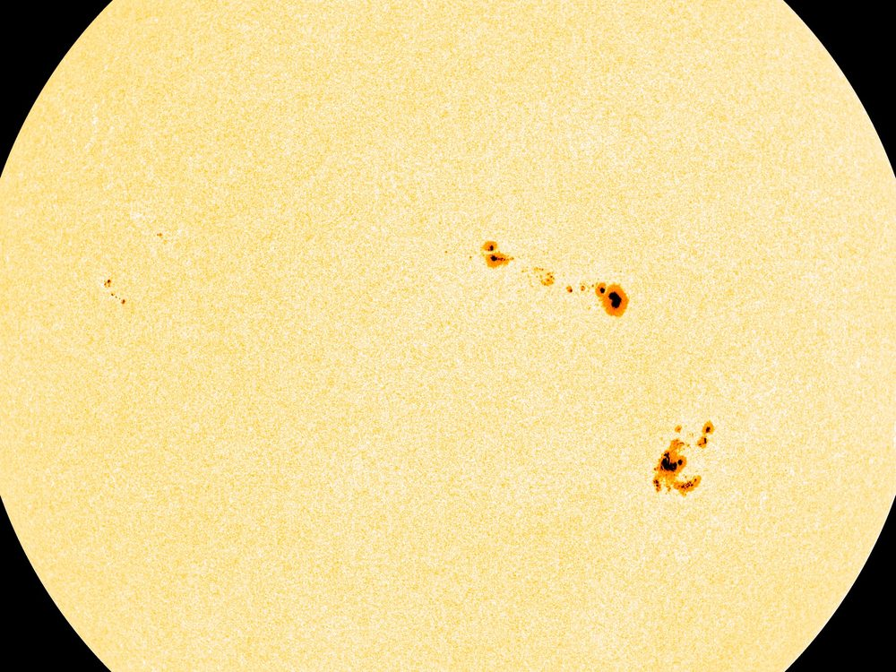
Figure 3. The Sun. Its light is eight minutes old by the time it reaches your eye.
This is not a limitation of our instruments. It is what a finite speed of light is. If light were instant, “now” would still be a problem for moving observers, but the night sky would at least be a live feed. It is not a live feed. It is an archive. Every direction is a different depth of time.
Look left at the Moon and you are looking 1.3 seconds down. Look at Jupiter and you are looking most of an hour down. Look at Andromeda and you are looking through the entire history of Homo sapiens and then some. The sky is not a dome with a single stamp. It is a stack of postmarks. A telescope is not a telephone.
People find this either depressing or wonderful. Both reactions are allowed. The scientific point is narrower. Because light is late, astronomy is already time travel of the only kind we actually have: we receive news of events that lie to our past, along our past light cone.
A light cone is not a party decoration. From any event — say, you snapping your fingers — draw every path a light ray could take into the future, and every path a light ray could have taken to arrive there from the past. The future cone is everything you can still affect. The past cone is everything that can still affect you. Everything else is elsewhere: real, possibly interesting, and unavailable as a cause or an effect of this snap.
Treat the cone as a traffic law. You may go into your future cone. You may have come from your past cone. You may not cut across elsewhere and arrive before the light. The posted limit is c. There is no shoulder. A radio, a probe, a letter, a shout across a yard — all of them buy a ticket inside the cone or they do not travel. The law is hot. Every failed attempt to signal faster than light, and every collider that has tried to catch a particle arriving before its own cause, has left the cone unbent. Warm: that no clever geometry later in the book will hand you a legal detour. Cold: that we have checked every cheat. We have not. Chapter 34 will be honest about the proposed ones. They have to break something in the loaf. They do not get to edit the 499 seconds to the Sun.
The night sky is the past cone, printed on the inside of your eye.
This is why “getting somewhere else in the universe” is not an engineering slogan. Most of the interesting somewhere-elses are already outside the future cone of any event you will live to occupy. You can wait. You can send a probe. You cannot, in this spacetime, jump sideways into elsewhere and arrive for dinner. Light’s lateness is not an inconvenience we can edit out. It is the geometry.
You do not need Andromeda to feel this. A conversation with someone on Mars is already broken. Light takes between about three and twenty-two minutes one way, depending on where the two planets sit in their orbits. The reply costs the same again. You cannot talk. You can only send, and wait, and send again. Elsewhere begins at the next planet over.
Put the same two people on the radios, years after the casserole, because the cone is easier to believe when it ruins a sentence. Eli, still in the kitchen, sends “How is the dust?” Mara, on the dead world, will hear it between three and twenty-two minutes later. She cannot say “wait, what?” in the way a kitchen allows. She can send her own sentence into a future Eli has not reached yet. By the time her words arrive, his next sentence is already in the air, or already abandoned. They are not talking. They are mailing. The interruption that makes a conversation a conversation is a timelike luxury — a luxury that requires the gap between speakers to be short compared with the time they are willing to wait. Elsewhere begins when the luxury ends. No colony is required for the demonstration. Two radios and an orbit are enough.
There is a kindness in the lateness, if you want one. The universe is not happening at you. It is arriving. The glow behind the stars, the one you cannot see without an antenna, has been arriving for thirteen billion years and will keep arriving tomorrow. You do not have to go anywhere to be in contact with the beginning. The beginning is late, and it is here.
The dark between the stars is late in another sense, and it has a name older than relativity. If the universe were infinite, eternal, and static, stuffed with stars, every line of sight would end on a surface as bright as a photosphere. The night would be a furnace. Heinrich Olbers was not the first to worry; he was the one the paradox kept. The night is not a furnace. Part of the reason belongs to later chapters: expansion stretches light and thins it. Part of the reason belongs here. The universe has a finite age. Light from the farthest possible furnaces has not had time to arrive, and many of those furnaces have not been burning forever. The black is an archive with empty early pages. That is a hot observational fact wearing a nineteenth-century question. The dark is late, and the loaf has a beginning.

4. Andromeda’s Navy
Here is the thought experiment that makes the kitchen argument unavoidable. It is often called the Andromeda paradox — the version physicists still use.
Mara is standing in the yard. Eli walks past her, toward Andromeda, at an ordinary pace — a stroll. Special relativity says that the set of events Eli calls “simultaneous with this passing” is tilted, very slightly, relative to hers. Over the distance to Andromeda, a slight tilt is not slight. On her “now,” the Andromedans (if any) are, say, sitting in committee. On his “now,” the committee has already launched a fleet.
The stroll is not a metaphor for speed. It is a speed. A comfortable walk is about 1.4 meters per second. M31, the Andromeda Galaxy, sits about 2.5 million light-years from the yard — a modern distance, not a poster guess. The tilt of “now” is the same arithmetic Einstein used on trains:
Δt ≈ v Δx / c²
where v is how fast Eli walks toward the galaxy, Δx is the distance to M31, and c is the speed we have already refused to negotiate.
Plug in the stroll. You do not get centuries. You get about four days. A few days of disagreement about Andromeda’s “present,” for a walk you would not break a sweat on, at a galaxy you cannot see without knowing where to look. That is already enough to break a single cosmic now. Raise the relative speed to a highway and the disagreement becomes about three months. At an airliner’s speed it is about two years. The Earth’s own 30 kilometers per second around the Sun, if you compared frames carelessly, would buy you centuries. The yard only needs the stroll.
At the moment their sleeves brush, they share a here. They do not share an Andromeda-now. If Eli stopped walking, the disagreement would shrink toward zero. The navy, if any, would not notice. Nothing in M31 is waiting on his hips. The tilt is a fact about slices, not a telegram to a fleet.
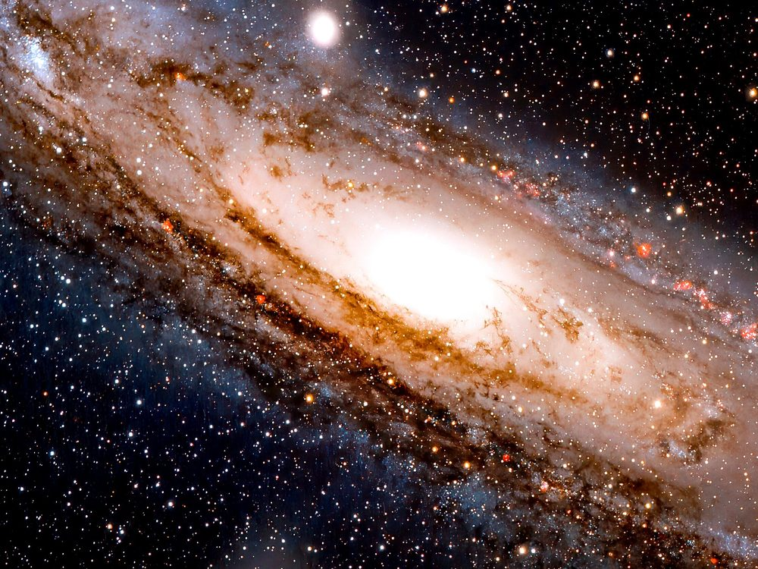
Figure 4. The Andromeda Galaxy, cropped to its bright disk. Whatever is happening there now is two and a half million years from your yard.
Neither of them can see the fleet. The light has not arrived and will not arrive for millions of years. The point is not what they see. The point is the temptation to call one slice real.
If you believe that only the present is real — that the past is gone and the future is not yet — then you have a problem. Mara and Eli, standing in the same yard, passing each other at walking speed, do not share a present at Andromeda. If his present is real and includes a launched fleet, and her present is real and does not, then “real” has split in the yard.
The split is not a feeling. It is a bookkeeping collision. She has granted real to whatever sits on her slice. Eli has granted real to whatever sits on his. The slices disagree at a distance where no signal can referee. Either reality is allowed to depend on who is walking past the compost heap, or real was the wrong prize to hang on a slice. The first option makes ontology a property of gait. The second option is the loaf.
The clean way out is to stop granting a privilege to the slice. The fleet-launch is an event. The committee meeting is an event. Both are in the loaf. You will learn about them, if at all, when their light arrives. Until then they are not “future” in some ghostly sense and not “present” in some official sense. They are simply events that are spacelike-separated from this moment in the yard.
Hilary Putnam and C. W. Rietdijk made this into a formal argument in the 1960s: if whatever is present-for-someone is real, and if reality does not depend on who is walking, then distant future events are already real. Rietdijk’s paper is 1966. Putnam’s “Time and Physical Geometry” is 1967. Philosophers have been picking at the logic ever since. Some reject the idea that “real for Alice” transfers to Bob. Some try to keep a privileged present by adding extra structure that relativity does not provide. Some accept the loaf and get on with their lives.
The transfer is the hinge they pick at. Alice walks. A distant event is present-for-Alice, hence real. Bob stands. Reality does not depend on gait, hence the event is real-for-Bob too, even if it is future-for-Bob. Repeat, and the future fills up. That chain is only as strong as the first gift: present implies real, and real is shared. This book does not need the chain as a proof. It needs the first gift to look expensive. Once you have seen the gift cost a preferred slice, you can put the gift back on the shelf.
Keep the temperature on that last move. The relativity tilt is hot. Clocks and rods and GPS and particle tracks all honor it. The inference “therefore the distant future is real in the same way this yard is real” is a reading. It is a reading this book accepts, because the alternatives have to smuggle in a preferred slice that no experiment has found. It is still a reading. Warm, not a photograph of a fleet. The quiet version is enough: do not give the word real to one cut of the loaf and withhold it from the crumbs a walk would recut.
Henri Poincaré said as much around 1898: you cannot assign a time to a distant event without a rule, and the honest rule will not be Newton’s. He still treated the rule as a convention among surveyors, and the ether was still being patched. Einstein’s 1905 paper is the rule written as physics. The yard is the same rule with a longer baseline.
This book accepts the loaf. Not as a religion, and not as a measurement — as the interpretation that does the least violence to a theory that has passed every test we have given it. Chapter 6 marks exactly where the tested theory ends and the reading begins. GPS satellites run a daily demonstration: if you do not correct their clocks for both speed and gravity, your phone’s map slides into a ditch. The corrections are the same mathematics that tilts the Andromeda slice. Leave the clocks alone and they drift by about 38 microseconds per day¹ — special relativity and gravity pulling in opposite directions, the net still large enough to walk a position off a road. The tilt that reallocates a few days of Andromeda is the tilt that, at 20,000 kilometers up, reallocates a fraction of a blink. We correct the blink because we like maps. We do not get to refuse the galaxy.
You do not need to believe that 2219 is “already happening” in some lurid sense. You need to believe something quieter: 2219 is a region of the same object 1914 is a region of. The difference is which events can still influence the ones that make up you.
1914 is not “still going on” in a kitchen. It is a region whose light, and whose causal leftovers, still reach you. 2219 is a region whose light has not, and whose causes you have not yet become. The vocabulary of happening — the glow, the stamp, the weather front — is what gets people into lurid trouble. Drop the glow. Keep the regions. You already do this with places. Lisbon is real when you are in the yard. You do not need Lisbon to be here. Times are places in the loaf. That sentence is warm. It is also the least theatrical reading that leaves Eli’s walk intact.
That quieter belief is enough to rewire the rest of the book. The beginning of the universe is not a story that used to be true. It is a region of the loaf. The heat death, if that is what we get, is another region. We occupy a thin braid in between.

5. You Are a Path
If the universe is a loaf of events, you are a thread.
A worldline is the set of events that is a particular object’s history. The Earth’s worldline is a long helix around the Sun’s, which is a longer helix around the galaxy’s. A photon’s worldline is a straight edge of a light cone — as straight as the geometry allows. A person is a bundle of worldlines, roughly parallel, that eat, argue, and occasionally write books.
The bundle is the honest picture and the slightly comic one. You are not a single thread. You are a rope of atoms that stay in conversation, plus a few that do not. The rope has a thickness of a body and a length of a life. Physics will still call the rope a worldline when the thickness does not matter. It matters when you want to know why a liver and a thought can share a name. They share a braid. The braid has a mileage. That mileage is the age your cells would confess if they kept better books than birthdays.
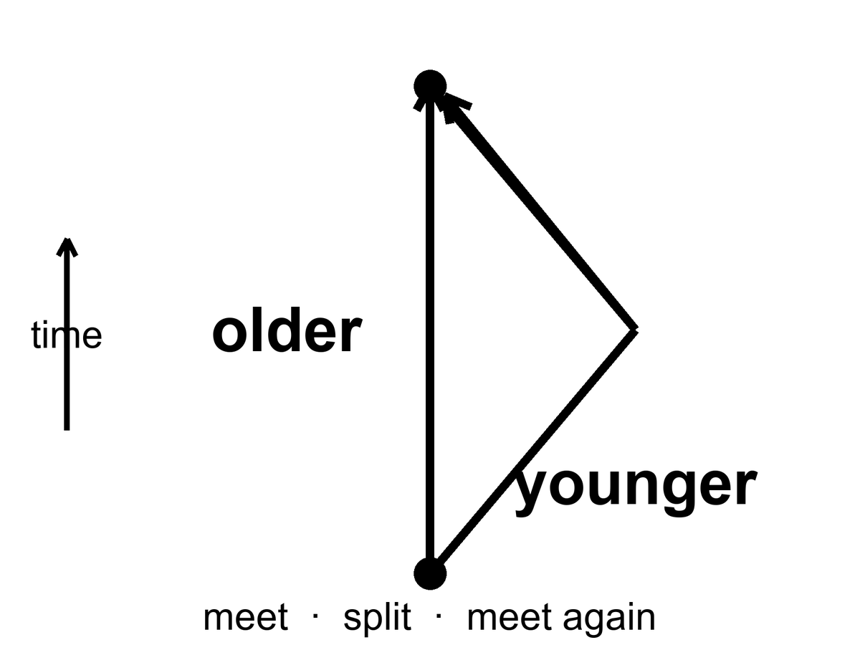
Figure 5. Two worldlines meet, split and meet again. The twin who travelled is younger: mileage through spacetime, not a trick.
You do not move through time the way a boat moves through a river. That sentence, which feels like common sense, smuggles the river back in. What you do is occupy a sequence of events. The sequence has a length. That length is the time your watch measures, and it is called proper time. Proper time is not a coordinate someone assigned from a tower. It is a property of the worldline, the way a hiking trail has a mileage that does not depend on which map you used.
where proper time is the mileage along your worldline, the seconds a clock traveling with you actually accumulates.
Picture two hikers, June and Cal, who leave the lot at 8:00 by the same clock on the wall. June takes the ridge. Cal takes the creek. They meet at the lake and compare. The surprise, if you still think time is a river, is that their watches need not agree, even if both kept honest seconds. In the mountain the difference is too small to see. In spacetime the same kind of difference is the whole twin story. The map can lie about mileage if it wants; the boots do not. Proper time is the boots.
Two worldlines that start together and end together need not have the same length. This is the twin “paradox,” which is not a paradox. The twin who accelerates, turns around, and comes home has a shorter worldline. She is younger. The loaf does not care that this offends the kitchen clock. Particle accelerators run the same experiment all day: unstable particles that travel fast live longer, as measured in the lab, because their worldlines between two lab events are shorter in proper time, which means their internal clocks tick through fewer of their own seconds. The word “live longer” is a lab word. In their own terms they live a normal life and the lab takes forever.
It is mileage, not a trick. The twin who stays home is the hiker who took the straighter trail through the loaf. In the geometry Einstein handed us, the straightest timelike path between two meetings is the longest proper time, not the shortest. That is the minus sign from Chapter 2 earning its keep. The traveler who turns around has taken the switchbacks. Her watch adds up fewer seconds. No one has to break physics to prefer a younger sister. You only have to stop asking the kitchen clock to be the mountain.
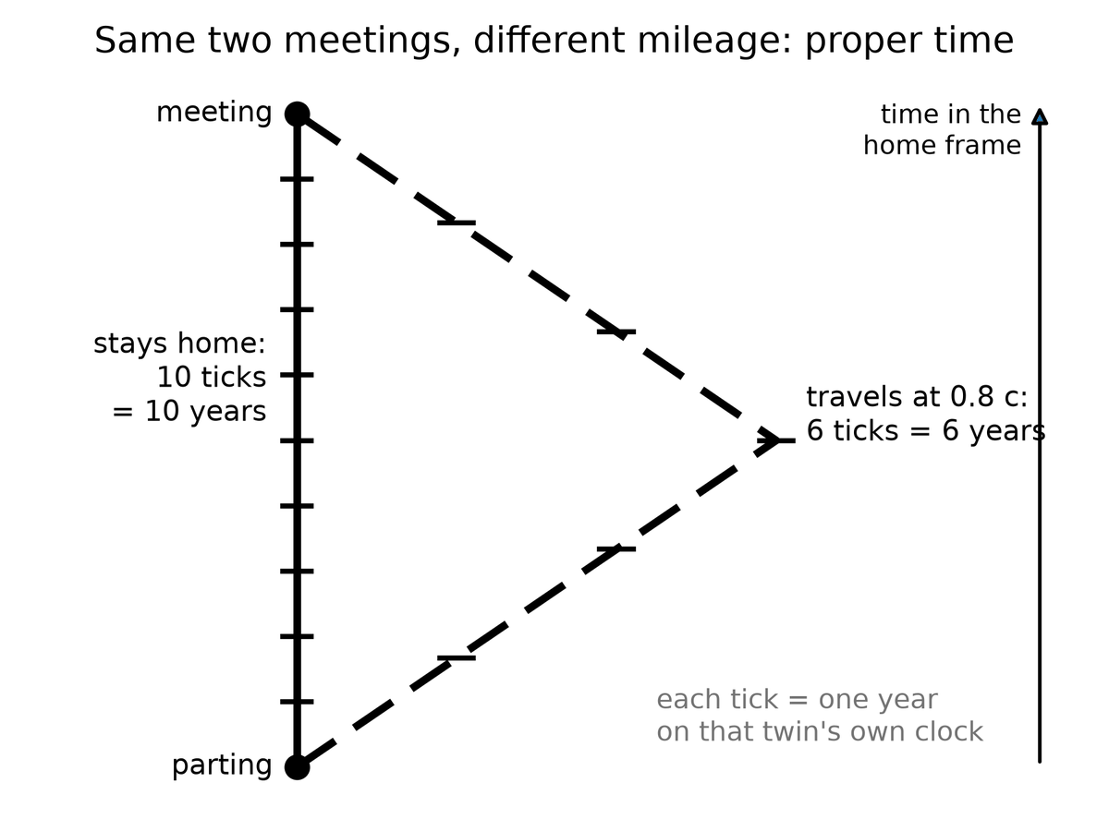
Spacetime Diagram 3. Twin proper time. Both twins go from the same departure to the same reunion. The one who stays logs 10 years; the one who travels at 0.8 of light speed logs 6. The bent path is the shorter one in proper time.
The muon is the classroom that does not need a twin. A muon at rest lasts about 2.2 microseconds before it decays. That is not a rumor. It is a measured lifetime, 2.2 × 10⁻⁶ seconds, repeated until it is boring. Cosmic-ray muons are born in showers tens of kilometers up. Even at nearly the speed of light, 2.2 microseconds buys only about 660 meters of travel, so without time dilation most of them should die in the upper air. They reach the ground in inconvenient numbers. Their worldlines between the shower and the dirt are short in proper time and long in the laboratory’s coordinates. The particles are not cheating death. They are hiking a shorter trail. Hot.⁶
The showers start nearer 15 kilometers. Without the mileage effect you would need a conspiracy of extra lifetime to stock a basement detector. With it, a muon whose energy buys a time-dilation factor of twenty or thirty has a trail long enough to punch the dirt. Students have been counting those punches since the 1940s.
In October 1971 Joseph Hafele and Richard Keating put that trail on commercial jets.⁷ They flew cesium-beam atomic clocks around the world, eastward and then westward, and compared them with clocks that had stayed in Washington. The eastward clocks came home about 59 nanoseconds behind the clocks that stayed; the westward clocks came home about 273 nanoseconds ahead, each close to its prediction. The signs flip with direction because the Earth’s rotation is already a velocity, and a jet adds to it one way and subtracts the other. Special relativity is not only for twins in textbooks. It is a fare class.
Gravity bends worldlines. That is what gravity is, in Einstein’s account: mass-energy tells spacetime how to curve; curved spacetime tells worldlines how to lean. A clock deeper in a gravitational well accumulates less proper time between two meetings than a clock higher up. This has been measured with aircraft, with towers, with a hydrogen-maser clock flown on a rocket in 1976,⁸ and with those GPS satellites. Near a black hole the same fact becomes extreme: an hour beside the horizon can be years farther out.
Bent, here, is not a metaphor for trouble. A worldline that stays near a mass is a different trail through the loaf than a worldline that stays high. The trail nearer the mass is shorter in proper time between two comparisons. The mass did not reach out and grab the clock. The mass told the geometry how to lean, and the clock added up the lean. Hot as a description of what we measure. Warm as the full story of why the geometry listens. Cold: that we have a finished quantum account of the listening. We do not. The clocks do not wait for one.
The tower came first, and it was short. In 1959 Robert Pound and Glen Rebka sent gamma rays up and down a 22.5-meter shaft in Harvard’s Jefferson Laboratory and measured the gravitational redshift — climbing out of a well costs a photon energy, the way climbing a hill costs a thrown ball speed, and a photon with less energy reads as a lower, redder frequency — of the Earth over the height of a building.⁹ Iron-57. A fraction of a fraction of the energy. They saw it. Later refinements made the agreement rude. You do not need a hole in the sky to learn that height is time. You need a basement and a roof and a nucleus that will confess. In 2010 optical clocks saw the same effect over a height difference of about a third of a meter.¹⁰
GPS is the public sum of the jet and the tower. A satellite clock, moving fast, runs slow by about 7 microseconds a day from special relativity. The same clock, sitting higher in Earth’s well, runs fast by about 45 microseconds a day from gravity. The net, if you do not correct, is about 38 microseconds a day — the number Chapter 4 already used as a threat to maps. At the speed of light it is about 11 kilometers of ranging error a day, and it accumulates. The engineers correct both pieces because both pieces are real.¹ The Andromeda tilt and the hiking-trail mileage are the same theory wearing different hats.
Chapter 21 will take the hour-beside-the-edge as far as a spinning hole and a poster number. If a clock in a basement already disagrees with a clock on a roof, a clock that hovers just outside a horizon will disagree with a clock in the suburbs of the same hole by an amount that stops being polite. The geometry is continuous. The kitchen is not a different law from the hole. The hole is the kitchen with the well turned up.
Once you are used to worldlines, several puzzles lose their fog.
“Where is the universe expanding into?” is a thing-question. Expansion is a change in the distance between worldlines of galaxies, measured at successive meetings with light. There is no need for an outside.
“What happened before the beginning?” is a river-question. If the loaf has a boundary — and it may — then “before” is a word that applies inside the loaf, not to a waiting room outside it. Chapter 45 will take this as far as anyone honestly can.
“Can I go back?” is a thread-question. Going back would mean your worldline looping so that it meets an earlier event on itself, or on someone else’s line, in the wrong order. The loaf’s geometry may or may not allow such loops. Ordinary spacetime, the kind we have measured, does not hand them out. Chapters 36 and 37 are about that.
Keep the temperatures on the path. Hot: clocks that take different trails between two meetings disagree, and the disagreement is the one the geometry ordered. Hot: muons, jets, towers, and phones all keep the same books. Warm: that the books are best read as a block of events with worldlines drawn through them. Cold: that this makes you a prisoner of a drawing. A path can still choose its next step inside its future cone. The drawing is the set of steps. It is not a warden.
For now, keep the thread. You are not a passenger in time. You are a path.

6. The Block
Call the loaf by its public name: the block universe.
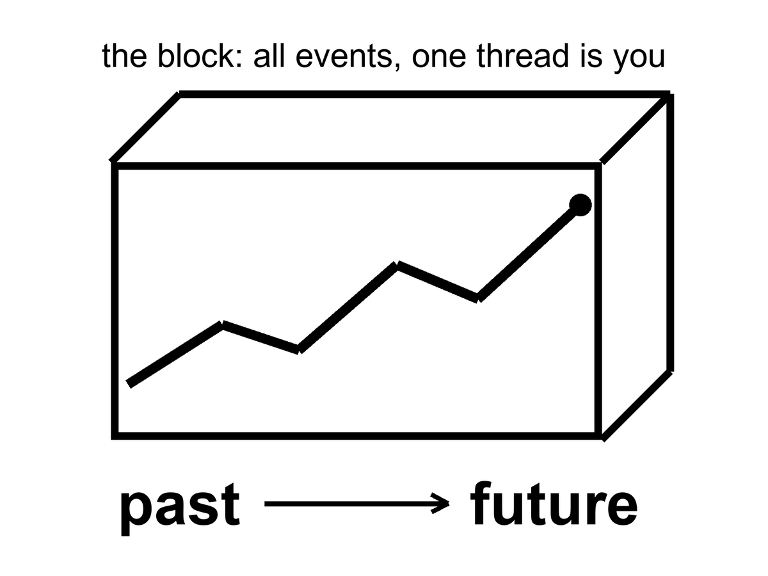
Figure 6. The block: a loaf of all events. One thick thread is you. Past and future are directions on the loaf, not a moving edge.
The block is not a brick. It is the claim that past, present, and future events are equally part of the inventory. The “present” is the event-cluster you are using as a vantage. It is not an ontological VIP section.
The loaf has a shape, not only a guest list. In November 1915 Einstein wrote the field equation that says how the shape is set: mass-energy on one side, geometry on the other. Matter tells spacetime how to curve. Curved spacetime tells worldlines how to go. You have already met the local consequences — the tower, the jet, the 38 microseconds. The global consequence is that the block is not a rigid box we inhabit. It is a geometry we are inside of, and the geometry answers to what is in it.
The first public test was not a kitchen. It was an eclipse. On 29 May 1919 Arthur Eddington’s teams on Príncipe and at Sobral photographed stars near the Sun and found their light bent by about the amount Einstein had asked for — on the order of 1.75 arcseconds at the limb, twice Newton’s corpuscle guess. The measurement was ruder than the headlines, and later eclipses and radio interferometers cleaned it. The claim that survived is hot: light follows the geometry, and the geometry is not flat when the Sun is in the way. The block is not a metaphor we chose because it sounded grave. It is one reading, this book’s reading, of a theory that has been catching starlight for a century.¹¹ The theory is hot. The reading is not a measurement, and the box below says exactly where the line falls.

Physics vs philosophy: from relativity to the block
What the evidence establishes (hot). Clocks that move, or sit higher in a gravitational field, tick at different rates, by amounts measured on airliners, up a tower, across a laboratory bench, and every day in GPS.⁷⁹¹⁰¹ Observers in relative motion disagree about which distant events are simultaneous, and no experiment has ever singled out one of their slices as the true one.¹² Every observer agrees on the light cones: which events can affect which.
What this book infers (interpretation). If no slice is privileged, then past, present, and future events are on the same footing: the block universe, which philosophers call eternalism.¹³¹⁴ That is a philosophical reading of a tested theory, not a measurement. No experiment can tell it apart from a universe with a hidden preferred slice, because the slice is hidden by construction.
What would change the verdict. A detected preferred frame (a violation of Lorentz symmetry, which experiments already constrain tightly¹⁵), or a quantum theory of gravity in which a physical global time reappears. Either would put a cosmic now back on the table without contradicting anything relativity already explains.

People dislike the block because it sounds like fatalism. If 2219 is “already there,” was anything I did today a choice? The honest answer is: your choice is an event too. It has causes in its past cone and effects in its future cone. The block does not steal the choosing. It refuses to make the choosing into a little glow that travels along the thread, lighting up real events and leaving the rest in storage. The choosing is a stretch of the thread.
There are rivals, and they deserve their best case, not a cartoon.¹⁶
Presentism says only the now is real.
Its strongest case. Every experience anyone has ever had was had in a present. Tensed facts (“it is raining now”) look irreducible. And a careful presentist can keep every prediction of relativity: add one preferred slicing of spacetime that no experiment can detect, and the equations, the clocks, and GPS are untouched. Cosmology even offers a natural candidate. The leftover glow of Chapter 9 looks the same in every direction for one family of observers, and their clocks define the “cosmic time” in which the universe is 13.8 billion years old.
What it gets right. It cannot be refuted by experiment, and this book does not claim otherwise. Cosmic time is real and useful; this book uses it in every chapter that gives an age. And the felt present is a datum that any account of time owes an explanation.
Why this book still declines it. The preferred slice does no work. It enters no prediction, it is posited and never measured, and in a lumpy universe (near a star, inside a black hole) the glow does not even define it cleanly. Declining it is a judgment of economy, not a proof.
The growing block says the past and present are real and the future is not yet. The loaf grows.
Its strongest case. The asymmetry between a fixed past and an open future is the deepest feature of experience and of action: we keep records of the past and make choices about the future. George Ellis’s “evolving block” gives this physical teeth: the future is not there yet because quantum outcomes are not settled yet, and spacetime crystallizes as they become definite.¹⁷
What it gets right. The arrow of time is real and needs explaining, and this book agrees it is not explained by the block alone (see below). If quantum outcomes are genuinely chancy, as collapse theories say, there is something the future lacks.
Why this book still declines it. Growth needs an edge, and an edge that runs across space is a preferred slice again. Ellis says so openly; his model needs a preferred foliation. The asymmetry it wants can be had more cheaply: a low-entropy boundary in the past, plus the way records form. So this book keeps the asymmetry and drops the moving edge. As physics, the evolving block is a research program, not a refuted idea.
The yard does not get kinder if you change the slogan. Mara stands. Eli walks. Their “nows” at M31 differ by days. If only the present is real, they do not share a reality at 2.5 million light-years, while sharing a reality at the fence. If the loaf grows, someone must say which crumbs have already been baked at that distance. A growing edge that both of them can honor is a preferred slice. Preferred slices are extra structure. Extra structure can be added. It has not been measured. Presentism and the growing block meet Andromeda with the same quiet cost: a walk is enough to recut the distant present, and the universe does not appoint a winner. Both views can pay that cost by adding the winner by hand. That is a reading of a hot tilt, not a proof that philosophers must shut up. Decoherence, which the evolving block leans on, is a possibility losing its power to interfere with the others once it leaks into a big, messy environment; Chapter 41 does this properly.
This book adopts the block as its working reading of spacetime, chosen for economy and flagged as an interpretation, and then notices where physics puts pressure on it. The arrow of time — why we remember the past and not the future, why eggs break and do not unbreak — is not explained by the block. The block is time-symmetric in its basic laws. The arrow needs a fact about the boundary: the early universe was absurdly ordered. Philosophers call it the Past Hypothesis; Sean Carroll has done most to popularize it, and it is why Part II is not optional philosophy. The hot, smooth beginning is the low-entropy end of the loaf. We are downstream of it. That is why there is a difference between looking that way and looking the other way.
Quantum mechanics puts a different pressure on, and this book treats that pressure as a core element, not a cameo.
The equation that describes an electron does not, by itself, pick a single outcome. It assigns an amplitude to each way the story might go. One reading — Hugh Everett’s, later sharpened by people who take the equation literally — says the leftovers are not discarded. When a measurement could have gone two ways, both ways persist, decohered, no longer able to interfere. The block is not only all the times. It is all the allowed versions. You are one thread in a loaf that splits.
That sentence is where a sermon likes to sit down. Reality only forms when it is observed. The equation does not say that. The equation says that amplitudes interfere until a system becomes entangled with something that will not give the interference back — an environment, a plate, a wall of photons that have left and will not return. That is decoherence. It is a calculation you can assign a time to. It does not require a soul.
So what counts as an observer?
Not a person, first. A person is a late, expensive observer: a nervous system that keeps a model and can be surprised. In the laboratory sense an observer is any degree of freedom that acquires a record — a correlation stable enough that you would have to conspire with the whole environment to undo it. A silver grain that darkens. A Geiger tube that clicks. A dust mote whose spin will never again line up with its twin. The leftover glow, last-scattering at 380,000 years, is a record written before any eye. The helium of Chapter 10 is a record written at three minutes. If “observe” means “leave an irreversible trace,” the universe has been observing itself since it was a fog. You were not needed for the fog to have a temperature.
If “observe” means “a mind noticed,” you have added a postulate the amplitudes do not ask for. Wigner can put a friend in a lab and argue about when the wavefunction collapses. That is a quarrel about the word record, not a proof that the Moon is a sketch until you look up. Consciousness-causes-collapse is a minority reading with a famous pedigree and, so far, no extra prediction anyone has confirmed. Chapter 41 gives its strongest modern version a fair hearing and says why this book still declines it. Everett does not need it. Decoherence does not need it. Relativity, which already forbade a single now, will not wait while a mind in one kitchen switches Andromeda on.
There is a better picture of what a mind feels like from the inside, and it does not need a collapse.
Call it a strange loop. A system writes symbols. Some of the symbols point at the system that is writing them. The map contains a sketch of the mapmaker. The hierarchy tangles: the “up” of explanation (neurons, then thoughts, then an I) folds back so the I is what the neurons are doing, and the neurons are what the I takes itself to be made of. No extra spark. A level-crossing. The word I is what that loop sounds like when it has a mouth. An observer, in the expensive sense, is a record that has begun to model the fact that it is a record. An ant is not that loop. A nest of ants, taken as a whole — a city that farms and wars and does not know the name of a single worker — is a cheap sketch of the same trick. Here it is a diagram of a self: meaning that is not in the parts, and is not a ghost. It is an isomorphism, a translation, a tangle.
That picture is warm as phenomenology and cold as a proof that the leftover glow needed us. The glow was a record without a loop. The helium was a record without a loop. The loop arrives late, on a thread, and then has the nerve to ask whether the fog was real before it got here. It was.
EPR — the 1935 complaint that quantum mechanics lets a measurement here fix a pairing there, “at once” — is the same room with better furniture. The pairing is real. Bell showed the pairings are stronger than any local recipe of hidden instructions.¹⁸ Aspect and the rest measured that, and in 2015 a test closed the main loopholes at once.¹⁹²⁰ Hot. What is not on offer is a telegram. You cannot choose what to do here in a way that sends a bit there. The no-signaling theorem is the grown-up name for Einstein’s unease, resolved without a radio. “Simultaneous action” is already a phrase the kitchen clock should not be allowed to use. There is no shared now in which the two ends happen together. There is a correlation in the loaf.
That is a warm claim. It is not a photograph of other lives, and it is not a travel method. Nothing in the equation hands you a way to hop from your thread onto a neighboring one and steal a different marriage, a different planet, a different you. The copies, if they are real, are as unavailable as Andromeda’s navy. They are on the inventory. They are not a destination. And the Moon was there before the first nervous system named it. The record was.
Holography puts a third pressure on. If the information in a region scales with its surface, not its volume, the loaf may be a projection of something thinner. That is a warm-to-cold idea, and it does not cancel the events. It relocates them.
What the block does, for a book about origins and endings, is simple and a little severe. It lets us talk about the first three minutes and the last three minutes as regions, not as moods. It lets a wormhole be a handle connecting two regions, not a machine that “goes.” It lets the Omega Point — a hoped-for final crunch in which life computes forever — be judged as a claim about the shape of the future region, which the data currently contradict.
You can still say “now” in the kitchen. You should. Just do not promote the kitchen to a cosmology.

PART II — The Past We Can Rebuild

7. The Explosion That Happened Everywhere
People hear “Big Bang” and picture a grenade in a dark warehouse: a bright point, a blast wave, shrapnel flying into empty rooms. That picture is wrong in every way that matters, and it is the reason smart readers keep asking a question that has no answer: what did it explode into?
It did not explode into anything. It was not a bomb in space. It was space, getting roomier, everywhere at once.
If you could have been present at a minute old — you could not have; there was no solid ground, no shadow, no place to stand — you would not have seen a fireball receding toward a horizon. You would have been inside the fireball, and so would every other direction. The glow would have been the walls, the floor, the air, the idea of “away.” Density would have been falling because the distances between nearby bits of stuff were stretching, not because the stuff was fleeing a scene.
A baker’s analogy earns its keep here. Imagine raisin bread dough rising in a warm bowl. Every raisin sees every other raisin recede. There is no special raisin in the middle of the dough. The “middle” is a habit we picked up from grenades. In a universe that is, on the largest scales, the same in every direction and at every place — the Cosmological Principle, a working rule with a lot of data behind it — every galaxy is allowed to feel like the center of the stretch. That feeling is a symmetry, not a privilege.
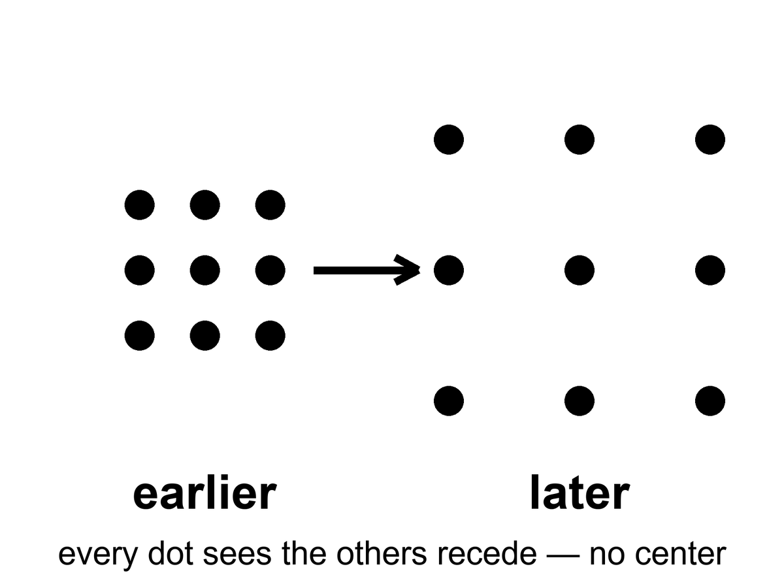
Figure 7. A grid of dots that grows. Every dot sees the others recede; no dot is the center.
Read the figure as a rule, not a cartoon. If every dot recedes from every other dot, you cannot stand outside the grid and point at the blast. There is no outside. The grown-up name for that rule is FLRW: Friedmann–Lemaître–Robertson–Walker, four people whose initials stand for a spacetime that is homogeneous and isotropic on large scales. Homogeneous means no special place. Isotropic means no special direction. Put them together and you are not allowed a center, and you are not allowed an edge you could walk to. An edge would be a special place. A center would be a special place. The equations refuse both.
The single number that does the work is a scale factor, written a(t).
where a(t) is the relative size of unbound distances at time t, set to 1 today by habit, smaller in the past, growing if the raisins are receding.
Distances between unbound things scale with a. Wavelengths of free light scale with a. Ordinary matter thins as 1/a³, because the same stuff is poured into a larger volume. Radiation thins faster, as 1/a⁴, because each photon is also getting tired. That bookkeeping is the whole of the simple expanding universe as a calculator. Appendix A7 writes the metric. Here it is enough to stop looking for a warehouse.
The equations that describe this are named for Alexander Friedmann, a young mathematician who, in the early 1920s, took Einstein’s gravity seriously enough to let the universe change size. Einstein had tried to freeze it with a fudge factor. Friedmann showed the freeze was optional. Georges Lemaître, a priest and physicist, said out loud what the math was hinting: the universe has a history. Edwin Hubble, with a telescope and a lot of patient plates of spiral nebulae, found that the farther a galaxy is, the faster it recedes. The grenade picture rushed back in through the newspapers. It has been misleading well-meaning people ever since.
The dates are not decoration. In 1922 Friedmann published expanding — and recollapsing — solutions of Einstein’s equations. Einstein’s first reply was that the paper contained a mistake. The mistake was Einstein’s. He had already, in 1917, added a term — the cosmological constant, written Λ — to keep the universe static, because a static universe was the respectable prejudice of the room. When the freeze proved optional, and then when the sky refused to sit still, Einstein regretted the term. Later retellings call it his biggest blunder. Whether he used that kitchen word, or only suffered the fact, is a historian’s fight. The physics fight is simpler: he had forced the loaf not to rise, and the loaf was rising.
Lemaître, in 1927, did the unfashionable thing of putting numbers on the stretch and saying, in print, that the universe had a history with a hotter, denser past — a primeval atom, in his phrase. Hubble, in 1929, plotted velocities against distances for a handful of galaxies and got a line. The line was noisy. The distances were too small by a factor of several. The slope was therefore too steep. The existence of the slope was the news. Chapter 8 will fight over the second digit of that slope. This chapter only needs the insult to the grenade: recession is a function of distance, not of a privileged warehouse.
Hot claim: the universe is expanding, and it was hotter and denser in the past. That is not a mood. It is the only account that has survived the leftover glow in Chapter 9 and the leftover helium in Chapter 10.
Warm claim: the simple expanding model — same in every direction, no special place — is a superb average. Under the average there is a foam of clusters and voids, which we will meet when quantum twitches get their chapter.
Cold claim, which this book will not smuggle in as fact: that the bang was a “beginning of everything” in the kitchen-clock sense, with a waiting room labeled BEFORE. The loaf may have a boundary. “Before” may not be a word that applies. Chapter 45 will sit with that until it stops itching.
Was there really a bang?
There was really a hot, dense, expanding everywhere. That is not a brand. It is two fossils and a stretch: the leftover glow, the leftover helium, the raisins receding. If you want the words “Big Bang” to mean a grenade, then no. If you want them to mean the past we can rebuild — a universe that was once a mixed fog, did nuclear work in minutes, and has been getting roomier since — then yes. The name is a nickname. The nickname stuck. The grenade did not.
It was not an exploding black hole. A black hole is a local one-way membrane in a larger loaf, made when a clump loses an argument with gravity. A white hole is that film run backward: a local fountain no one has seen. The bang was not local. There was no outside to explode into, no warehouse, no shrapnel crossing a pre-existing dark. Here: a hole is a place. The bang was a time. You can write math in which a collapse, time-reversed, looks like a bang. You cannot point at the leftover glow and say “that was a star that burst.” Stars come later. Holes come later. The fog comes first.
How old, if we are allowed a kitchen number? About 13.8 billion years (the Planck fit gives 13.79, uncertain by about twenty million years within the standard model²¹), counted from the hot fog we can reconstruct — not counted from a waiting room labeled BEFORE. That is a hot-enough claim for this chapter: the leftover glow, the leftover helium, and the stretch-rate of now, run backward through the equations, meet at a finite age. The number will get a few more digits later. It will not turn into infinity.
Then why is the part we can see about 93 billion light-years across, if light has only had 13.8 billion years to travel? Because the dough kept rising while the light was in transit. A photon that has been flying for 13.8 billion years did not fly through a frozen warehouse. The places it left have been pulled farther apart the whole time. The farthest stuff whose light has had time to reach us sits, today, at a proper distance of about 46 billion light-years. Diameter, roughly 93 billion. That is not the universe’s edge. It is our archive’s edge. Chapter 26 will make the distinction official. Here: the loaf is larger than the slice we can still taste.
So what was it from?
Not from a kitchen nothing — not from an empty room with the lights off and a magician. Empty, in physics, is already a something: a vacuum with rules, jitters, a leftover shove, a geometry. Pair production makes a particle and its opposite from energy, and the energy had to be in the account. The early soup made particles and antiparticles by the truckload and then almost canceled them. We are the rounding error: about one leftover nucleon per billion photons, Chapter 10’s ratio, the reason atoms are a footnote. That leftover is a warm problem with a name, baryogenesis — why the cancellation was rude by one part in a billion. We have recipes (a bit of leftover difference between matter and antimatter, a bit of out-of-equilibrium cooking). We do not have the dish photographed. “Matter from nothing” is a poster. Matter from a slightly unfair soup is the grown-up line.
Andrei Sakharov, in 1967, wrote down what a kitchen would need to keep one extra ladle of matter when the soup tried to cancel. Three conditions, in ordinary language. First, the books must be allowed to go out of balance: the soup must be able to change the baryon count, to make a nucleon without making its twin. Second, the soup must be rude in a particular way. It must treat matter and antimatter a little differently, and it must treat left and right a little differently, which physicists write as C violation and CP violation — charge conjugation and its partner, the combined swap of particle-identity and mirror. Third, the cooking cannot be in equilibrium. A pot that has fully settled forgets its rudeness; the extra ladle gets undone on the way back. You need a moment when the reactions cannot keep up with the cooling — a slammed oven door, a stretch that outruns the chemistry.
Those three are warm. We have seen C and CP rudeness in laboratories on Earth, in kaons and B mesons, at the level of a small insult, not yet at the level of one leftover in a billion. We have not photographed the cosmic moment. The ratio is hot. The recipe that produced the ratio is a research program.
What about the soup’s own origin — the first slice of loaf?
Inflation, if you buy it, pushes the question back: a burst of stretch, then a reheating that is the hot fog. The burst still wants a field, a vacuum, a reason. Quantum-gravity sketches try to stop using “before”: Hartle and Hawking round the loaf off so time only becomes time when there is enough of it; Vilenkin tunnels from a technical nothing that is not a kitchen nothing. Those are cold, and they are allowed to be. The fossils do not reach that room. They reach the fog, the three minutes, the glow. We do not owe you a waiting room labeled BEFORE in order to say the fog was real.
For now, retire the grenade. Retire the bursting hole. Keep the dough. The past we can rebuild is not a point. It is a hotter, smaller-spaced version of everywhere, made of a soup that almost canceled and didn’t, and we do not yet own the first word of the recipe. We own the leftovers. That is already a courtroom.

8. Everything Is Stretching
In the 1910s, Vesto Slipher, working nights at a stubborn telescope in Arizona, noticed that the light from many spiral nebulae was shifted toward the red. Red, in the physics of waves, is the stretch. A siren falling away from you drops in pitch for the same family of reasons. Slipher did not yet know those nebulae were other galaxies. He had the stretch before he had the nouns.
The years were 1912 to 1917, more or less, a run of plates at Lowell Observatory. Slipher was measuring spectra: the fingerprints of atoms in light — hydrogen, calcium, the usual set of lines. In spiral nebulae those lines sat in the wrong place, shifted toward the red for most of them, toward the blue for a few. Receding, approaching. He did not yet have a distance ladder tall enough to turn the shifts into a law. He had a pile of redshifts and a puzzle. By 1917 he had two dozen spirals, and the pile was mostly red. The sky was already voting.
A law needs a ruler, not just a pile. The first honest cosmic ruler was a kind of star that brightens and dims on a schedule. Henrietta Leavitt, in 1912, working through plates of the Small Magellanic Cloud at Harvard, found that the longer the period, the brighter the star. Cepheids, named for the prototype in Cepheus. Once you have that relation, a Cepheid is a standard lamp: measure how fast it winks, infer how bright it truly is, compare with how faint it looks, and you have a distance. Hubble used those lamps to show that the spirals sat far outside the Milky Way. Then he used them again as rungs. Without Leavitt there is no Hubble law. There is only Slipher’s pile, glowing and unnamed.
Hubble and Milton Humason turned the stretch into a law. Plot distance against recession speed and you get a line, sloppy at first, cleaner every decade since:
v = H₀ × d
where v is how fast a distant galaxy recedes, d is its distance, and H₀ — Hubble’s constant — is the slope, the stretch-rate of now.
Humason had been a mule driver on the mountain before he became the person who could hold a faint galaxy on a slit for hours. The 1929 paper was a handful of points.²² The 1930s were Humason going fainter, the line getting longer, the slope refusing to go away. Hubble’s first number was about 500 kilometers per second per megaparsec, wildly high, because the distances were wildly short. The modern fight is not whether there is a slope. The modern fight is whether the slope is nearer 67 or nearer 73.
The number has been fought over for a century and is still being fought over a little. The fight is about the second digit, not about the existence of the line. Galaxies recede. Farther means faster. That is hot.
Say the digits out loud, because the argument is real and it is not a crack in the bang. One camp reads the leftover glow of Chapter 9 through the simple expanding model and gets about 67 kilometers per second per megaparsec.²¹ Another camp climbs Leavitt’s ladder in the nearby universe — Cepheids in hosts that also explode in a particular way — and gets about 73.²³ Both error bars are small enough that the two numbers do not overlap. That is the Hubble tension.

Status as of October 2026: the Hubble tension
Measured. The early-universe route (the leftover glow plus the standard model) gives about 67.2 to 67.4 km/s/Mpc, uncertain by about 0.4 to 0.5.²¹ Baryon acoustic oscillations from DESI, calibrated with the helium-era physics of Chapter 10, give about 68.5 ± 0.6.²⁴ The Cepheid–supernova ladder gives about 73.2 ± 0.9,²³ and a 2026 combination of many local methods gives 73.5 ± 0.8, quoted as about seven standard deviations from the glow’s value.²⁵
Contested. A ladder that uses a different kind of star (the tip of the red giant branch) lands near 70.4, with error bars wide enough to touch both camps.²⁶ So the live question is whether one rung of the local ladder still hides a systematic error, or whether the simple model needs a new ingredient early or late.
What would settle it. Independent distances that use no ladder at all: gravitational-wave “standard sirens,” time delays in lensed quasars, and more host galaxies measured by more than one method. None has yet reached the needed precision. It may mean a rung is still mis-cut. It may mean the simple model is missing a late-time ingredient. It does not mean the raisins have stopped receding. Appendix A8 keeps the algebra. Here: the first digit is a 6 or a 7. The existence of the stretch is not on the table.

The later ruler, the one that extends the ladder past where Cepheids fade, is a kind of exploding star: Type Ia, a white dwarf that goes thermonuclear with a peak brightness you can standardize. Chapter 18 will hire those explosions to show that the stretch is speeding up. Do not steal 1998 from that chapter. This chapter only needs the job description. Cepheids get you to nearby galaxies. Type Ia get you farther. Both are lamps. Both can be wrong in the second digit. Neither is optional if you want a number for H₀ that is not just a slope on a chalkboard.
A megaparsec is a terrible kitchen length and a perfect cosmic one: about 3.26 million light-years, the distance at which the Hubble law starts to drown out the local shoving. Nearby, galaxies have peculiar velocities — they fall toward neighbors, swing in groups, approach like Andromeda, which is coming toward us at about 110 kilometers per second because the two galaxies are gravitationally bound. The Hubble law is not a traffic ticket issued to every smudge. It is the motion that remains after you leave the bound clump. Plot only the Local Group and you will not find a slope. Plot past a few tens of megaparsecs and the slope sits up. H₀ in kilometers per second per megaparsec means so many extra kilometers per second of recession for each extra megaparsec of distance. At 70, a galaxy 100 megaparsecs away recedes at about 7,000 kilometers per second.
The redshift itself is not a guess. It is a shift of named lines. Hydrogen’s Lyman-α, the calcium H and K pair Slipher knew, the oxygen lines that light up star-forming gas: you know where they sit at rest, because you can measure them in a lamp. In a distant galaxy they sit redward by the same factor for every line. That common factor is 1 + z. If the lines disagreed with one another, the stretch would be a fraud. They do not disagree. A single z slides the whole fingerprint. A speedometer reading of v = cz is only a translation for small z. At z = 1 you are not allowed that translation. You are allowed the scale factor.
What is stretching is not the galaxies themselves, as if someone had put Andromeda on a rack. Bound things — people, planets, solar systems, galaxies — hold together. What stretches is the space between the unbound. Light traveling through that stretch gets its wavelength pulled longer. A photon that left a hydrogen atom as a sharp ultraviolet line arrives here as a tired red one. The amount of stretch is written 1 + z, where z is the redshift. A galaxy at z = 1 sent its light when the universe was half the scale it is today. A galaxy at z = 6 is a teenager from when the first big galaxies were still assembling. The leftover glow of Chapter 9 sits at z about 1,100. We are looking at the universe when it was about a thousandth of its present size.
Put the scale factor back on the table, because the sentence deserves its own line:
a = 1 / (1 + z)
where a is how large unbound distances were when the light left, compared with today, and z is how much the wavelength has been pulled.
At z = 1, a = 1/2: half-size. At z ≈ 1,100, a ≈ 1/1,100: the leftover glow. Redshift is not a speedometer glued to a galaxy. It is a receipt for how much the dough rose while the photon was in the mail.
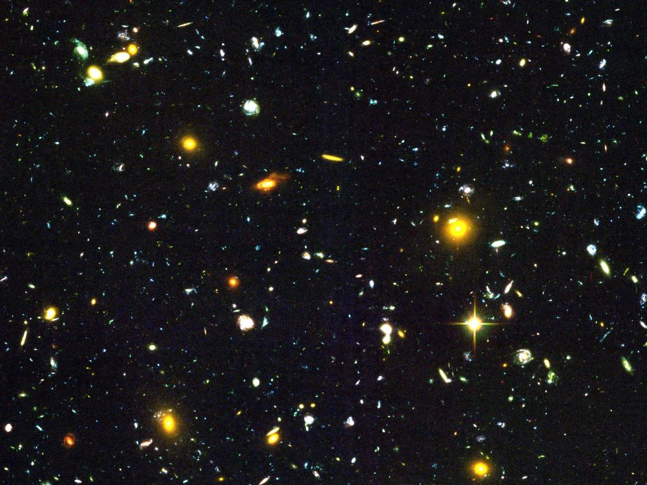
Figure 8. A handful of distant galaxies, each still sharp. Almost every one is receding.
There is a cruelty hidden in the kindness of the deep field. The most interesting smudges are so far that their light has been in transit for most of the age of the universe. We will never send a reply that arrives while anything there still resembles what we photographed. the night sky is not a room. It is a history of rooms, stacked by how much they have been pulled since the light left.
The James Webb Space Telescope did not invent high redshift. It made it rude. There are galaxies at z > 10. That sentence is hot: spectroscopically confirmed objects from when the universe was a few hundred million years old, already shining as galaxies, not as a rumor of gas. The fight — and it is a real fight — is how mature they look. Some of them seem too massive, too dusty, too done for the time on the clock, if you feed certain models of how fast stars should have assembled. That fight is warm. It is a fight about the first factories, not about whether the dough rose. Early galaxies exist. How quickly they put on weight is a measurement in progress, not a loophole in Chapters 9 and 10.
There is a distinction the newspapers keep flattening. Light-travel time is how long the photon was in the mail. Proper distance now is where the sender sits in today’s dough. At z = 1 the mail took about eight billion years; the sender now sits farther than eight billion light-years because the dough rose in transit. At the leftover glow the mail took 13.8 billion years and the sender’s current seat is about 46 billion light-years. This chapter only needs you not to treat z as a speed and not to treat lookback time as a ruler you can lay on the table without the scale factor.
One more detail, because it is beautiful and true. The Hubble law does not pick a center. If every raisin recedes from every other raisin in proportion to distance, then your raisin is allowed to write the same law. The slope is a property of the dough, not of a privileged kitchen.
A rough inverse of H₀ is a Hubble time. If the slope is 70 kilometers per second per megaparsec, 1/H₀ is about 14 billion years. That is not the age, because the stretch-rate has not been constant — matter used to brake, the shove now speeds — but it is the same order as 13.8, which is why a slope could smell an age before the leftover glow gave us a clock. Hubble’s first number implied something like two billion years and was already in a fight with rocks. The second-digit fight of 67 versus 73 is a fight inside a number that finally agrees with the stones.
Appendix A8 writes the redshift into the scale factor and shows how H₀ is a snapshot of a function H(t) that has not been constant. Dark energy, when we get there, is a statement about that function’s later life. The stretch is older than the speeding-up. The speeding-up is a plot twist, not the opening scene.

9. A Baby Picture in Microwaves
In 1964, Arno Penzias and Robert Wilson were trying to make a radio antenna in Holmdel, New Jersey, shut up.²⁷ It hissed. The hiss came from every direction. They cleaned out the pigeons. They checked the wiring. The hiss stayed. A few miles and a few conversations away, a Princeton group was looking for exactly that hiss: the leftover heat of a once-hot universe, stretched by expansion into microwaves, cooled to a few degrees above absolute zero.
The Princeton group had names, and they had a theory, and they were a little late. Robert Dicke had built the kind of radiometer that can hear a sky this quiet. Jim Peebles had calculated that a hot, dense past should leave a glow at a few degrees Kelvin. Peter Roll and David Wilkinson were getting ready to look. In 1965 the Holmdel hiss and the Princeton calculation met, and the leftover glow stopped being a prediction. It became a measurement. Penzias and Wilson had not been hunting a bang. They had been hunting a clean antenna. The universe does not care what you were hunting.
They had found the baby picture.
It is not a photograph in the camera sense. You cannot walk outside and see it. You need a radio ear. But it is as real as the Sun, and in some ways ruder, because it is in your kitchen too. A small fraction of the snow on an old analog television was this glow, leaking into the living room, older than any continent.
Why microwaves, not visible light? Because the oven cooled. A blackbody’s peak wavelength stretches with a. At last scattering the fog was optical: 3,000 K, a dull red if you could have had eyes, which you could not. Stretch by a thousand and the peak sits near a millimeter, in the microwave, a frequency around 160 gigahertz on the FIRAS curve. That is why Penzias and Wilson heard a hiss on a radio horn and not a glow on a photographic plate. Alpher and Herman had predicted a leftover of a few degrees Kelvin in 1948. They did not have Holmdel. They had the right order of magnitude and a number that waited seventeen years for an antenna that would not shut up.
The temperature is 2.725 kelvin — two and three-quarters degrees above the coldest anything can be.²⁸ The spectrum is a blackbody so clean it makes laboratory blackbodies look sloppy. A blackbody is the glow of something in thermal equilibrium, a “we have mixed thoroughly” signature. The early universe was mixed. Then it stretched, and the glow stretched with it, and the mix was frozen into the sky.
COBE, the Cosmic Background Explorer, carried the instrument that made that sentence unkind to rivals. FIRAS — a spectrophotometer built to argue with the sky — found a blackbody at 2.725 K so tight that the error bars sit inside a line on a plot. John Mather’s team had measured the temperature of the universe the way a baker measures an oven: not by mood, by a curve. If you want a hot claim with a decimal, take that one. The leftover glow is not “about three degrees.” It is 2.725, and it is a blackbody, and the departures from that curve are so small they had to be hunted on purpose.
A blackbody this clean is also a veto. Starlight bounced off dust, a fog of leftover starlight, a glow from nearby radio junk: those stories produce the wrong shape. They can make a hiss. They cannot make FIRAS. The curve is the courtroom. The pigeons were a reasonable first suspect. They were not a spectrum.
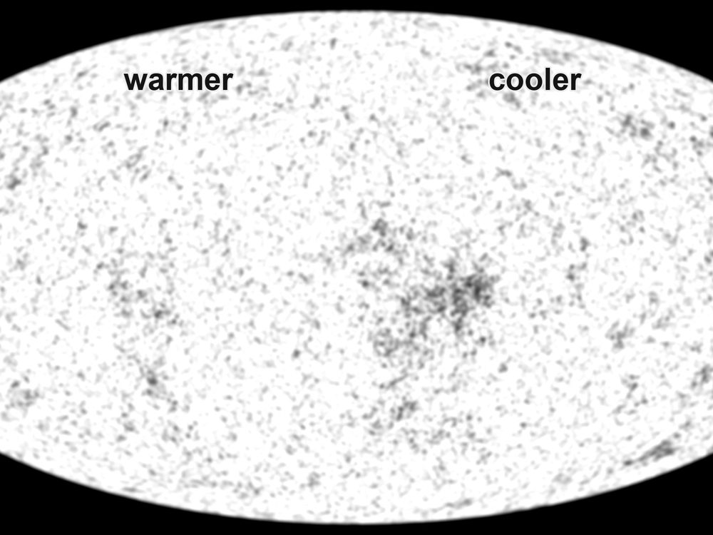
Figure 9. The microwave sky as a grayscale oval, warmer and cooler patches. This is a measurement, not a snapshot from a camera.
The freckles have a date. COBE’s DMR map, in 1992, showed that the sky is not perfectly bland: differences of about one part in 100,000, the first photograph of the seeds Chapter 14 will grow into galaxies. George Smoot’s team had not found continents. They had found the rumple in the dough. WMAP, through the 2000s, turned the rumple into a spectrum of sizes. Planck, with maps in 2013 and a final cosmology release in 2018, sharpened the weather chart until the peaks in that spectrum became a courtroom of their own: how much ordinary matter, how much extra pull, how fast the stretch, how flat the large-scale geometry. Those later maps are how Chapter 11 gets its percentages. This chapter only needs the baby: a blackbody with freckles, photographed on the whole sky.
Why 380,000 years? Before that, the universe was a plasma: nuclei and electrons, loose, swimming in light. Light could not travel far. It kept bouncing off free electrons, the way sunlight has trouble getting out of the middle of the Sun. When the universe cooled enough for electrons to lock onto nuclei and make the first hydrogen atoms, the fog lifted. Photons that last scattered then have been flying in straight-ish lines ever since. We photograph the surface of last scattering the way you photograph a cloud bank from an airplane: you do not see through it. You see the top.
Two nouns get mixed here, and they should not. Recombination is the chemistry: electrons locking onto nuclei, the universe becoming electrically neutral for the first time. (The name is a fossil; nothing had combined before. It was combination. The word stuck anyway.) Last scattering is the optics: the last time a typical photon bounced off a free electron and then ran. They happen at nearly the same age, because once the electrons are locked, the fog has nothing to bounce off. Nearly is not identical. A few electrons stay free. The last bounce is a little later than the locking, a surface with a thickness, not a pane of glass. Kitchen language: the soup sets, and then the last steam stops hitting the lid. We photograph the lid.
Before the fog lifted, a photon’s mean free path was a kitchen, not a cosmos: bounce, bounce, bounce, like light in milk. After, the mean free path became the size of the observable universe. That is the whole optical trick. We are not looking through milk. We are looking at the last skin of milk, stretched into an oval.
The temperature then was about 3,000 K — a red-hot fog, the color of a stove element, not a microwave. Stretch the wavelengths by 1 + z ≈ 1,100 and 3,000 K becomes 2.725 K. The number is not a coincidence. Temperature of free light scales with 1/a. Cool the oven by stretching the kitchen.
One large pattern is not a freckle and should not be sold as one. The whole sky is a few thousandths of a degree warmer in one direction and cooler in the opposite direction: a dipole. It corresponds to a motion of about 370 kilometers per second toward Leo, the Sun’s peculiar velocity relative to the leftover glow. We are not at rest in the dough. We orbit the Galaxy; the Galaxy falls toward a crowd; the crowd has a velocity of its own. Maps like Figure 9 have that dipole subtracted, the way you subtract the motion of the train before you argue about the scenery. What remains is the baby picture, not our weather.
The oval is not raw sky. Our own Galaxy shines in microwaves too — dust, electrons spiraling in magnetic fields, a plane of junk across the middle. Planck’s maps are the sky after that junk has been modeled and taken off, a subtraction as necessary as wiping flour off a scale. What you are allowed to call cosmology is the remainder. WMAP, the Wilkinson Microwave Anisotropy Probe, carries David Wilkinson’s name because he was one of the people waiting in 1965 and one of the people who spent a career making the wait into a map. He died before the full harvest. The probe did not. The sky does not pause for obituaries.
Inside the freckles there is a sound, almost literally: the plasma, before last scattering, could ring. Overdense patches compressed, bounced, compressed again, a fluid with light as the spring. Those acoustic oscillations froze at 380,000 years into a preferred set of angular sizes on the sky — peaks in a power spectrum. Planck’s 2013 and 2018 papers are, in large part, a reading of those peaks.²¹ This chapter will not steal Chapter 14’s seeds or Chapter 11’s inventory. It will say that the baby picture is not a blur. It is a freeze-frame of a ringing fog, and the ring has been measured.
Those freckles are not decoration. They are the seeds of Chapter 14, written in temperature. A patch that was a little denser then is a little more likely to be a cluster of galaxies now. The baby picture is also a will.
The evenness of the picture is its own unpaid bill. Look at two patches on opposite sides of Figure 9. Their temperatures match to a part in a hundred thousand. In the simple bang of this part, those patches have never been in each other’s past light cones. They have not had time to talk, to mix, to agree. That is the horizon problem. It is a real problem. It is not a reason to throw out the leftover glow. It is a pointer: Part III exists because this sky is too even for a kitchen that never shared a pot. Do not solve it here. Notice that the baby picture both confirms the hot fog and hands you a puzzle the fog, by itself, does not pay.
Hot claim: the leftover glow exists, is a blackbody, is almost the same in every direction, and has freckles at the level of one part in a hundred thousand. Warm claim: those freckles are the fingerprint of slightly uneven density in a hot, expanding plasma. Cold claim: any story of the first 10⁻³² seconds that does not eventually produce this picture is entertainment.
When you look at Figure 9, you are not looking at a place. You are looking at a time. The oval is the entire sky. The entire sky is one age. That is what “the explosion happened everywhere” looks like when it has had 13.8 billion years to cool in public.

10. The First Three Minutes
Steven Weinberg gave this interval its fame, and he was right to. Between about a hundredth of a second and a few minutes, the universe did something we can reconstruct with the same nuclear physics we use in the Sun and in weapons labs. Before that, the story gets warmer and then cold. After that, for a long time, not much of nuclear interest happens. The three minutes are a workshop. We still own the tools.
He was not the first to guess that a hot past would cook light nuclei. In 1948 Ralph Alpher and George Gamow published a paper with Hans Bethe added, as a joke, as the middle author, so the names would read α, β, γ — alpha, beta, gamma.²⁹ The αβγ paper argued that the early universe could build nuclei by capturing neutrons, and that a leftover glow should still be around. The capture-chain details were wrong in ways that later work had to repair: you cannot climb the whole periodic table in three minutes, because there are no stable lodgings at five or eight nucleons. The helium insight was the seed. The leftover-glow insight was the other seed. Weinberg’s book, decades later, is the workshop with the tools calibrated. Gamow’s joke is how the idea first got a table.
At a hundredth of a second, the temperature is about a hundred billion degrees. No atoms. No nuclei that last. A soup of light, electrons, positrons, neutrinos, and a few leftover nucleons — protons and neutrons — swimming in a glare that would unmake any chemistry you have a word for. The nucleons are outnumbered by photons about a billion to one. That ratio is still written in the sky. It is why the universe is so empty of atoms compared with light, and why we are a footnote in a photon’s memoir. The billion dead twins are the antimatter that did not get a chair. Food, when we get to it, is a later argument about leftovers. The first leftover is this: the soup was unfair, and the unfairness is why there is anyone to eat.
Write the temperature once, as a kitchen clock, so the later ticks have a place to hang.
T ≈ 10¹¹ K at t ≈ 0.01 s
where T is the temperature of the soup and t is time since the hot fog we can reconstruct — not since a waiting room.
At that glare, electrons and positrons are still being born in pairs from photons and annihilating back. Neutrinos still talk to the rest of the pot. The nucleons are a trace ingredient, a pinch of salt in a vat of light.
Neutrons are slightly heavier than protons. In equilibrium, there are fewer of them. As the soup cools, the reactions that turn protons into neutrons and back slow down. At about one second, neutrinos stop talking to the rest of the soup — they decouple — and the neutron-to-proton ratio freezes near one-to-six, then keeps dropping slowly because free neutrons decay. You have about ten minutes before most of the leftover neutrons would be gone. The universe does not give you ten minutes of workshop time. It gives you about three.
The free neutron’s lifetime is about fifteen minutes. That is why the workshop is in a hurry. Leave the nucleons sitting as a warm gas with no oven and the neutrons wander off into protons, electrons, and ghostly leftovers, and there is nothing left to glue into helium. Ten minutes would have wasted most of the inventory. Three minutes spends it. The clock is nuclear, not rhetorical. A kitchen timer on the counter is the same kind of object as this: a half-life with consequences for the recipe.
Decoupling, here, is not a mood. It is a race. The soup is thinning and cooling. The weak reactions that let neutrinos knock nucleons around get slower. When the reaction rate falls behind the stretch rate, the neutrinos leave the conversation, streaming as their own leftover — a cosmic neutrino background we have not photographed as a map, but whose presence is felt in the helium and in the leftover glow’s peaks. One second is the door slam. The neutron fraction at the slam, plus a little decay on the walk to minute three, is the inventory the workshop will be allowed to spend.
At roughly three minutes, the temperature has fallen to a billion degrees. Deuterium — a proton glued to a neutron — can at last stay stuck. Before that, the glare broke deuterium as fast as it formed. This is the deuterium bottleneck, a traffic jam with a clock. Once deuterium survives, helium-4 assembles with almost greedy efficiency. There are no stable nuclei with five or eight nucleons, so the assembly line stalls at helium. A sprinkle of lithium is a leftover rounding error. Almost every neutron that survived is now locked in helium.
T ≈ 10⁹ K at t ≈ 3 min
where that billion-degree tick is the oven setting at which deuterium stops being smashed, and helium can be baked.
If nearly every leftover neutron is locked in helium-4, and you started with about one neutron per seven nucleons after decay, the mass fraction of helium sits near one quarter.
Y_{p} ≈ 0.25
where Y_{p} is the primordial mass fraction of helium-4, counted before stars had a chance to lie.
Deuterium that escaped the greedy step survives as a sprinkle.
D/H ≈ 2.5 × 10⁻⁵
where D/H is deuterium nuclei per hydrogen nucleus in uncooked gas, a thermostat for how crowded the nucleons were in the pot.
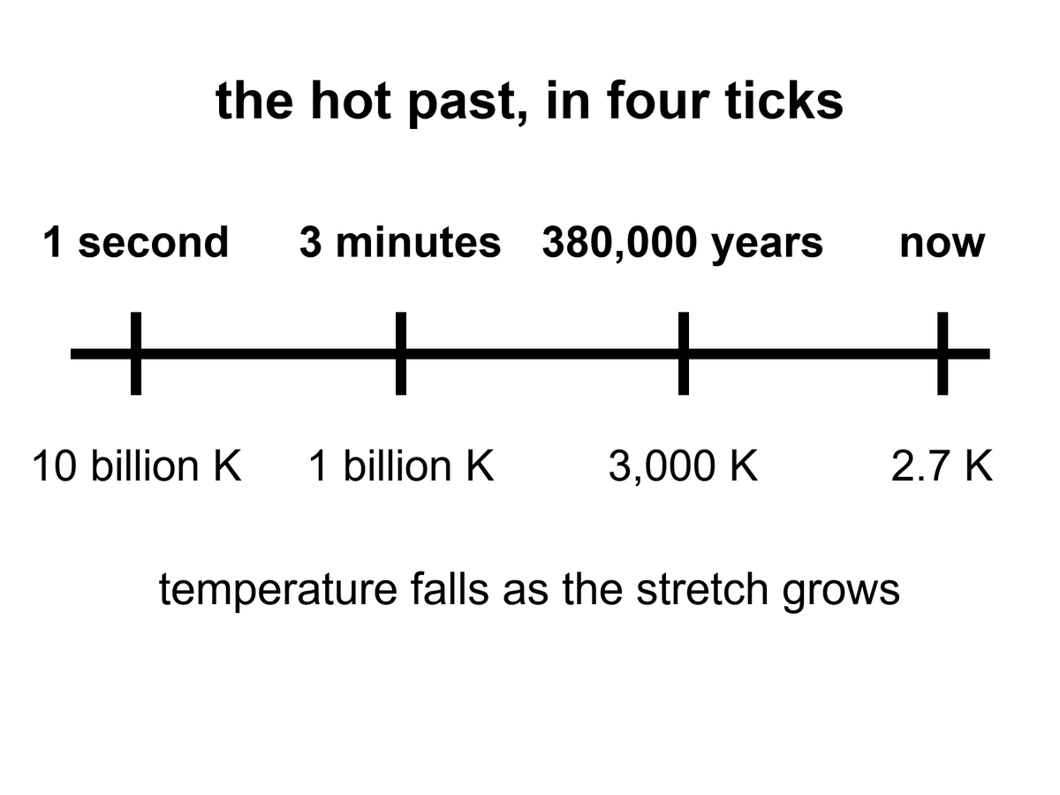
Figure 10. Four ticks on one line: one second, three minutes, 380,000 years, now. The temperature under each tick falls as the stretch grows.
Then the workshop closes. The soup is still too hot for atoms. It will be too hot for 380,000 years. But the nuclear work is done. The universe has committed, by weight, to about three-quarters hydrogen and one-quarter helium, plus a dust of the rest. Stars will later lie about this. They will burn hydrogen into more helium and brag. The first helium is not their brag. It is a fossil.
Weinberg’s afterword, years later, had to make room for inflation and for freckles in the leftover glow. He did not have to take back the three minutes. The three minutes have only gotten sharper. That is what a hot claim feels like when you meet one in the wild.
If you could inventory the ordinary atoms in the universe — not the dark extra pull, not the dark extra shove, the atoms — you would find that about one-quarter of their mass is helium-4. That is an absurd amount of helium to blame on stars.
Stars are helium factories, yes. Our Sun is making helium in its core right now, at a stately, suburban pace. In ten billion years it will have converted a respectable fraction of its hydrogen. It will not have converted a quarter of the hydrogen in the universe. There has not been time, and there have not been enough stars. The first stars, which were massive and brief and sloppy, made a mess of carbon and oxygen and the iron in your blood. They did not flood intergalactic space with a quarter-by-mass of helium. Something else did.
Say that as a budget, not as an insult. Take every star that has ever shone in the observable loaf, give it a generous lifetime, let it burn at a generous efficiency, and you still cannot cook a quarter of all baryons into helium. Stars make metals — astronomers’ rude word for anything heavier than helium — in interesting amounts. They make extra helium locally, in cores and in winds. They do not set Y_{p}. The sky’s baseline helium is older than the first star. That is why the workshop is not optional, and why Alpher and Gamow, joke author included, were pointing at the right oven even when the recipe was still a mess.
The something else is the workshop, caught in the act.
Astronomers measure primordial helium in the least sophisticated gas they can find: dwarf galaxies that have made almost no stars, clouds that have not had a chance to lie. The number they keep finding sits near a quarter by mass, with a little scatter and a lot of argument about the second digit. Deuterium, which stars destroy more easily than they make, is a second fossil. Too much deuterium and the early workshop was too empty of nucleons. Too little and it was too crowded. The observed sprinkle of deuterium is a thermostat for the nuclear minutes. Lithium is the sulky cousin: the prediction and the measurement still do not quite shake hands. That fight is real and unfinished. It does not cancel the helium.
The practical kitchen for helium is an H II region: a nebula where hot stars have stripped electrons off hydrogen, so the gas glows in lines you can put a spectrometer on. Look in metal-poor dwarf irregulars — galaxies that have barely cooked a periodic table — and the helium lines sit near that quarter by mass. Look at deuterium in high-redshift clouds, uncooked by stars, and you get a few deuterium nuclei per hundred thousand hydrogen nuclei, about 2.5 × 10⁻⁵. The photon-to-baryon ratio that makes those numbers come out is the same billion-to-one already sitting in the leftover glow: about 10⁹ photons per nucleon. Two fossils, one crowding number. Lithium-7 is the exception that still itches: the workshop predicts two to three times more than the oldest stars seem to hold, or the stars seem to hold two to three times less than the workshop baked. Factor two or three, not a factor of a hundred. Warm, unfinished, not a loophole.
The lithium fight has a name on the stellar side: the Spite plateau, a floor of lithium-7 in the oldest, most metal-poor stars, lower than the three-minute prediction by a factor of two or three. Either the stars ate some after they formed, or the workshop’s lithium-7 channel is still missing a correction, or both. People who work on stellar atmospheres and people who work on nuclear rates have been polite at each other for years. The helium does not care. The deuterium does not care. Lithium is allowed to be the sulky cousin and still sit at the table.
Here is the detail that makes the fossil personal. Every breath you take is mostly nitrogen and oxygen, cooked in stars that died before the Sun was a cloud. The helium in a party balloon is mostly not that. Some of it leaked from Earth’s crust, where uranium and thorium have been throwing helium nuclei like litter for eons. Some of the helium in the cosmos, the quarter that is not a party trick, has been helium since before there was a periodic table with more than two honest entries. You cannot hold that helium. You can know it.
Hot claim: the light-element abundances match a hot, expanding workshop³⁰ with a known nucleon-to-photon ratio. Warm claim: the remaining lithium tension is a problem for astronomers and nuclear theorists, not a loophole for a cold beginning. Cold claim: any rival origin story that cannot produce this helium is not an origin story. It is a mood.
The leftover glow says the universe was once a mixed, hot fog. The leftover helium says the fog did nuclear work on a three-minute clock. Two fossils, two methods, one past. That is as close as cosmology gets to a courtroom.

11. Almost Nothing, Almost Everywhere
Smooth the universe. Take every star, every planet, every wandering rock, every atom in every lung, and spread them until the lumps are gone. You will have, on average, about one atom of ordinary matter in a space the size of a closet — a cubic meter, give or take the fights about the second digit. A good vacuum pump on Earth is proud to do worse.
Insist on the second digit and the closet is a little emptier than the sentence suggests: about 0.2 ordinary atoms per cubic meter, once you weigh the universe properly and give the atoms only their share. “About one” is the kitchen insult. 0.2 is the receipt. Either way, you are not living in the average. You are living in a lump.
That is the catalog’s first insult. We live in a freak clump. The clump is not the rule. The rule is the emptiness.
The second insult is that the atoms are not even the main clump. When astronomers weigh the universe the way you weigh a truck — by how hard it pulls, not by how shiny it is — the atoms are a minority. About five percent of the energy budget is the stuff of chemistry. About a quarter is an extra pull that does not shine. About two-thirds is an extra shove that makes the stretch speed up. Chapters 17 through 19 are the inventory of those insults. Here it is enough to feel the loneliness of the five percent.
Elena weighs a bag of flour on a kitchen scale and trusts the number because the bag pushes down. She does not trust the number by how white the flour looks. Shine is a terrible scale. A bag of powdered sugar and a bag of whole wheat can fool the eye; they cannot fool the spring. Cosmology’s spring is gravity. Rotation speeds in the outskirts of galaxies, the way clusters lens background galaxies, the peaks in the leftover glow: those are pulls. The shine — stars, nebulae, the kitchen table — is the five percent announcing itself with light. Weigh the loaf by pull and the flour is a minority ingredient. Chapter 17 is the extra pull. Chapter 18 is the extra shove. Notice, only, that Elena’s habit is the right one, and that the cosmos does not owe her a bag that matches the photograph.
The bookkeeping has a name. There is a critical density, ρ_{c}, the amount of stuff that would make the large-scale geometry sit on a knife-edge: neither curling closed toward a recollapse nor hinging open so fast that galaxies never find each other.
ρ_{c} = 3H₀² / 8πG
where ρ_{c} is that critical density, H₀ is the stretch-rate of now, and G is Newton’s constant — the same G that weighs apples, planets, and Elena’s flour.
What we actually have is counted in units of that knife-edge:
Ω = ρ / ρ_{c}
where Ω is a density parameter, a fraction of critical, and the pieces of Ω are allowed to add.
The leftover glow, plus the stretch, plus the way structure grew, currently split the bill about like this: Ω_{b} ≈ 0.05 in ordinary atoms (baryons), Ω_{c} ≈ 0.27 in extra pull that does not shine, Ω_{Λ} ≈ 0.68 in extra shove. The sum sits near 1, which is why “flat” keeps surviving the maps. Those decimals will move in the fourth digit. They will not swap the story that chemistry is a rounding error with a press agent.
Put a kitchen number on the knife-edge, because “critical density” sounds like a mood and it is a mass. For a Hubble constant near 70 kilometers per second per megaparsec, ρ_{c} is about 9 × 10⁻²⁷ kilograms per cubic meter — a few proton-masses in each empty closet if all of it were atoms, which it is not. Only the baryon slice, the 0.05, gets to be atoms, and that is how you arrive at 0.2 per cubic meter. The rest of the pull does not sit on Elena’s scale as flour. The shove does not sit on it at all. “Flat” means the large-scale geometry is the one in which parallel lines stay parallel and the angles of a cosmic triangle add to 180 degrees. Planck’s maps like that answer. Part III will ask why the pebble sat on the blade. This chapter only weighs the bag.
Radiation is a rounding error now: the photon share, Ω_γ, is a few parts in ten thousand. Photons dominated the budget when the universe was young and the wavelengths were short; they lost the argument because each photon got tired as well as diluted. Neutrinos, decoupled at one second, are another small slice — a relic you feel in the helium and in the leftover glow’s peaks, not the extra pull of Chapter 17. The extra pull does not shine and does not, as far as the maps can tell, live in the periodic table. The extra shove does not dilute as matter does. Those two sentences are previews. They are not the chapters.
The 0.05 in Ω_{b} is not a guess from counting stars. Stars are a terrible census of atoms: most ordinary matter is not in stars. It is in hot gas, warm gas, a thin salt in clusters, a fog between galaxies. The leftover glow’s peaks and the three-minute deuterium thermostat agree on the baryon crowding to a level that would be vanity if they did not use different physics. That agreement is why 0.05 is hot enough to print. Counting kitchens will not get you there.
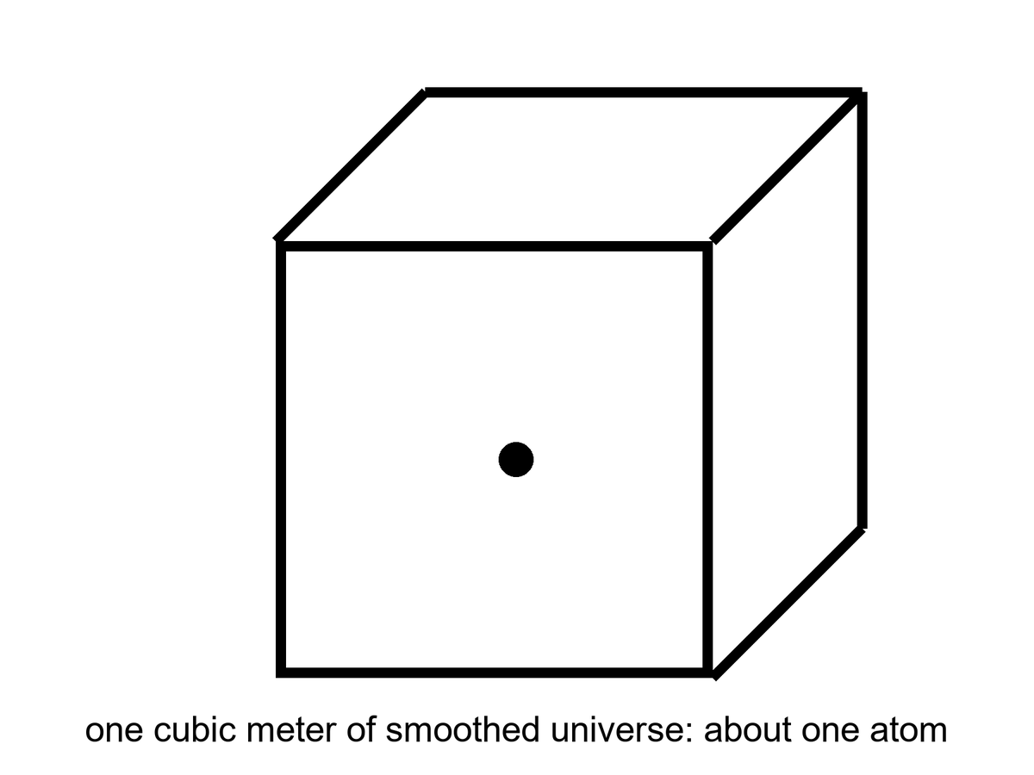
Figure 11. A cubic meter of smoothed universe holds about one atom. Almost nothing, almost everywhere.
Figure 11 is the most dishonest honest picture in the book. The cube is a meter on a side. The dot is an atom. If you drew the cube at the scale of Elena’s kitchen, the next atom of the average cosmos would not be in the house. It would not be on the block. You would need a walk that feels like a mistake. We do not take that walk, because we live in the freak, and the freak is full of dots that stuck. The figure is what you get when you refuse the freak and insist on the climate.
Barrow liked to shock readers with billions, and the billions are still shocking if you let them be specific. The observable universe is about 93 billion light-years across, not because it is 93 billion years old — it is 13.8 — but because the stretch has been pulling the farthest light’s starting points farther while the light was in transit. Inside that sphere there are a few hundred billion galaxies you could, in a generous mood, name. Each galaxy has, give or take, a hundred billion stars. Multiply and you get a number that looks like a lie: on the order of 10²² stars. Then remember the closet with one atom. The stars are the rare weather. The emptiness is the climate.
The 93-billion-light-year sphere is a census volume, not a wall. Ten-to-the-twenty-two is an order of magnitude, not a roll call: a hundred billion here, a hundred billion there, and the product is a 1 with twenty-two zeros and an argument about the first factor of ten. You may add a zero when the deep fields finish arguing about faint galaxies. You will not add emptiness to the stars and make the stars the rule. Figure 11 is the rule. The Milky Way is a rounding error that learned to shine.
Compare the densities so the closet stays honest. Air in Elena’s kitchen is about 2 × 10²⁵ molecules per cubic meter. The space between stars in the Galactic disk is already a vacuum by kitchen standards — maybe a million atoms per cubic meter in the better neighborhoods, far less in the halo. The smoothed cosmos is 0.2. Each step is a humiliation of the last. You cannot see 0.2 atoms per cubic meter. You can only weigh its consequences, or refuse to smooth, and live in the clump.
The clumps nest. A person is a clump in a kitchen. The kitchen is a clump on a planet. The planet is a clump around a star. The star is a clump in a galaxy. The galaxy is a clump in a group; our group is falling toward Virgo; Virgo sits in a larger web. Chapter 14 will grow the web from freckles. Here the point is only inventory: every noun you care about is a place where the average failed, gravity won, and the stretch was told to wait. The 10²² stars are 10²² local victories. They still occupy a negligible fraction of the 93-billion-light-year sphere.
Stars themselves are a later luxury. They are places where gravity won a local argument against the stretch, piled gas until the pile was hot enough to fuse, and then spent millions or billions of years turning hydrogen into the rest of the table. When the more massive ones die, they throw the table into space. Planets are the sediment of that throw. You are the sediment of the sediment, walking around asking where the sediment came from.
The catalog, then, is not a list of objects. It is a list of exceptions. A star is an exception to emptiness. A planet is an exception to the habit stars have of being unfriendly. A kitchen is an exception to the habit planets have of being dead. A book is an exception to the habit kitchens have of being used for casseroles.
The past we can rebuild explains how the exceptions got their raw material. It does not owe the exceptions a destiny. The leftover glow and the leftover helium will still be true if no one ever builds another kitchen. That is not a threat. It is the courtesy of a universe that does not need us in order to have had a first three minutes.

PART III — A Burst, Then Seeds

12. Three Puzzles the Hot Bang Cannot Solve
The leftover glow and the leftover helium make the hot, expanding past look inevitable. They do not make it comfortable. Three puzzles sit in the model like bills on a table, and the three-minute workshop does not pay them.
The first is the horizon problem. Look at the microwave sky in two opposite directions. The temperatures match to a part in a hundred thousand. For two patches to agree that tightly, they usually need to have talked — to have exchanged light, mixed, come to terms. In the simple hot bang, those opposite patches have never been in each other’s past light cones. They are like two strangers who have never met and have never had a friend in common, wearing the same shirt to the same size. You can call it a coincidence. Physicists get hives.
At 380,000 years, when the fog lifted and the leftover glow set out, a causal horizon — the farthest a light signal could have traveled since the simple bang began — was a small patch on the sky we photograph now. A couple of degrees. A thumbnail at arm’s length. The whole dome of the microwave sky is not a couple of degrees. Opposite patches sit a hundred thumbnails apart, and then some. The causal horizon at last scattering is much smaller than the sky. In the simple bang, the patches labeled A and B in Figure 12 have never been in each other’s past light cones. They did not mix. They did not come to terms. They still match, to one part in 10⁵, as if agreement were free.
You can try to rescue the simple bang by saying the universe started already even, on scales that had never talked. That is not a solution. That is a shrug wearing a lab coat. It pushes the evenness into the initial conditions and then looks innocent. Physics is supposed to make evenness, or at least to inherit it from a time when talking was possible. The simple bang, run backward from the leftover glow, does not give you that time. The leftover glow is a photograph of a single age, the entire sky at 380,000 years. The photograph is too even for the age.
Agreement, in physics, is not a fashion. Two patches of plasma come to the same temperature because photons ricochet between them until the hot spots have given their extra to the cold spots. That is thermal equilibrium, the same “we have mixed thoroughly” signature that makes the leftover glow a blackbody. Mixing needs a path. A path needs time. In the simple bang the time from a hot start to last scattering is 380,000 years, which sounds generous until you remember that the last-scattering surface we see is not 380,000 light-years across. Expansion has been stretching the rulers. The region that could have mixed by then subtends about a degree or two on today’s sky. Opposite patches — 180 degrees of argument — contain thousands of those little mixed rooms, none of which had a hallway to the others.
One part in 10⁵ is not a casual “pretty even.” It is the measured amplitude of the remaining freckles after the dipole of our own motion is subtracted. The average temperatures of opposite hemispheres match far tighter than a kitchen thermometer. Chapter 3’s light cones, applied at 380,000 years, do not overlap for A and B. Figure 12 is that non-overlap, drawn as a circle because the sky is a circle when you have only two dimensions of paper. The simple bang has no conversation that can buy the match. It has only a hope that the start was already a match. Hopes are not mechanisms.
The second is the flatness problem. The universe’s geometry — whether parallel lines stay parallel on the largest scales — is astonishingly close to “flat,” which is another way of saying the density is astonishingly close to a special critical value. In the simple bang, that closeness is unstable. A little too much density in the first second and the universe would have recollapsed before helium was done. A little too little and it would have become so empty, so fast, that galaxies would never have found each other. We live on a knife-edge that the equations keep trying to throw us off. Either someone balanced a pebble, or something drove the pebble to the middle of the blade.
Barrow liked a pebble on a blade. The blade is the critical density: the exact budget of stuff that makes Ω = 1, the universe in which the large-scale geometry does not curl into a ball or splay into a saddle. A little above, and gravity wins on a short clock. A little below, and the stretch wins so fast that clumps never find each other. We measure, today, a universe so close to that blade that the leftover glow, the later bombs of Chapter 18, and the frozen sound-scale in the galaxies all vote flat to within a percent or better. That is a fact about now. The insult is a fact about then.
In a decelerating bang — radiation, then matter, no burst — the quantity |Ω − 1| is driven away from zero as time runs forward. Closeness is unstable. Run the same equations toward the past and the required closeness blows up. By the time the clock reads one second, the pebble has to sit in the middle of the blade to something like one part in 10¹⁶. Not one part in a hundred. Not one part in a million. A 1-second pebble that would shame a watchmaker. Bump it, and you do not get a slightly different kitchen. You get a recollapse before helium, or a desert that never makes a galaxy.
Nobody balanced it with fingers. Either the initial conditions were an unpublished miracle, or something drove the pebble to the middle and held it there long enough that later physics would look inevitable. Inflation, in the next chapter, is the candidate drive. Here, notice only the bill: the simple bang does not explain the pebble. It assumes the pebble, and then spends 13.8 billion years trying to kick it off.
One second is not a mystic number. It is the door of Weinberg’s workshop: neutrinos have just decoupled, the neutron-to-proton ratio is freezing, the nuclear minutes are about to start. If the pebble is already wrong at that door, the workshop never opens, or opens onto a warehouse with no walls. The required closeness at the Planck time is worse — 10⁻⁶⁰, a number Barrow would have put on a chalkboard to watch a room go quiet. We do not need the Planck time to feel the insult. The 1-second pebble is rude enough. A pebble is not a mechanism either. It is a way of saying the tuning has a clock reading, and the clock reading is uncomfortably early.
The third is the relic problem. Grand unified theories — warm-to-cold ideas about how the forces were once one force — tend to produce leftover monsters: magnetic monopoles, heavy stable particles, knots in fields. The simple bang would have left the universe ankle-deep in them. We do not trip over monopoles on the way to the mailbox. Something diluted the relics, or they were never made in our past, or the grand theories are wrong. The first option is the one inflation was built to offer.
A magnetic monopole, in this context, is not a bar magnet you can put on the fridge. It is a knot in a grand-unified field, a particle that would be a north without a south, heavy, stable, and — if the simple bang passed through the grand-unified temperature — as common as the horizon would allow. One per causal patch, roughly, and then they sit there, too massive to decay, too stubborn to hide. They would outweigh the atoms. They would wreck the leftover helium’s accounting. They would be underfoot.
They are not underfoot. That is a fact you can take to the mailbox. So either the grand theories are wrong about the knots, or the knots were never cooked in our past, or something diluted them by a ridiculous factor — 10²⁵ in entropy, says the appendix, if you want a number to flinch at. Inflation was built, in part, as a dilution machine. Guth was thinking about monopoles when he started. The even sky and the pebble came along as bonuses. The bonuses are now the famous posters. The monopoles are the quiet third bill.
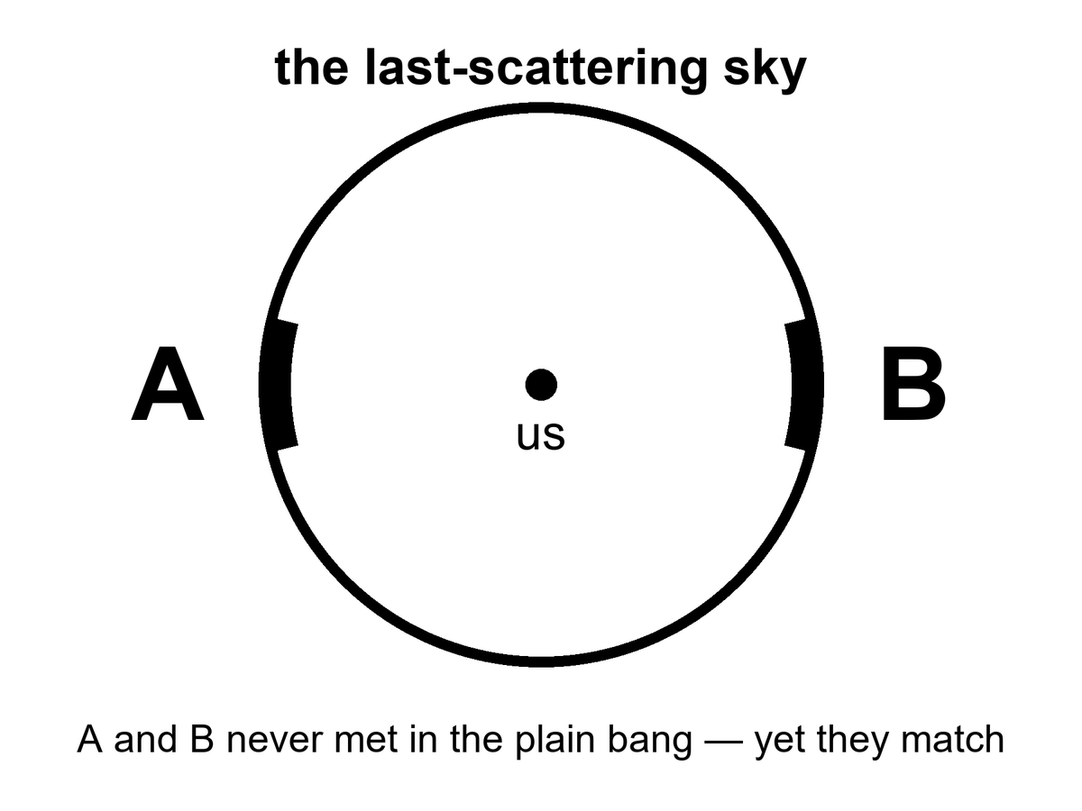
Figure 12. The last-scattering sky. Patches A and B on opposite sides never met in the plain hot bang, yet they match.
Weinberg paid the nuclear minutes. He paid them with the same nuclear physics we still use in stars and in laboratories, and the helium still sits in the account. These three remain. They are not evidence that the workshop was a fiction. They are evidence that the workshop started with a table already set, and nobody at the table could say who set it.
None of these puzzles says the hot bang is false. They say it is incomplete as a story of initial conditions. Weinberg could reconstruct the nuclear minutes without knowing why the sky was so even. Guth, in 1980, asked whether a brief, violent stretch before those minutes could set the table so the minutes would look inevitable.
Guth was not, in 1980, handing the community a finished preface. He was a particle theorist staring at monopoles, asking whether a false-vacuum stretch could dilute them, and noticing that the same stretch would also even the sky and drive the pebble. The paper is a question with a mechanism attached, not a verdict. Old inflation, the first mechanism, will fail to exit. That failure is Chapter 13’s opening debt. The question survives the debt. The three bills are still on the table either way.
That question is the opening of Part III. It is not yet the solution. Guth’s first try will have a graceful-exit problem, a mess about how to stop, which Chapter 13 will have to clean. The sky will later be photographed in polarization by people who were sometimes too eager. Those fights belong to the next pages. Here the honest inventory is three unpaid bills, a paid nuclear dinner, and a physicist asking whether a burst could be the missing payment.
That is a different kind of move. The three minutes are a reconstruction. Inflation is a proposed preface. Prefaces can be wrong even when the book is right. Keep the temperatures straight. The puzzles are hot. The leading solution is warm. The details of the preface — what field, what potential, what first 10⁻³⁶ second — are still being written in pencil.

13. Inflation, Without the Hype
Here is inflation without the poster.
Suppose, in a sliver of time so short that “sliver” is already too romantic, a patch of the universe was filled with a field that behaved like a temporary cosmological constant: a stuff whose tension was so odd that gravity, locally, repelled. The stretch that matters is an e-fold: every distance grows by a factor of e, about 2.7, not by a tidy doubling. About fifty to sixty of those e-folds are what the job asks for. Distances that had been smaller than a proton became larger than a grapefruit, then larger than a solar system, then larger than the part of the universe we can see. Then the field decayed. Its energy dumped into particles. The dump is called reheating, which is a calm word for setting a universe on fire. After the dump, you have a hot bang: soup, light, the three minutes, the leftover glow.
The kitchen is a pot on a high flame.
For a sliver the pot does not simmer. It boils over: the volume of steam is not a polite trickle, it is a room-filling insult, doubling and doubling. Then the whole violent pot dumps into a larger pot of soup. The dump is reheating. After the dump you have the hot bang. The boil-over is not the soup. The soup is what you can reconstruct. The boil-over is the proposed preface that makes the soup’s evenness less of a miracle.
The count that matters is e-folds. Each e-fold stretches every distance by a factor of e, about 2.7. A doubling would be a different count, and this chapter will not teach the wrong one. About 50 to 60 e-folds are what the three puzzles ask for: enough stretch that the whole sky we photograph was once inside one talking neighborhood, enough that a curved surface looks flat, enough that one relic per pre-burst patch becomes one relic per observable universe, or fewer. Sixty of them take a proton-scale patch and throw it past everything we can see. The clock for the whole insult is of order 10⁻³² seconds. That number is a round order, not a kitchen timer. It depends on how hard the field was shoving. It is short the way a lightning strike is short, except lightning is leisurely.
Slow-roll is how the pot is allowed to boil that long without instantly dumping. If the field sprinted down its hill, the boil-over would be over before it had stretched enough, or it would dump in a mess of bubbles. Slow-roll is a hill so flat the field creeps. Hubble friction acts like a damper. Sixty e-folds of almost-constant shove, then a dump. The field that does this job is called the inflaton because physics names things by their chores. We have not met it in a detector. It is unnamed in the only sense that matters: no mass, no charge, no track in a tank.
Reheating deserves a slower look, because the dump is where the preface becomes the book we already trust.
While the field is slow-rolling, its energy is locked in the odd tension: vacuum-like, smooth, shoving. When the field reaches the bottom of the hill it oscillates. Oscillation is particles, or at least the right to become particles. Those particles collide, thermalize, and you have a radiation bath — the hot bang, at last, with a temperature that depends on how the dump was done. The reheating temperature is model-dependent. The appendix will not apologize for that. What is not model-dependent is the order of operations: burst, dump, soup, three minutes, leftover glow. You do not get to skip the dump and still claim the helium. The helium is soup-work. The burst is table-setting.
Fifty to sixty e-folds is a window, not a sacred count. Too few, and a corner of today’s sky was never inside the talking neighborhood; the horizon bill stays unpaid. Too many is allowed by the local job description and starts to grow the rumor of Chapter 15: extra stretch somewhere else, extra rooms, a pot that does not stop. The local sky asks for about sixty. It does not ask for infinity. Do not let infinity borrow sixty’s paycheck.
Picture two kitchens, two years apart. In the first, 1980, a pot is boiling so violently that bubbles of “done” soup nucleate in a superheated sea and never quite fill the pot; the walls between bubbles are a mess. That is old inflation, Guth’s first try, the graceful-exit problem as a cooking failure. In the second, 1982, the flame is high but the pot is a wide, almost-flat pan. The whole surface comes up to temperature together and then, when the field finds the lip, dumps as one. That is slow-roll. Linde’s pan and Albrecht–Steinhardt’s pan were independent. Physics sometimes invents the same dish twice in one year when the bill is loud enough.
Why bother? Because the three puzzles go pale.
The opposite patches of sky did talk. They talked when they were neighbors, before the burst pulled them out of conversational range. The burst then stretched their agreement across the whole sky. The horizon problem becomes a memory of an old neighborhood.
The knife-edge of flatness gets driven toward the middle. Stretch a curved surface enough and any small patch looks flat. A basketball, to an ant the size of an atom, is a plane. Inflation is the move that makes us the ant.
The relics get diluted. One monopole per pre-burst patch becomes one monopole per observable universe, or fewer. We stop tripping.
That is the job description. It is not yet a proof. A preface that pays three bills is a good preface. It can still be the wrong preface, or the right job done by a field we have not named.
Repulsive, here, is not a personality. Einstein’s gravity, for ordinary stuff, pulls. For a stuff whose pressure is negative enough — a cosmological-constant-like tension — the same equations shove. The burst is that shove, brief and huge. It is not anti-gravity in a comic-book sense. It is the Friedmann equation with a budget that has the wrong sign for anyone who grew up on apples. Then the budget changes, because the field rolls and dumps, and apples make sense again. Figure 13 is that change of budget: a steep rise labeled burst, then a gentler slope labeled after. The after is the hot bang we already rebuilt. The rise is the proposed reason the after looks so unsurprising.
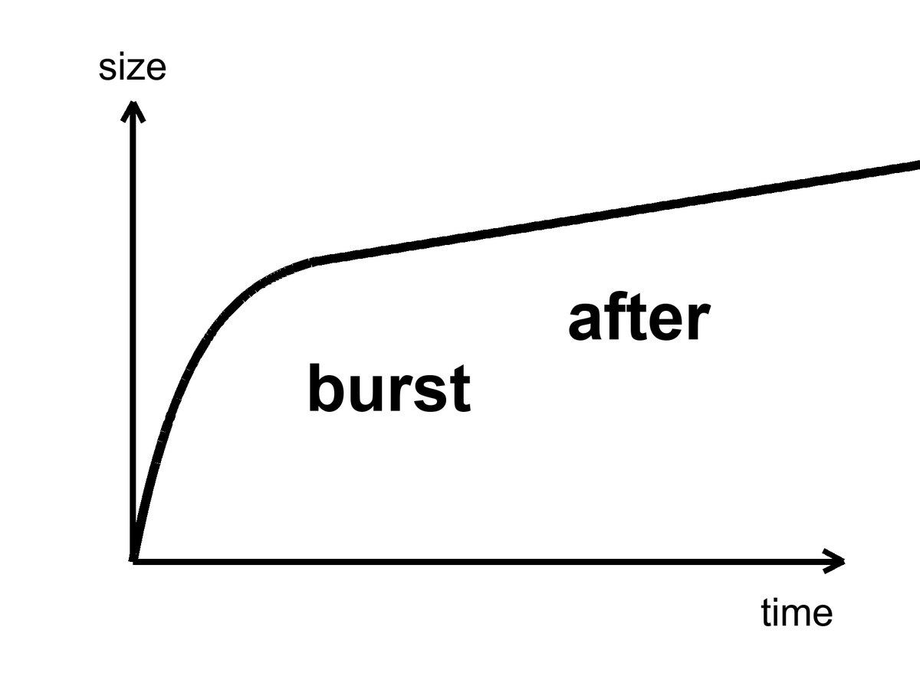
Figure 13. One curve: a steep burst, then a gentler slope. Inflation is the burst; everything else is after.
Alan Guth’s first version had a graceful-exit problem: the burst did not know how to stop without making a mess. Andrei Linde, and independently Albrecht and Steinhardt, found a smoother hill for the field to roll down — slow-roll. Linde later suggested that the starting values of the field could be chaotic, different in different places, some patches inflating a lot, some not. That idea will grow a maybe-multiverse in Chapter 15. Do not let it jump the line. The local burst is the working theory. The froth of other bursts is a rumor the local burst can tell if you let it drink.
What inflation has not done: name the field. We have no particle in a detector called the inflaton. We have a shape that works and a sky that looks like the shape predicted. That is more than a mood and less than a conviction. Appendix A13 writes the e-folds and the slow-roll parameters. Here it is enough to know that “inflation” is not a brand. It is a job description: a brief, repulsive stretch that sets the table for the hot bang we can actually reconstruct.
A humility from 2014 belongs on this page, because poster-inflation hates humility and the sky does not.
A telescope at the South Pole, BICEP2, looked for swirls in the leftover glow — B-modes — that a burst would have printed with gravitational waves. In 2014 the team announced a detection. The world did a lap. Warm claim, briefly worn as hot. Then dust in our own galaxy, polarized dust, sat down in the same seat as the signal. A 2015 joint analysis with Planck was the kill. The swirl was not the burst. The swirl was grit in the kitchen, the kind that lives in the Milky Way and polarizes starlight for a living. Humility is not a personality trait in a press office. It is what the sky did when someone claimed to have photographed the first 10⁻³² second.
The kill is worth teaching because it is how a warm claim dies correctly.
B-modes are a swirl pattern in the polarization of the leftover glow. Inflationary gravitational waves would write one kind of swirl, a primordial kind, whose amplitude is a number called r, the tensor-to-scalar ratio. Dust writes another kind, because dust grains in our galaxy align with magnetic fields and scatter starlight with a handedness of their own. BICEP2 looked at a clean-looking patch of southern sky at 150 GHz and saw swirls. Planck, looking at many frequencies, could tell dust from glow by color. Dust is redder in a specific way. The joint analysis showed the color of dust. r was not measured. An upper limit remained. Upper limits are not nothing. They are a fence the hill has to live behind. They are also not a detection. The poster that said first direct evidence had to be taken down. Taking it down is part of the science. Leaving it up would have been a different book.
What survived the dust is quieter and better. Planck measured the tilt of the primordial spectrum: n_{s} ≈ 0.965, a little redder than a perfectly scale-invariant 1. Slow-roll likes that song. A hill that is not perfectly flat, a field that creeps, a spectrum that leans a little toward larger scales: that is the shape, not the photograph of a particle. A tilt is a clue. Clues are allowed to be warm. They are not allowed to be a victory lap.
String theory sometimes offers inflatons the way a catalog offers furniture. The catalog is large. It cannot currently be tested. We will not pay the book’s rent with a catalog.
A catalog is tempting because the job description is wide. Many hills slow-roll. Many fields, in many theories, can pretend to be a temporary cosmological constant for 10⁻³² seconds and then dump. String theory’s catalog is famous for being large. Large is not the same as found. A furniture catalog does not furnish a kitchen. Until a particular hill is killed or confirmed by a number — a value of r, a feature in P(k) the leftover glow does not have, a leftover particle in a tank — we have a job, not a hire. The unnamed inflaton is not a failure of imagination. It is a failure of detection. Failures of detection are allowed to sit on the table beside the soup. They are not allowed to be called dinner.
Keep the temperatures straight on this chapter too. Hot: the three puzzles are real, and a brief stretch of the sort described would pale them. Warm: slow-roll inflation, 50 to 60 e-folds, a dump into soup, a tilt near 0.965, is the working preface. Cold: we have named the field, bagged it in a tank, and photographed its gravitational waves. We have not. The pot boiled over. We are eating the soup. The name of the cook is still a blank line.

14. How a Quantum Twitch Became a Galaxy
If inflation had stretched the universe perfectly smooth, there would be nothing to look at. No galaxies, no stars, no kitchens. Perfection is sterile. The universe is saved by a twitch.
Quantum fields cannot sit still. Even in their quietest state they jitter. During the burst, those jitters — differences in the field from place to place, at the smallest scale the quantum rules allow — get stretched from subatomic to cosmic the way a note written on a balloon becomes unreadable when you inflate it, except here the note becomes a continent. A region that jittered a little dense stays a little dense. After reheating, gravity, which has all the time in the world, starts calling in the debt. The dense patches pull. The thin patches get thinner. After a few hundred million years, the dense patches are making the first stars. After a few billion, they are making galaxies that look, cropped and gray, like Figure 14.
The kitchen mistake is to think of a twitch as a metaphor for “something small.” It is not a metaphor. An electron in a wire does not have a definite path. The same family of rule that forbids that path forbids a quantum field from sitting at one exact value in every place. Inflation is not a new kind of uncertainty. It is an amplifier. It takes the jitter the quantum rules already insist on and stretches it until the jitter is the size of a future cluster. Gravity is the sculptor. Gravity does not invent the pattern. Gravity spends 13.8 billion years pulling on a pattern that was already written, faintly, in a field that could not sit still.
This is Mukhanov’s territory, and Guth’s, and a workshop of people in 1982 who realized that inflation does not just solve puzzles. It makes the seeds. The leftover glow’s freckles are those seeds, photographed at 380,000 years, before gravity had done much sculpting. The pattern has a sound: almost the same power at every scale, a little redder on large scales, a spectrum written P(k) in the appendix and “almost scale-invariant” in conversation. Planck measured the tilt. The tilt matches slow-roll inflation’s favorite song. That is the warm claim at its warmest.
The 1982 workshop — a room of chalk, not a cathedral — is worth a pause because this is the moment the burst stopped being only a bill-payer. Viatcheslav Mukhanov, with G. V. Chibisov a year earlier, and then a crowd that included Hawking, Starobinsky, Guth, Turner, Bardeen, Steinhardt, had the same rude thought: if a field is jittering while it stretches, the jitter is a spectrum of density. After the dump into soup, that spectrum is a set of slightly overdense and underdense patches. The leftover glow is the photograph of those patches as temperature. Galaxies are the same patches, later, as matter. One twitch. Two exhibits.
The numbers are small on purpose. The amplitude of the primordial spectrum, A_{s}, is about 2 × 10⁻⁹. Two parts in a billion. That is how loud the twitch was, as a fractional difference in density, when it was stretched beyond the causal horizon and frozen. The tilt is n_{s} ≈ 0.965, Planck’s digit, a hair redder than 1. If n_{s} were exactly 1, every scale would have been given the same fractional power. Slow-roll does not quite do that. The hill is not perfectly flat, so large scales, which exit the horizon earlier, get a little more to work with. The leftover glow’s freckles sing that song. The song is not a galaxy. It is the score gravity will play.
P(k) is a recipe for how much power lives at each spatial scale. Scale-invariant means the fractional jitter looks the same if you zoom in or out, like a coastline that is wrinkly at every magnification. Almost scale-invariant means the coastline is a little calmer when you zoom into small bays, a little wilder when you back up to the whole shore. That is the red tilt. A_{s} ~ 2 × 10⁻⁹ sets how wrinkly, overall, the coastline was. Gravity turns wrinkle into continent. The leftover glow is the coastline at 380,000 years, still a coastline, not yet a continent. Figure 14 is a continent.
During the burst, a jitter of a given size is stretched until it is larger than the causal horizon — it exits. Outside the horizon it freezes: the patch cannot talk to its neighbors, so the overdensity stays an overdensity. After the burst, the horizon grows again, and the jitter re-enters. Gravity can then start sculpting. Different scales exit at different times during the 50 to 60 e-folds, which is why the spectrum is a story about a hill, not a single stamp. Large scales exit earlier. If the hill is slowly changing, large scales get a slightly different amplitude. That slight difference is n_{s} − 1. Planck’s 0.965 is a sentence about the hill’s slope, written in the leftover glow.
Mukhanov’s name is on the variable that lets you quantize the twitch in an expanding background — a combination of field jitter and metric jitter that the appendix will write as if it were a friend. You do not need the friend to understand the claim. You need this: the same quantum rule that smears an electron’s path smears the unnamed field’s value. The burst is a loudspeaker. Gravity is a chisel. The 1982 workshop is the moment a room of people heard the loudspeaker and realized they were also looking at a sculpture garden.
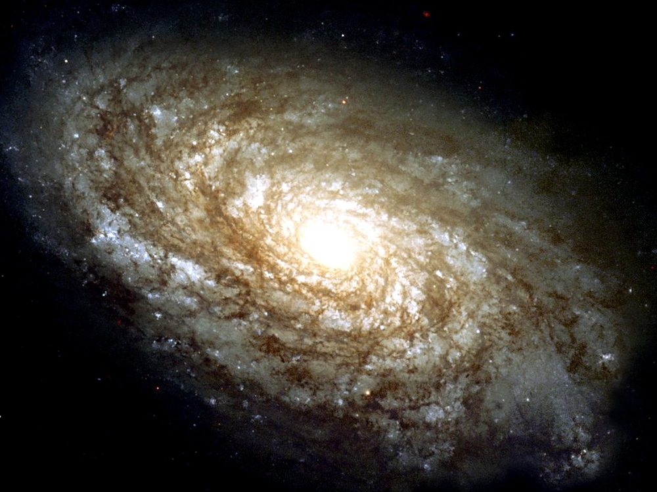
Figure 14. A nearby spiral galaxy, NGC 4414, filling the frame. A quantum twitch, stretched and pulled for thirteen billion years.
The timeline of exhibits, kept at the right temperature:
Hot: the leftover glow has freckles whose statistics we have measured. Their amplitude and tilt are numbers, not adjectives.
Warm: those freckles are the stretched jitter, and gravity grew them. The first stars, in this working picture, light up around 100 to 200 million years after the dump — a range, not a birthday. JWST photographs later exhibits: galaxies already assembled, already chemically rude, already sitting on the web that Chapter 16 will name. Those photographs are not a laboratory of the twitch. They are the museum downstairs from the laboratory.
The first stars are a warm chapter in a hot book. Theory says the first lumps that can cool and collapse do so around 100 to 200 million years after the dump, in minihalos that would look, if you could see them, like failed galaxies: a few hundred thousand or a few million solar masses of extra pull, a handful of massive, short-lived, metal-free stars. We have not photographed those stars as individuals. We have photographed, with JWST, galaxies that are already later exhibits — assembled, chemically polluted, sitting at redshifts that still make the stretch look like a time machine. Those galaxies are not the twitch. They are the twitch after gravity has had a few hundred million years to work and after the first stars have already lived and died and thrown carbon into the kitchen. Do not let a sharp infrared image pose as a laboratory of quantum jitter. It is a museum label that says LATER.
Gravity as sculptor is not a metaphor you can retire. Overdense patches pull. Underdense patches get emptied. On small scales the extra pull of Chapter 17 helps the lumps hold together against the stretch. On large scales the stretch eventually wins, and the web freezes. In between, for a few billion years, the sculptor is busy. A spiral disk is a late, local luxury: gas that cooled, spun, and settled in a halo that the twitch had already chosen. The choice was a nick of size 10⁻⁵ in the leftover glow. The luxury took the rest of cosmic time.
Cold: we have watched a twitch become a spiral in a laboratory. We have not. We have watched the intermediate photograph — the leftover glow at 380,000 years — and done the math that grows a 2 × 10⁻⁹ jitter into a disk like Figure 14. That is allowed to be enough, if we say so.
Chaos belongs here as mechanism. A jitter of one part in a hundred thousand is nothing in a kitchen and everything in a cosmos. Change the jitter’s pattern and you get a different web of galaxies — still a web, different rooms. That is not destiny. It is sensitivity. Chapter 16 will give chaos its own chair. Here, notice that the most important structures you will ever see began as noise.
Do not let the spiral in Figure 14 pose as a time-lapse of a quantum event. It is a nearby galaxy, light a few tens of millions of years old, a late sculpture. The twitch that seeded the line of lumps it grew from is not in the frame. The twitch is in the statistics of the leftover glow, and in the fact that a universe this empty still managed to make a disk this pretty. Gravity had time. Time is the sculptor’s only luxury. The quantum rule supplied the chisel’s first nick.
Between the freckles and the first stars there is a long, dark kitchen.
Last scattering is 380,000 years. The first stars, warm, are 100 to 200 million years. In between, the universe is not empty of stuff. It is empty of light worth a name. Neutral hydrogen, leftover helium, the extra pull gathering in the dark, the stretch still going. Lumps that were 10⁻⁵ too dense in the glow become, slowly, lumps that can cool. Cooling is the unglamorous step. Gravity pulls. Gas that can radiate away its heat can keep falling. Gas that cannot stays puffy and fails. The first stars are the first successful coolers, not the first lumps. JWST’s later exhibits have already inherited metals from coolers that died. That inheritance is why a sharp galaxy at high redshift is not a photograph of the nick. It is a photograph of a kitchen after several meals.
Hot claim: the leftover glow has a pattern of freckles whose statistics we have measured. Warm claim: those freckles are stretched quantum jitters, grown by gravity into galaxies. Cold claim: we have watched a twitch become a spiral in a laboratory. We have not. We have watched the intermediate photograph and done the math. That is allowed to be enough, if we say so.

15. Bubbles That May Never Stop
Once you have a field that can burst, you can ask whether the bursting ever takes a holiday.
In many versions of slow-roll, the field reaches the bottom of its hill in some places and keeps rolling, or keeps jittering, in others. The places that keep going keep stretching. The places that stop become hot bangs — pocket universes, bubbles, whatever noun you can stand. Our observable sky would be inside one stopped place. Outside, the bursting might still be hiring.
This is eternal inflation, Linde’s and Vilenkin’s child, Guth’s grown rumor. It is a live hypothesis. It is not a photograph.
The kitchen is a pot that keeps boiling in the next room.
You live in the room where the pot already dumped into soup. The soup is the leftover glow, the leftover helium, the stretch, the galaxies. In the next room — a room whose door is not a door, because the stretch between rooms is not a hallway you can walk — the original pot may still be boiling over. New dumps, new soups, new leftover glows that are not ours. You cannot go there. A bubble is not a destination. It is not a planet with a pad. It is a volume that reheated, or a volume that has not, separated from you by a stretch that does not sell tickets. Bubbles are a maybe about the loaf, not a travel brochure.
A destination has a worldline you can aim at. A bubble that nucleated elsewhere, behind a stretch that has been doubling for longer than our soup has existed, does not. Light from that bubble does not arrive. A ship does not arrive. The word “neighbor” in the cold claim at the end of this chapter is a courtesy and a trap. Neighbors, on Earth, share a street. These would share only a mathematics.
In many slow-roll models the quantum jitter in the field, per Hubble time, can be larger than the classical roll down the hill. Where the jitter kicks the field up the hill, that patch stretches more and the hill remains. Where it kicks down, that patch dumps into soup and becomes a bubble. The stretching patches make more volume than the dumping patches. Volume wins. The boil-over in the next room does not stop because the next room keeps being remade. That is eternal inflation as a mechanism, not as a mood. Linde’s picture is often this self-reproduction on a hill. Vilenkin’s picture is often bubbles nucleating in a false-vacuum sea. The nouns differ. The next-room pot is the same insult: the bursting may not take a holiday.
If the underlying physics has many ways to stop — many valleys for the field to fall into, many sets of effective constants — then different bubbles can freeze out with different laws. That is the expensive copy machine of Chapter 40, and it is where the anthropic filter of Chapter 42 gets its only real job. Weinberg’s argument that the cosmological constant should not be much larger than what still allows galaxies needs an ensemble. Eternal inflation plus a landscape is the ensemble people reach for.
Do not write the filter here. Chapter 42 will have to say, carefully, what an ensemble is allowed to explain and what it is only allowed to excuse. Here it is enough to see why Weinberg’s Λ is lonely without company. A vacuum energy — a hum of energy that empty space carries even with nothing in it — as small as the one we weigh is a joke if it is a unique, first-principles output of a theory. It is less of a joke if many vacua are tried and we can only find ourselves in one that still makes galaxies. That sentence is a pointer, not a proof. The pointer needs two things this chapter can name and cannot certify: a bursting that never quite stops, and a menu of valleys. The bursting is eternal inflation, Linde and Vilenkin, a live maybe. The menu, in its most advertised form, is a landscape inherited from string theory.
Weinberg, in 1987, asked how large a cosmological constant could be before galaxies fail to form.³¹ The answer is: not much larger than what we weigh. That is an upper bound from the existence of galaxies, not a calculation of the vacuum from first principles. An upper bound of that kind is idle unless many values are tried. One universe, one Λ, and Weinberg’s bound is a coincidence we live inside. Many bubbles, many Λs, and the bound becomes a filter: we could not have found ourselves in the bubbles that shoved too hard, too soon. Chapter 42 is the filter chapter. This chapter only points at the drawer the filter would need. Do not open the drawer and call it a house. Do not write the filter’s sentences here. Point, and leave the pointing visible.
The landscape, in its most advertised form, comes from string theory. String theory cannot currently be tested. A landscape of valleys inherited from an untestable framework is not a measurement. It is a maybe stacked on a maybe. This book will let the stack sit on the table. It will not serve it for dinner.
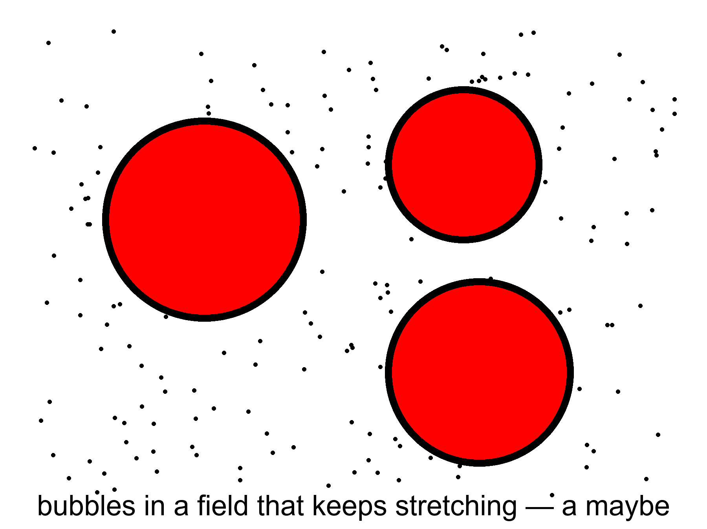
Figure 15. Three bubbles in a field that keeps stretching. A picture of a possibility, not a photograph.
Figure 15 is a picture of a possibility. It is not a map. Maps have distances you can travel. These circles do not.
There is a further rumor: that the bursting has no beginning, that bubble has always begotten bubble. The Borde–Guth–Vilenkin result says otherwise for a wide class of stretching spacetimes: if the average expansion is positive, the spacetime is past-incomplete. Eternal inflation, even if it has no end, still faces a boundary in the past. The bubbles do not give you a free forever-behind-you. They give you a messier loaf.
Past-incomplete, in the kitchen, means this. Follow a worldline backward through a spacetime that has been stretching, on average, and you run out of geodesic — the straightest path the geometry allows, the trail a free stone or a free clock actually follows — before you run out of curiosity. You do not get a quiet eternity of boiling behind you. You get a boundary, a place where the description stops and a different description — quantum gravity, a bounce, a sentence we do not own — would have to take over. BGV is not a proof that the loaf had a kitchen-clock beginning. It is a proof that this kind of forever-behind-you is not for free. The next-room pot does not pay the first-word bill. Chapter 45 will sit with that bill. Here: eternal inflation is not a machine for manufacturing a past without an edge.
Measure problem, in one sentence: if there are infinitely many bubbles and infinitely many observers, the word “typical” breaks. You cannot say “most universes are like this” until you say how you count. No one has a count that everyone else has to accept. Until they do, “the multiverse predicts X” is a hope in a lab coat.
Volume-weighted counting rewards the patches that stretched longest. Observer-weighted counting tries to ask where a typical observer sits. Pocket-weighted counting treats each dumped soup as one. They disagree. They disagree about whether we are typical, whether the cosmological constant we weigh is typical, whether anything is typical. An ensemble without a measure is a drawer of photographs with no rule for which one is “the” photograph. Chapter 42 will need a rule if it wants the filter to be more than a mood. This chapter’s job is to admit that the drawer is a rumor, and that the rumor is not a destination.
Infinity is the rude guest. If the next-room pot never stops, there are infinitely many dumped soups. Infinitely many observers. Infinitely many values of anything you care to count. A ratio of infinities is not a prediction until you say which infinity sits in the denominator. Different measures are different denominators. They are not a minor bookkeeping quarrel. They change what the rumor is allowed to claim. Until one of them is forced on us by a principle we already trust, “the multiverse predicts X” should be read as “some ways of counting would like X.” That is a thinner sentence. It is the honest one.
Warm claim: inflation can be eternal in many models. Cold claim: it is, and we live in a bubble with neighbors we will never meet. The sky we have does not require the neighbors. It permits them. Permission is not a postcard.

Physics vs philosophy: from inflation to a multiverse
What the evidence establishes. The leftover glow is even to a part in a hundred thousand, geometrically flat to within a fraction of a percent, and freckled with a slightly “red” spectrum (n_{s} ≈ 0.965).²¹ A brief early burst of stretching explains all three; no inflaton field has been detected, and the swirl pattern (B-modes) that would confirm gravitational waves from the burst has not been seen.³²
What some physicists infer. That many models of the burst never stop everywhere, so other bubbles with other effective constants exist. That is a property of models, extrapolated far past any patch we can observe.
What this book infers. Eternal inflation is a warm feature of a warm theory and a cold claim about the world. No observation we can make reaches another bubble, unless a bubble collision left a disk-shaped mark on the glow; searches have found none.³³

Keep the next-room pot on a back burner, not on the dining table. The local burst of Chapter 13 is the working preface to the soup we can taste. The pot that may still be boiling elsewhere is a maybe that the local burst can tell if you let it drink. Letting it drink is allowed. Paying rent with the drink is not.
The next-room pot is also a humility about nouns.
People hear “bubble” and picture a place, a film of soap, a destination with an inside you could visit if you had a better ship. The picture is a liar in three ways. First, the wall of a nucleated bubble, in the versions that have walls, is not a surface you approach. It is a stretch you cannot catch. Second, other dumped soups need not share our leftover glow, our helium fraction, our shove. Different valleys, different effective constants: that is the landscape rumor, and the rumor is untestable while it is borrowed from string theory. Third, even a bubble that dumped with laws like ours is not “next door.” Next door is a kitchen word. These rooms do not share a hall.
Guth’s grown rumor, Linde’s child, Vilenkin’s child: the bursting as a process that, once started, makes more of itself. That is the live hypothesis. It may be false. Slow-roll can be arranged, in some hills, so that the classical roll always beats the jitter and the pot dumps everywhere at once. Those hills pay Chapter 13’s bills without hiring Chapter 15. The sky we have does not yet force the hiring. It permits it. Permission, again, is not a postcard. Figure 15 remains a picture of a possibility. Frame it as a possibility and the chapter has done its job. Frame it as a map of destinations and the chapter has failed.

16. Chaos Is an Engine
Chaos, in physics, is not a mood and not a mess. It is a precise kind of sensitivity: two starts that differ by a breath end in rooms that do not recognize each other. Weather is chaotic. A pendulum swinging over a magnet can be chaotic. The approach to a final crunch, if the universe had been headed for one, would have been chaotic — Barrow proved things in that vicinity, and Belinski, Khalatnikov, and Lifshitz gave the mixmaster a name. A recollapsing cosmos would not politely reverse the film. It would scramble.
The kitchen is a dropped tray of yeast.
Same flour. Same water. Same yeast. The tray hits the floor and the grains go everywhere. Two bakers, starting from two almost identical spills, do not bake the same loaf. One kitchen gets a dense crumb. The other gets holes like a sponge. The ingredients did not change. The sensitivity did the work. Lyapunov, if you want the surname on the sensitivity, is the person who taught mathematics to measure how fast nearby starts stop being nearby. A Lyapunov time is a clock for forgetting. Weather forgets in days. A mixmaster crunch would forget in a scramble of axes. A quantum twitch, stretched and then pulled by gravity for 13.8 billion years, forgets the subatomic room and remembers only a web.
At the beginning, chaos is an engine.
The quantum twitch of Chapter 14 is sensitivity as a gift. Stretch it, and you get a web. The cosmic web — filaments of galaxies around voids like holes in a sponge — is what gravity does with a nearly scale-invariant jitter after thirteen billion years. It is not a design. It is what you get when pull is allowed to run on noise.
Same engine, two temperatures. At the start, sensitivity is how a nick of size 10⁻⁵ becomes a sponge you can survey. At a hypothetical crunch, sensitivity is how a last decimal becomes a mixer nobody holds. The mathematics is cousin to itself. The moral is not. One gift. One theft. Do not let a poster collapse them into “chaos means we cannot know anything.” We can know the leftover glow. We can know the web’s family. We cannot know, from a grain of yeast, which hole in which loaf. That is the precise kind of not-knowing. It is enough.
The web is not a drawing. It is a survey. The Sloan Digital Sky Survey and the Two-degree-Field survey mapped enough galaxies that the sponge became a fact you could crop and print. Figure 16 is that crop: filaments as dark on light, voids as the light, a later exhibit of the same jitter that freckled the leftover glow. Two nearby starts in the primordial noise — two almost identical spills of yeast — would not grow the same rooms. They would still grow a web. Still a sponge. Different holes. That is chaos as an engine: the family of outcomes is stable, the particular kitchen is not.
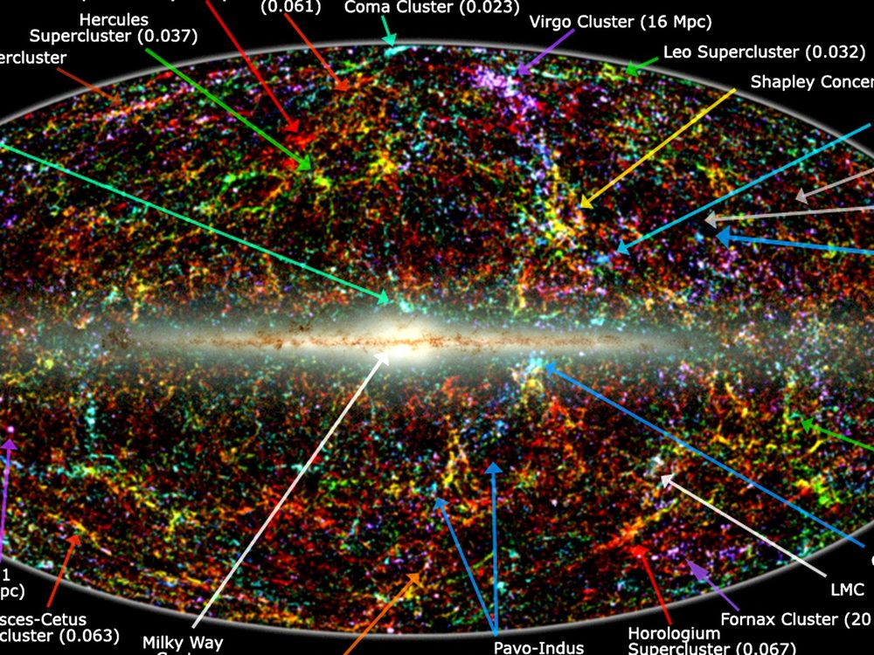
Figure 16. The whole sky as a map of a million galaxies from the 2MASS survey. The band across the middle is our own Milky Way blocking the view; the clumps and filaments everywhere else are the web grown from twitches. The small labels name nearby clusters and can be ignored.
Barrow’s habit, useful here, was to walk you up to a large number and then refuse to call the number a destiny. The web is a large fact. It is not a plan. Mixmaster is a large fact about a kind of ending we do not appear to be headed for. It is not a control panel.
The mixmaster, named for a kitchen mixer because the axes of a collapsing universe would stretch and squash in a chaotic rotation, is Belinski, Khalatnikov, and Lifshitz: BKL. Near a spacelike singularity — a place, Chapter 24's proper subject, where the loaf tears and the equations stop describing what happens next — the generic behavior in general relativity is not a polite, spherical crunch. It is an oscillation of shapes, sensitive to the last decimal, a Lyapunov nightmare. Barrow proved things in that vicinity that matter for anyone who wants a last moment to be a steering wheel. Nearby starts become unrecognizable rooms. A civilization of perfect computers would not find a handle. The geometry would melt the handle.
Picture a collapsing room whose walls do not approach you together. One axis crunches while another stretches, then they trade, then they trade again, the sequence sensitive to the last decimal of the starting shape. That is Mixmaster, Bianchi IX in the jargon, a kitchen mixer beating a dough that is the geometry itself. BKL argued this is generic: not a special, spherical collapse, but the thing Einstein’s theory wants to do when a spacelike singularity is approached. Barrow took that generic chaos seriously enough to ask what a final intelligent observer could still control. The answer, in the vicinity of those proofs, is: almost nothing, unless you add extra structure the known laws do not hand you. Ideas for ideas can add the structure. Data have not.
At the end, if there were a crunch, the same family of sensitivity would be a theft. Tiny differences near a final singularity would be amplified until no one, not even a civilization of perfect computers, could steer. That fact will matter when someone tries to sell you a required Omega Point: a last moment in which mind takes the controls and computes forever. Chaos at the crunch is not a control panel. It is a warning that control panels melt.
Chapter 19 will finish that sale’s refusal on other grounds: the shove is winning, the bombs of 1998 are not a crunch track. Even in a universe that did crunch, BKL plus Barrow would still be waiting at the far end with a scrambled mixer. Forever-mind fails twice. Once because the data do not crunch. Once because a crunch, if you had one, would not be a computer. Do not let the Omega Point borrow this chapter as a mood. It is a mechanism. The mechanism is unkind to steering.
In the middle — which is where we live — chaos is why forecasts have horizons. We can reconstruct the three minutes because the soup was mixed and the laws were simple. We cannot forecast a galaxy’s weather in year 10¹². We can forecast the stretch. The stretch, with dark energy in the budget, looks dull and huge. Dull and huge is a kind of mercy. The web freezes in place as the shove between filaments wins. Galaxies go dark on their own clocks. The engine that built them idles.
Weather versus stretch is the distinction worth taking home. Weather is Lyapunov’s child: a breath here, a different storm next week. The stretch is not that kind of forecast. The Friedmann equations, fed a budget of pull and shove, do not forget their nearby starts on a weather clock. They tell you the dough will keep rising, and, with the shove in the account, rising faster. You can be wrong about the second digit of the Hubble number and still be right that the voids will get ruder. You cannot be a little wrong about a hurricane’s seed and still be right about next Tuesday. Do not confuse the two clocks. One is why you pack an umbrella. The other is why the cosmic web is a fossil in progress.
Barrow would have called the Omega Point an idea for ideas and then, if he were in a kind mood, walked you to the mixmaster and let the mixer do the unkindness. Chapter 19 will do the data. Here the mixer is enough: crunch chaos is a second lock on that door. Nearby starts, unrecognizable rooms. No steering wheel survives the last decimals.
Keep chaos in the book as a tool, not a vibe. It made the rooms. It will not let anyone own the ending. It is the opposite of a watchmaker and the opposite of a destiny. It is what a twitch can do when the universe gives it time.
If you want a last kitchen instruction: pick up the tray. Notice that picking it up does not unspill the yeast. The web is already baked into the surveys. The leftover glow is already on the antenna. Chaos, as an engine, has already done the morning’s work. What it will not do, tonight or in a crunch, is hand you a recipe that steers the last decimal. Barrow’s pebble, Guth’s unpaid bills, Mukhanov’s twitch, Linde’s next-room pot, and this dropped tray are one family of honesties. The universe is sensitive. It is not a mood. It is how rooms get made, and why nobody owns the ending.

PART IV — The Missing Most

17. The Extra Pull
Dark matter is a terrible name. It sounds like a feeling, or a brand of chocolate, or the opposite of enlightenment. It is none of those. It is a pull we can weigh and cannot photograph in ordinary light.
Barrow, in the short origin book this one uses as a model, had a habit of refusing a pretty noun until a measurement had earned it. Dark matter has not earned a pretty noun. It has earned a scale. The scale is the extra weight in galaxies and in clusters: more pull than the shining stars and gas can account for, by a factor of several. The name is a confession. We weighed it. We have not bagged it.
In the kitchen you do not weigh a truck by climbing into the trailer and counting crates. You weigh it by how the bridge leans when the truck rolls on — by the strain gauges, the sag, the way the other traffic feels the extra. Dark matter is the trailer you cannot open. The bridge still leans. That is the whole method of this chapter, and it is why the extra pull is a hot fact even while the particle is a warm rumor.
In the 1930s, Fritz Zwicky timed the galaxies in the Coma Cluster and found them moving too fast. The visible stars did not supply enough gravity to hold the swarm. He said so, rudely, and was mostly ignored. In the 1970s, Vera Rubin and Kent Ford timed stars in the disks of spiral galaxies and found the same insult at a friendlier scale: stars out in the suburbs orbit as fast as stars closer in, as if most of the mass were in a big, dark halo, not in the shining bulge. The light is a liar about the weight.
The Coma paper is 1933, and the cluster is a city of cities: thousands of galaxies in a well so deep that, if you time them as Zwicky did, the virial theorem becomes a speed trap. If the members are this fast, the well has to be this deep, or the swarm would have flown apart long ago. The well was too deep for the starlight. The rudeness was not the problem. The problem was that nobody wanted an extra ingredient that did not shine. Extra ingredients are expensive. Astronomy in the 1930s was still finishing the argument about whether spiral nebulae were even other galaxies. An invisible majority was a second insult.
Rubin and Ford brought the second instrument down to a single disk. A rotation curve is speed versus distance from the center, a plot that Newtonian common sense said should fall once you leave the shining bulge. Their curves stayed flat. Flat is not a mood. Flat is v staying large while r grows, which, if gravity is still gravity, means M is still growing in the dark. They did this galaxy after galaxy, with a spectrograph and a stubbornness that later textbooks still under-thank. The suburban stars were clocks. The clocks did not slow.
What dark matter is not, while we are cleaning the noun:
It is not dark energy. Dark energy shoves. Dark matter pulls. They share a marketing department and nothing else.
Keep the divorce or the rest of this part will lie to you. The extra pull clumps. It makes halos. The extra shove does none of those things. Chapter 18 is the other spouse. Do not let a shared adjective fuse two ingredients.
It is not a black hole in the everyday sense, though a zoo of old, small black holes is a cold candidate people still kick. Ordinary black holes made from dead stars are not numerous enough, and we have looked.
Microlensing surveys have walked the Magellanic Clouds looking for the wink of a compact object passing in front of a star. They did not find a halo made of dead stars. A halo made of primordial pebbles of collapsed spacetime is still allowed by some papers and disliked by others. It is not the working fluid.
It is not the failure of our eyes. We have looked in radio, infrared, X-ray. The missing weight does not glow in those either, not as atoms would.
It is not a mood in the equations. The leftover glow’s freckles have a pattern that, when grown by gravity, matches a universe in which most of the pulling-stuff does not collide with light. Atoms slam into photons in the early plasma and leave a different signature. The extra pull did not slam. It is non-baryonic in the jargon: not the protons-and-neutrons club. Appendix A17 says that more carefully. Here: it is a different ingredient, not hidden steam.
The leftover helium of Chapter 10 already counted the baryons. There are not enough of them. You cannot hide the extra weight in more hydrogen that forgot to shine. The nuclear minutes already took inventory. The leftover glow’s odd and even acoustic peaks take the same inventory a second way. Two fossils, two methods, one minority of atoms. The extra pull is the difference between that minority and the weight the clocks and the arcs demand.
Candidates have names that sound like card games. WIMPs: heavy, shy particles that would leave a rare cough in an underground tank. Axions: wisps from an old fix to nuclear physics, convertible into photons in a magnetic field if you listen with a sufficiently obsessive radio. Sterile neutrinos: a shy cousin of the neutrinos we already know. None of them has been caught in the act. The tanks have gotten very quiet. XENON, a vat of noble liquid under a mountain in Italy, listens for WIMP coughs and hears the Earth’s radioactivity and the Sun’s neutrinos and not much else. LZ, a larger vat in a South Dakota mine, does the same with a stiller ear. The radios have gotten very proud. The sky has not changed its mind about the pull.³⁴³⁵
WIMPs were the easy hope: weakly interacting massive particles, heavy enough to sit still on galaxy scales, shy enough to pass through a mountain, common enough that a ton of liquid xenon should, over a year, record a few recoils. The year keeps ending without the recoils. Axions were a patch Peccei and Quinn wrote for a problem in the strong force; if they exist at the right mass they can be the halo, and a magnetic cavity can try to turn them into a microwave whisper. The whisper has not arrived. Sterile neutrinos are a shy extra flavor that would not join the usual weak interactions; some recipes make them cold enough to scaffold galaxies, some make them warm enough to erase dwarf galaxies we can still see. None of the three has been caught in the act. That silence is a scientific result, not a failure of nerve. A WIMP at the mass and interaction strength that would have made the tanks cough by now is, to a first approximation, not there. The window has not slammed shut on every mass. It has slammed shut on the masses that were supposed to be easy.

Status as of October 2026: dark-matter searches
Measured. The extra pull itself: galaxy rotation, lensing, the Bullet Cluster, and the peaks of the leftover glow.³⁶³⁷²¹
Searched for, not found. The largest xenon detectors, LZ in South Dakota and XENONnT in Italy, have reported no convincing WIMP signal.³⁴³⁵ In September 2026 LZ reported a single unusual event in an extended energy window, at a significance of about 2.6 standard deviations once the size of the search is accounted for: worth watching, not a discovery.³⁸
Open. Axions, lighter or heavier WIMPs, sterile neutrinos, primordial black holes in some mass windows, and modified gravity (which must still explain the Bullet). A detection in a tank, or a signal in the sky that only one candidate can produce, would change this box.

Modified gravity — change the law instead of adding an ingredient — still has clever friends. It has a harder time with clusters, with the leftover glow, and with the Bullet, where two kinds of stuff have been caught in the act of not staying together. The working theory is an extra ingredient. The working theory has a hole in it the size of a noun. That is allowed. Chemistry once had a hole named “what is fire.” The hole was not a reason to deny the flame.
MOND, and the relativistic clothes it has tried on, can mimic a flat rotation curve in a lonely disk with a tweak to Newton at low accelerations. A lonely disk is not a colliding pair of clusters. If gravity itself were simply stronger on large scales, the slammed gas and the extra weight would still sit on the same map, because they would be the same map. They do not. Some papers try to dress modified gravity so the offset still happens. The try is allowed. The try has not become the working theory. Barrow would have walked you to the photograph, named the extra ingredient, and then said the noun is still an idea for a laboratory, not a trophy.
How do you weigh something that refuses to shine?
You watch what it does to things that do. Galaxies lean. Clusters lean. The leftover glow rang like a bell, and bells remember what was pulling on them.
Rotation curves are the suburban clocks: stars and gas, timed in their orbits, going too fast. Gravitational lensing is the more theatrical trick. A cluster’s weight bends spacetime, and the bend makes multiple, stretched images of galaxies behind it — arcs, crosses, rings. Count the arcs, measure the stretch, and you have a scale. The scale disagrees with the starlight by a factor of several. The disagreement is the extra pull.
Weak lensing, which does not make a full arc, still shears the background into a statistical lean. Stack enough galaxies and the lean is a map. Strong lensing is the theater. Weak lensing is the survey. Both weigh the trailer by the bridge. Neither needs the crates to glow.
The leftover glow offers a third scale. The freckles are a sound. The sound has harmonics, like a bell. The position and height of those harmonics depend on how much ordinary matter was slamming into light, and how much quiet matter was only pulling. The bell says: a little slamming stuff, a lot of quiet stuff. The numbers line up with the clocks and the arcs. Three instruments, one extra weight.
Before atoms formed, the plasma could ring: photons and baryons slamming, compressing, bouncing, while the extra pull sat in the wells and did not slam. Odd peaks versus even peaks are a baryon census. Peak positions are a total-matter census. A single method can lie. Three methods, of different families, lying in the same direction, is a courtroom. That is why this chapter’s first sentence is hot even though the last noun is missing.
Then there is the Bullet.
The catalog name is 1E 0657-56. In 2006, Clowe and colleagues published the map that made the argument visual even for people who dislike maps.
Two clusters have passed through each other. The gas — atoms, shining in X-rays — slammed, shocked, and lagged in the middle, the way two crowds trying to walk through each other get stuck at the doors. The extra pull, mapped by lensing, did not slam. It went on through, like two ghosts politely declining to notice they had overlapped. In the famous color posters, gas is pink and mass is blue. On a Kindle those posters lie. Figure 17 is one composite: the slammed gas labeled where it piled up, the mass labeled where lensing put it, same scene. The contours do not sit on the gas. That is the photograph of “not atoms.”
If you wanted modified gravity to swallow the extra pull, this is the exhibit it has to explain without an extra ingredient that can leave the gas behind. The gas is most of the shining baryons in the cluster. After the crossing, the gas is in the middle. The lensing mass is not. Collisionless stuff goes on through. Collisional stuff sticks.
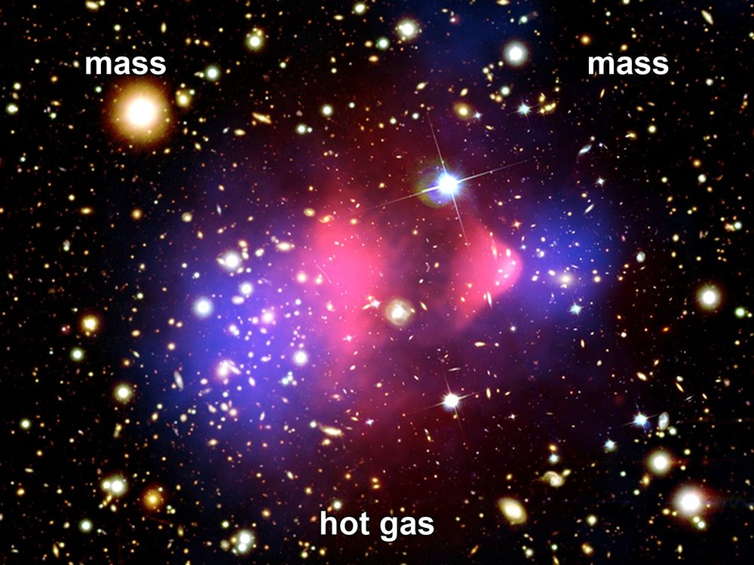
Figure 17. The Bullet Cluster as one composite: hot gas piled in the middle; mass, mapped by lensing, on either side. The pull did not stay with the gas.
Hot claim: there is more pulling-stuff than shining-stuff, and the extra stuff does not collide the way gas does. Warm claim: it is a particle we have not bagged, or a small zoo of them. Cold claim: we know its name, its mass, and which underground tank will cough first. We do not.
The extra pull is why galaxies are not just pretty. It is the scaffolding they grew on. Without the quiet halos, the twitches of Chapter 14 would have had a harder time becoming spirals before the stretch pulled the scaffolding out of reach. You live in a suburb of a ghost.
The baryons, left to themselves, would have been a thinner foam. The quiet wells were already there, grown from the same freckles, and the gas fell in. The scaffolding is not a purpose. It is a head start. Gravity ran on noise in the dark wells first; the shining disks are late tenants. The ghost is an ingredient, not a destiny, and not a synonym for the shove. It owes you a weight. The weight is on the bridge. The trailer is still locked.

18. The Shove
In 1998 two teams of astronomers, racing each other with dying stars, found that the stretch is not sulking. It is speeding up.
Saul Perlmutter’s Supernova Cosmology Project, and the High-Z team of Adam Riess and Brian Schmidt, were doing the same rude job: hunting Type Ia supernovae far enough away that their light had been in transit for billions of years, and asking whether the stretch had been tiring the way gravity said it should. Two teams, two pipelines, one sky. That is how you keep a shared mistake from dressing up as a discovery. In 2011 the three of them shared a Nobel Prize for the answer. The answer was no. The stretch had been getting a second wind.
The dying stars were Type Ia supernovae, a kind of standard bomb: a white dwarf that reaches a bad weight and detonates with a brightness you can almost trust. Trust the brightness, measure how faint it looks, and you have distance. Measure the stretch of its light and you have the universe’s size when it exploded. Plot size against time for bombs going off over the last several billion years and you expected, if you were educated before 1998, a slowdown. Gravity pulls. Stretching should tire.
The bombs were too faint. They were farther than the tired-stretch story allowed. The stretch had accelerated. Something was shoving.
Acceleration, in the kitchen, is not a galaxy putting its foot down. A raisin does not gun an engine. The dough between raisins changes its mind about how fast to rise. The plot of distance against stretch, once it is corrected for the way candles look faint, tips the wrong way for a tired universe. Gravity is still pulling inside the raisins. Between them, the budget has a term that does not thin, and that term has started to win.
A Type Ia is not a random firework. It is a white dwarf — a dead star’s leftover ember, about Earth’s size and the Sun’s mass — stealing matter from a companion, or merging with another dwarf, until it crosses a mass where electron degeneracy can no longer hold it. The explosion is nuclear and brief and, after you calibrate the way the light fades, nearly the same candle each time. Nearly is doing a lot of work. The teams spent years arguing about dust, about evolution, about whether a candle at redshift one is still the candle you calibrated nearby. The argument did not eat the result. Later candles, better calibrated, still sit too far away. That is how a hot claim is born: not from a press conference, from a result that survives the people who wanted it to be dust.
The simplest shove is a cosmological constant: an energy that comes with empty space itself, a tension Einstein once put in to freeze the universe and then regretted. The vacuum, in quantum field theory, is allowed to have a cost. The cost it should have, if you naively add up the jitters of every field down to the Planck scale, is off by a number so large it has become a joke: 10¹²⁰, give or take a few zeros. The measured shove is tiny. The predicted vacuum is a monster. This is the worst prediction in physics if you are in the mood to be rude, and one of the deepest problems if you are not.
Einstein wanted a static loaf. The constant was a fudge to hold the raisins still. When Hubble’s stretch showed the raisins were not still, he dropped it; George Gamow later reported that Einstein called it his biggest blunder. The sky, seventy years later, hired the blunder back — not to freeze the loaf, but to speed the later rise. If the vacuum energy were even a few orders of magnitude larger, galaxies would not have had time to assemble before the shove tore the wells apart. Weinberg said that out loud in 1987, as an anthropic upper bound, before the bombs had voted. The bombs voted near the bound. That is either a clue about an ensemble of vacuums — Chapter 15’s rumor — or a coincidence we have not earned the right to spend. Warm either way. Not a photograph.
Dark energy is the placeholder name for the shove. It might be Einstein’s constant. It might be a field that changes slowly, a “quintessence,” which is a word that sounds like a perfume and behaves like a maybe. It might be a mistake in how we read distances. The last option has been losing for twenty-five years. The leftover glow, the baryon acoustic oscillations — a leftover sound-scale printed in the way galaxies cluster — and the bombs now tell the same story. About two-thirds of the budget is the shove.
Quintessence would have an equation of state w that can wander a little. Einstein’s constant sits at w = −1 and does not wander. For twenty years the data sat at w ≈ −1. Since 2024 that has become a live argument.

Status as of October 2026: is dark energy constant?
Measured. The expansion is accelerating, and a shove makes up about two-thirds of the budget.³⁹⁴⁰²¹
Contested. The DESI survey’s 2025 maps of the frozen sound-scale, combined with the leftover glow, prefer a shove that weakens with time at about 3 standard deviations, rising to about 4 with one supernova sample and falling below 3 with another.²⁴ A July 2026 DESI analysis that adds the shape of the hydrogen forest gives 2.7 to 3.2 standard deviations, with the same direction of drift.⁴¹ The Dark Energy Survey’s full six-year result reports w ≈ −0.82 today and drifting, at about 3 standard deviations with the glow.⁴² A Bayesian reanalysis finds no decisive evidence, and a recalibration of one supernova sample removes much of the preference.⁴³
Not yet known. Whether the drift is real physics or an unmodeled systematic. Particle physicists conventionally ask for 5 standard deviations before calling a discovery; none of these results reaches it. The next DESI and Euclid releases, and the Rubin Observatory’s supernovae, should decide.

Either way, the working fit is a shove that still looks, at the present level of precision, close to empty space with a tiny, stubborn cost. A w that later turns around and becomes a crunch is still a cold loophole.
The sound-scale is worth a kitchen minute. In the plasma of Chapter 9, baryons and photons rang together. When the fog lifted, the ringing froze. The frozen wavelength is a ruler about 150 megaparsecs long, comoving — a stick you can still lay across the clustering of galaxies today. That is BAO: baryon acoustic oscillations. It is not a bomb. It is a leftover chime. Lay the ruler at different redshifts and you measure how the stretch has been behaving, H(z), the Hubble rate as a function of how much the universe has grown. Appendix A18 writes the Friedmann line for the case w = −1:
H²(z)/H₀² = Ω_{m} (1+z)³ + Ω_{r} (1+z)⁴ + Ω_{Λ} + Ω_{k} (1+z)²
Matter thins as the cube of the stretch. Radiation thins as the fourth power. A cosmological constant does not thin. That is the whole plot twist in one line: at late times the thing that does not thin takes over, and the stretch accelerates. Acceleration, in the data, begins around redshift 0.6 — a few billion years ago. The last part of the bake is the fast part.
It does not clump. It does not make halos. It does not sit in the Bullet. It is not dark matter in a hat. If you take nothing else from this chapter, take the divorce: pull and shove are not a couple.
The extra pull is scaffolding. The extra shove is a later wind between the scaffolds. You can live in a suburb of a ghost and still be carried apart from the next suburb by a dough that has started to hurry. The marketing department will keep printing “dark” on both bottles. The kitchen will keep two spoons.
Once the shove is in the budget, the future changes personality.
Without it, you still had a fight between pull and stretch. Enough atoms-and-ghosts and the universe might someday stop expanding and fall back. Too little and it would stretch forever, tiring, thinning, cooling. The knife-edge of Chapter 12 was, in part, a knife-edge of fate.
With the shove, the fight is already over, unless the shove itself is a liar that will someday switch sides. The stretch accelerates. Isolated lumps — galaxies, bound clusters — remain bound. Between them, space wins and keeps winning. The cosmic web freezes. New filaments stop forming. The voids get ruder.
A second-digit fight has been making the newspapers, and it should not be allowed to steal the first digit. The Hubble tension of Chapter 8 (67 from the glow, about 73 from local ladders, with the status box there) is an argument about the slope now, about whether we have misread a candle or missed a wrinkle. It is not an argument that the stretch is not accelerating. Both camps still need a shove. The bombs are still too faint. The 150-megaparsec ruler still says the late bake sped up. Do not let a fight about the second digit become a rumor that 1998 did not happen.
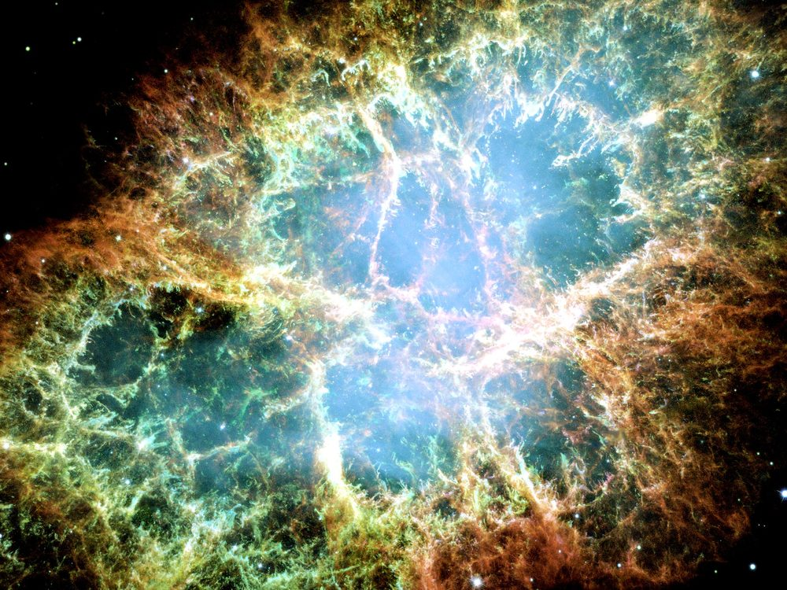
Figure 18. A supernova remnant, the Crab Nebula. Explosions of a related kind, seen much farther off, taught us the stretch is speeding up.
This is why a required Omega Point — a final crunch in which life steers the universe and computes forever — fails as physics, not as poetry. Poetry can crunch whatever it wants. The bombs, the leftover glow, and the frozen sound-scale say we are not on a crunch track. The next pages put shoes on that sentence.
A detail for later travel: the accelerating stretch makes a cosmic event horizon. There are galaxies whose light, emitted today, will never reach us, and there are galaxies we now see whose future light never will. Most of the universe has already left, not by walking away, but by the dough rising too well. Chapter 26 is the map. Chapter 18 is why the map is not optional.
A horizon of this kind is not a black hole. It is a fact about which events can still be connected by light in a loaf that keeps hurrying. If the shove stays near w ≈ −1, the map gets ruder with time: more of the web leaves the set of events that can still answer a signal. That is not despair. It is a reason to keep the word now local, and a reason Chapter 26 has a job.
Hot claim: the expansion is accelerating. Warm claim: a cosmological constant, or something that looks like one, is the shove. Cold claim: we know why the shove is the size it is. We do not. The worst prediction in physics is still on the board.

19. Why Forever-Mind Does Not Follow
Frank Tipler, working from a book he wrote with Barrow, described a final state in which the universe recollapses, intelligent information-processing takes the controls, the amount of computation diverges, and this last, infinitely clever moment is — he was not shy — God. He called it the Omega Point. He said the known laws require it. He said life must never die out.
The book was The Anthropic Cosmological Principle, 1986, a thick, serious, sometimes dazzling inventory of how the constants look arranged, followed by a last act that stopped being an inventory. Barrow’s name is on the cover. Barrow’s later habit, in the short origin book, was the one this chapter will keep: walk you up to a speculation and then call it an idea for ideas. Tipler kept walking. He later wrote a thicker popularization in which the last computation wore the noun more openly. The Omega Point is what you get if you let an idea for ideas put on a lab coat and then a mitre.
The known laws do not require it. The data have been voting no since 1998.
A crunch needs the pull to win. The shove is winning. For the Omega Point to be a destiny rather than a story, the shove would have to fade, reverse, or be a mirage. None of those is the working theory. A story can still imagine a different bubble, a different branch, a later surprise in the vacuum. A destiny cannot hide in a surprise. Destiny is supposed to be what the laws demand. The laws, plus the bombs — the Type Ia supernovae of Chapter 18, not weapons — demand a long, thinning, accelerating future, not a steered collapse.
Here is the kitchen version, and it is ruder than a diagram. Imagine a will that names destinies the bank account cannot pay. The will is eloquent. It leaves the house to a dynasty, the orchard to a school, the future to a mind that never sleeps. Then you open the ledger. The shove is two-thirds of the budget. Recollapse is not in the data. The will is still a document. The bank is still empty of that particular future. You do not get to call the will a law of physics because the prose was confident.
Perlmutter, Riess, and Schmidt did not set out to probate a metaphysical estate. They set out to weigh the stretch. The estate failed anyway. A required forever-mind needed the loaf to turn over. The loaf tipped up. Twenty-five years of leftover glow, of the 150-megaparsec ruler, of later candles, have not put recollapse back on the working track. Warm loopholes remain — a w that turns around, a vacuum that decays, a different bubble. Spend those as destinies and you have left the data for a story. Chapter 18 already said the story is allowed. Destiny is not the word for a loophole.
Barrow himself, in the short origin book this one uses as a formal model, had a better habit: he would walk you up to a speculation and then call it an idea for ideas. The Final Anthropic Principle — intelligent processing must arise and must never die out — is an idea for ideas that put on a lab coat. Martin Gardner made a joke of the acronym. The joke was unkind. The data have been unkinder.
In the 1986 book the Final Anthropic Principle is stated as a requirement, not a hope: observers come into existence, and once they do, they persist. That is FAP. Gardner, a working skeptic with a magazine column and no patience for cosmic last acts dressed as theorems, suggested that a principle which demands eternal observers deserved a cruder expansion of the letters. He did not need the 1998 bombs. He needed only the difference between a condition we observe from — we are here, therefore the universe is the kind of place that can have a here — and a commandment that we must remain. The first is the weak anthropic cut, a likelihood filter, useful once you have an ensemble. The second is a wish with a Latin name. Chapter 42 will give the filter its honest job. Here the job is simpler: FAP is not selected by the leftover glow, the leftover helium, the extra pull, or the extra shove. It is selected by a desire that the story not end without a speaker.
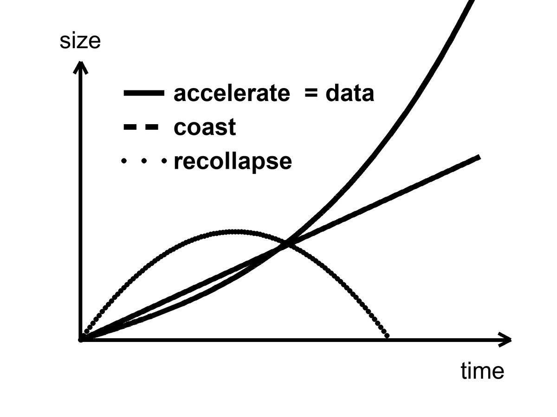
Figure 19. Three futures for the size of the universe: recollapse, coast, accelerate. The curve marked data is the accelerating one.
Look at the figure until it is boring. Recollapse is a curve that turns over. Coast is a curve that tires. Accelerate is a curve that tips up. The data sit on the one that tips up. Appendix A19 writes the same sentence with density parameters: observed matter about 0.3, observed shove about 0.7, deceleration parameter negative. Closed, matter-only recollapse needed a universe heavier than the critical density and no lasting shove. We are not that universe. The working fit is the accelerating curve.
Chaos, from Chapter 16, is the second objection, even in a universe that did crunch. Near a final singularity — the same wall Chapter 16 named and Chapter 24 properly explains — the mixmaster scrambles. Steering requires control. Control requires that nearby futures stay nearby. They do not. Infinite computation in a dying crunch is a wish that the geometry be a computer. Geometry is not that polite.
This is the objection that would survive a miracle. Suppose, against the bombs, the shove later faded and the loaf turned over. Suppose a civilization of perfect machines was ready with a plan. The plan still has to steer a geometry that, near the end, swaps its axes the way a chaotic kitchen fire swaps which pan is hottest. You cannot cook a required last thought on a stove that will not hold a setting. FAP said life must never die out. BKL says that even a dying crunch is not a stove you can borrow. The first objection is the data. The second is the shape of Einstein’s ending, crunch or no crunch.
Belinski, Khalatnikov, and Lifshitz — BKL, in the jargon — showed that a generic spacelike crunch in Einstein’s theory does not approach a polite point. It approaches a sequence of Kasner eras: squash in two directions, stretch in one, then swap, then swap again, the axes changing in a way that is chaotic. Barrow proved things in that vicinity about how little control you get. Say that again without the names, because the names can sound like a priestly veto. If the loaf recollapses, the last slice is not a quiet room in which a civilization of perfect machines can store more and more bits in less and less space. The last slice is a scramble. Tiny differences become different universes of shape. A steered crunch to a single, infinitely processed point is a measure-zero demand unless you add extra structure by hand. Extra structure by hand is not “the known laws require it.” Extra structure by hand is a story.
Tipler needed a recollapse, a cosmology that could be forced toward a point, a way to dump unlimited energy into unlimited computation, and a reading of God as that last computation. Each of those is a cold brick. Stacked, they are a chapel. This book will not bless the chapel. It will also not sneer at the hunger that built it. People want the story to have a speaker at the end. The leftover glow does not hire speakers. The Bekenstein count of Chapter 23 will later make the bit-budget ruder still: shelf space likes area, not a vanishing volume asked to hold an infinity. The first objection does not need that count. The first objection is the shove.
None of this says mind is small. It says mind is not a clause in the gravitational field equation. If we want mind to last — in machines that do not sleep, in libraries of Earth sent to dark seas under ice, in a greenhouse on a dead world — that is a project. Projects can fail. Destinies, if they are real, cannot. The distinction is the moral of this book’s second half. Meaning, if you want it, is local, expensive, and optional. The leftover helium does not care. The leftover glow does not care. The shove does not care. That is why a greenhouse is interesting. It is a care that the universe did not budget for.
The greenhouse is a thought with dirt on it: someone, somewhere, keeping a volume of air at a temperature a plant can use, on a world the shove and the pull did not arrange for gardening. The hours are still hours. The failure modes are still failure modes. The universe did not set aside a line item. The line item, if it exists, is us, locally, for a while. That is not a blessing of forever-mind. It is the opposite. Forever-mind was the claim that the field equation would staff the garden. The field equation staffs a stretch. The garden, if it happens, is overtime.
Meaning, in this book, is that overtime. It is not a clause that appears when the scale factor is large. It is a woman checking a valve, a library that can fail in a fire, a melt-probe that can miss the sea. The leftover helium will still be a quarter by mass if the valve sticks. The shove will still be two-thirds of the budget if the library burns. That is not a scolding. It is why the care is interesting. Care that the cosmos already budgeted for would be weather. Care it did not budget for is a project.
Hot claim: the working cosmology is not a recollapse. The bombs, the leftover glow, and the frozen ruler say the stretch is accelerating. Warm claim: the shove will keep behaving like a cosmological constant, w ≈ −1, long enough that the web freezes and most worldlines never meet again. Cold claim: mind is scheduled to take the controls and compute without end. That claim is not selected by the data. It is a will the ledger cannot honor.
Forever-mind does not follow. What follows, if you want a moral from a budget, is smaller and ruder and better: meaning is a local project, or it is not a project at all. The universe did not budget for it. That is the permission. It is also the bill.

PART V — One-Way Membranes

20. A Horizon Is a Fact About Events
A black hole is not a cosmic drain with a personality. It is a one-way membrane in the loaf.
Pick an event — a flash of light, a last radio beep, the moment a clock’s hand ticks. From that event, some future events can still be reached by a signal that never exceeds light. Some cannot. The boundary between those two sets, when gravity has bent the loaf enough, can close on itself. Inside, every future of every event leads deeper. Outside, you can still choose. The closed boundary is the horizon. It is not made of a material. It is made of facts about which events can influence which others.
That sentence is the whole chapter, if you let it sit. A horizon is not a black wall, not a hungry mouth, not a place you could chip with a hammer. It is a sorting of the loaf. Chapter 3 already gave you the tool: from any event, a future light cone of things you can still affect and a past cone of things that can still affect you. In ordinary space those cones stay open. Near a sufficiently compact mass they tip and close. Cross the closed surface and Earth’s worldline is no longer in your future cone. You can still be in Earth’s past cone for a while — as a signal, as a photograph, as a last beep. The asymmetry is not a mood. It is geometry.
This is a different object from the cosmic event horizon of Chapter 26. That one is a fact about the whole loaf’s later stretch: galaxies whose light, emitted today, never arrives. This one is local. A star collapses. A membrane forms around a clump. Most of the universe does not notice. Do not blur the two just because both are called horizons. One is a weather of the expanding dough. One is a fact about a compact mass.
We knew the local kind was real before anyone made a picture of a shadow. In the 1960s and 1970s, X-ray telescopes found binaries in which a visible star whipped around an unseen compact partner too heavy to be a neutron star. Cygnus X-1 was the rude prototype: a blue giant, a dark companion of more than a few Suns, gas screaming in X-rays as it lost an argument with an orbit it could not leave. The case was circumstantial and then it was not. No other object that heavy and that small holds itself up. The membrane was inferred the way a well is inferred from a missing bucket and a splash you cannot retrieve. The later pictures did not invent the well. They stopped the argument about whether the splash was a mood.
Karl Schwarzschild, in 1916, found the first exact hole in Einstein’s equations while dying, more or less, on the Eastern Front. He was an artilleryman as well as a mathematician. Between trajectory tables he took Einstein’s new field equations, assumed a mass that did not spin and did not charge, and found a clean solution Einstein had not yet written down. He posted the result to Berlin. Einstein read it to the Prussian Academy. Schwarzschild was dead by May, of an illness the war had not invented but had not helped. The radius that now carries his name is
r_{s} = 2GM / c²
where G is Newton’s constant, M is the mass, and c is the speed of light.
The formula is not a decoration. It says how small you must squeeze a mass before the membrane forms. Double the mass, double the radius. The speed of light sits in the denominator as a square, which is why everyday objects have absurdly tiny horizons and stars have horizons you could, in a dark mood, walk across. Appendix A20 writes the line and notes that the horizon is a coordinate scare, not a curvature scare: invariants stay finite there. The singularity, later, is the place the theory actually breaks.
A fact about events can still have a radius. That is the useful shock. The sorting of cones happens at a place you can write in kilometers, or millimeters, once you know the mass. For a stellar hole of ten Suns the radius is about thirty kilometers — a city you could hide under a cloud. For Sagittarius A* it is about twelve million kilometers, a good fraction of Mercury’s reach. For M87* it is tens of billions of kilometers, a solar system of darkness. None of those numbers is a wall. Each is the distance, in Schwarzschild’s labels, at which “you can still send a letter home” stops being true. The labels misbehave at that surface; the facts do not. Light aimed outward from just inside never arrives. Light aimed outward from just outside can, if it is lucky and not circling the photon sphere forever.
For the Sun, that radius is about three kilometers. The Sun is not a black hole; it is much larger than its Schwarzschild radius, and proud of it. Squeeze the Sun into those three kilometers and the membrane forms. For Earth, the radius is about nine millimeters — a pea, not a city. For a mountain, it is smaller than a nucleus and we do not live in a cartoon. Nature does not squeeze mountains. Nature squeezes the cores of heavy stars. When the core can no longer hold, and the leftover is heavier than the two or three Suns a neutron star can bear, the membrane is not optional. It is what the equations do with that much mass in that little room.
For the object in the middle of the galaxy M87, the radius is comparable to a solar system. Six and a half billion Suns, packed so that the one-way surface is tens of billions of kilometers across.⁴⁴ The Event Horizon Telescope did not photograph the membrane. It photographed the shadow: the silhouette of paths that could not escape, against a glowing ring of gas that still could. The picture was released in 2019. It is a radio mosaic from a planet-sized interferometer, not a snapshot from a tourist bus. In 2022 the same collaboration published the hole in our own cellar — Sagittarius A*, four million Suns, a horizon the size of a planetary orbit, flickering on the timescale of a coffee break.⁴⁵ Andrea Ghez and Reinhard Genzel had already timed the stars that whip around that cellar, and taken a Nobel for the timing. The shadow was the picture that matched the clocks.
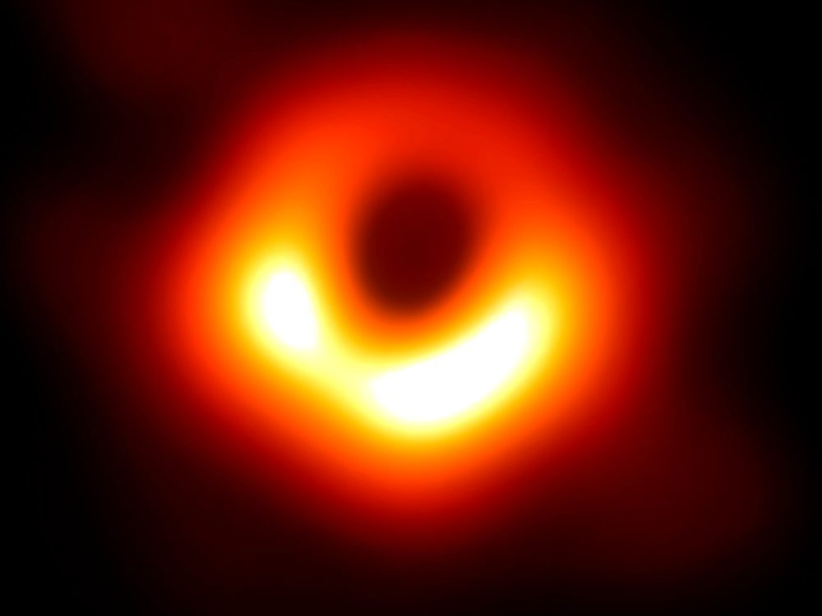
Figure 20. The ring and dark center of M87*. The shadow of a one-way surface.
A woman at a console in 2019 — invented, as the How to Read promised; the ring is not — watched the press image load and said, to no one, “That’s a hole.” She was almost right. It is the absence of paths. Photons that grazed the photon sphere, a circle at one and a half Schwarzschild radii for a hole that does not spin, can loop and still crawl out to a telescope. Photons that aimed closer cannot. The dark patch is a census of failed escapes. The bright ring is a census of last chances. The membrane itself is not in the JPEG. It is a fact about events the JPEG is allowed to imply.
Hot claim: horizons of this kind exist. Stars orbit something compact and enormous in galactic centers. Mergers ring spacetime and LIGO hears the ring.⁴⁶ The shadow is now a picture. On 14 September 2015 — a Monday, if you like kitchen calendars — a ripple passed through Hanford and Livingston, a few milliseconds apart, the way a fact about two colliding holes should. The event is called GW150914. Two holes, about thirty-six and twenty-nine Suns, finished a dance 1.3 billion light-years from this kitchen and became one hole of about sixty-two Suns. Three Suns’ worth of mass left as gravitational waves. For an instant the glow in those waves outshone, in raw power, every star we can name. The announcement came in February 2016. Since then the catalog has grown: more stellar holes, neutron-star pairs, a zoo of masses no optical telescope had weighed. The ringdown is the loaf settling after a slap. It is as close as we have come to hearing a horizon be a horizon.
Warm claim: inside the membrane, Einstein’s theory keeps going until a singularity, a place where the theory itself throws up its hands. The classical interior is a prediction of the same equations that got the shadow and the ringdown right. It is not a photograph. Cold claim: we know what replaces the singularity. We do not. Quantum gravity is a research program. Loop sketches try to bounce. String theory offers replacements — fuzz, a tangle of extra dimensions, a horizon that is not quite a horizon. String theory cannot currently be tested. A replacement that cannot be weighed is an idea for ideas, in Barrow’s honest sense, not a second picture to hang beside Figure 20.
The kitchen mistake is to think of the hole as an object you could poke. The useful thought is the membrane of events.
Imagine a last radio beep. A probe, invented, falls toward a stellar hole while a ship waits far out. The probe’s beacon is a metronome. At first the ship hears it on schedule, Doppler and all. Then the ticks stretch. Each beep arrives redder, then redder still, as if someone were pulling the wavelength the way Chapter 8 pulls galaxy light. The probe, by its own clock, crosses the membrane in finite proper time and keeps falling. The ship never quite receives a last tick. The signal fades, redshifts, and is lost in the noise. Earth can still include the probe in its past, for a while, as a redder and redder last beep. The probe’s future cone no longer includes Earth. That asymmetry is the whole joke and the whole tragedy. It is also why a hole is not a door.
Barrow liked to shock readers with a number that fits in a teaspoon. Earth’s horizon is nine millimeters. The entire planet, squeezed to a pea, would wear a membrane you could hide under a thumb. We do not do that. Gravity, given a few dozen Suns in a collapsing core, does. The shock is not the cartoon. The shock is that the same formula that makes a pea out of Earth makes a solar-system-sized shadow out of M87*, and that both numbers are now, in different ways, measured.
So: a horizon is a fact about events. It is not a personality, not a drain, not a door. The next chapter parks a clock beside one and watches “now” come apart in a more intimate way. Chapter 24 will take the door away for good. Here, keep the beep. If you remember nothing else, remember that the probe’s last second is not a second the ship is allowed to share.

21. An Hour Beside the Edge
Clocks run slow when they sit deep in a gravitational well. This is not a rumor from a story. Chapter 5 measured it on a tower, on airliners, and across a laboratory bench, and GPS corrects for it every day.
GPS satellites, at about 20,200 kilometers, gain about 45 microseconds a day from the weaker gravity and lose about 7 from their speed.¹ You do not need a black hole to believe that a well changes a clock.
What “slow” means, if we are being careful, is not that the lower clock is broken. It is that its worldline is shorter between two meetings. Proper time is mileage. A path that sits deeper in a well is a shorter path, the way a trail that cuts through a valley can be shorter than a trail that stays on the ridge, except here the “shorter” is time itself. Pound and Rebka measured the tax on light. Hafele and Keating measured the tax on clocks that flew and clocks that stayed. GPS spends the tax every second so your map does not drown. The black-hole chapter is the same tax, made rude. Nothing new is invented at the horizon except the size of the bill.
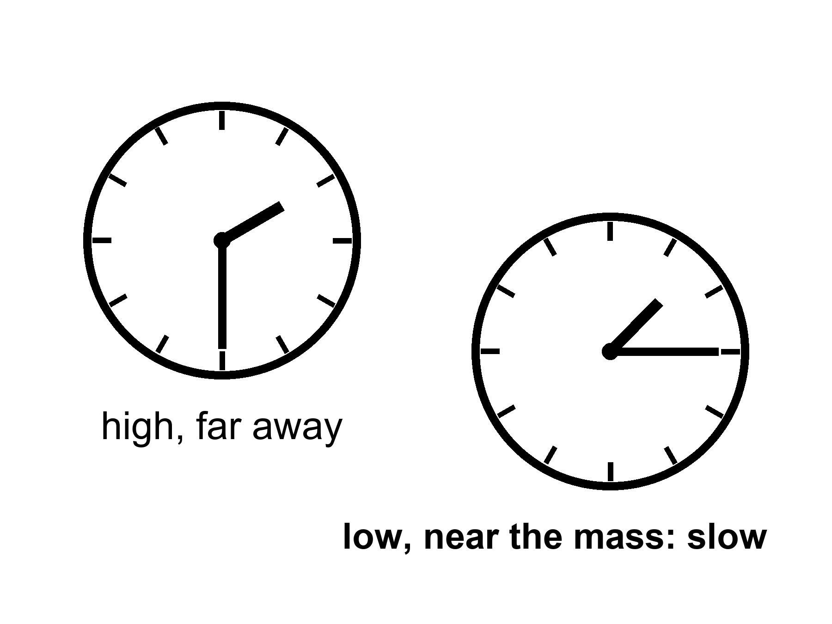
Figure 21. Two clocks, one lower in a gravity well. The lower face runs slow.
Near a horizon the same fact becomes rude. A clock hovering just outside, fighting with rockets to stay put, ticks slowly compared with a clock far away. An hour there can be years elsewhere. The numbers in posters — an hour for seven years — require a hole that is both enormous and spinning almost as fast as a hole is allowed to spin. Spin helps. A spinning hole, a Kerr hole, drags space with it and permits stable orbits closer in, where the well is deeper and the tides, for a given mass, are gentler. A supermassive hole can have an hour-beside-the-edge without spaghettifying the visitor. A stellar-mass hole would turn the visitor into a rumor of atoms before the hour was interesting.
Say the poster line out loud, then put a temperature on it. Warm claim: if you have a hole of millions or billions of Suns, spinning so close to the extremal limit that the leftover wiggle is a rounding error, and you park a station in the last orbits the equations still call stable, then an hour of proper time on the station can be years on a distant ship. Generic Kerr hole, generic orbit: the dilation is real and milder. Hours can be days. Days can be weeks. The seven-year postcard is a near-extremal special, not a brochure for every hole in the catalog. Appendix A21 writes the static factor √(1 − r_{s}/r) and notes how close to extremal spin the poster ratio really needs. Allowed is not the same as typical. Typical is not a holiday.
The innermost stable circular orbit — ISCO, in the jargon — is the last racetrack. For a hole that does not spin, it sits at three Schwarzschild radii. Matter in a disk can orbit outside that circle. Inside, it plunges. A Kerr hole, spinning, drags the loaf. Prograde orbits — going with the spin — can sit closer. In the extremal limit the last stable track crowds the horizon itself. That is why spin is not a flourish. It is how you get a station into a well deep enough for the poster, without asking the station to hover on rockets that would have to burn like a star. Even then the station is not comfortable. It is parked on a knife-edge the equations permit and astrophysics may not often build.
Frame-dragging is the grown-up name for the drag. A spinning mass pulls inertial frames around with it, the way a spoon pulled through honey pulls the honey. Lense and Thirring wrote the weak-field version a century ago; Gravity Probe B later measured a tiny twist of gyroscopes in Earth orbit and found the honey, faintly. Near a Kerr hole the honey is not faint. Orbits lean. Light leans. The last stable circle for a stone going with the spin can sit far closer than the last stable circle for a stone going against it. Accretion disks, the glowing junk that makes X-ray binaries and the EHT ring possible, live on those tracks. The woman in the station, if she exists at all, lives on one too. She is not hovering by brute force. She is falling sideways forever, on a rail the spin still allows. The rail is not a gift. Miss it inward and she plunges. Miss it outward and she is no longer in the poster well.
Tides are the other half of the honesty. The stretch across a body scales, near the membrane, as the inverse square of the hole’s mass. A ten-Sun hole, the sort LIGO hears, would pull your head from your feet before you had a philosophical thought about cones. Sagittarius A*, four million Suns, is gentler at its horizon; you could cross the membrane and still be a person for a while, which is not a kindness, only a delay. M87*, billions of Suns, has tides at the horizon that a human body would barely notice. The doom is the same. The itinerary of the doom is not. Do not confuse “the tides will not shred you at the door” with “the door is a place to live.”
Imagine a woman in a small station, parked in that close orbit, tending a rack of algae because someone still has to eat.
The station is the size of a bus that never learned to be a home. The algae live in clear sleeves along one wall, a green smear that bubbles when the pumps are honest. She checks the pH with a strip that stains her fingers. She eats a paste that was sunlight last month, then a smear, then a meal if you are not picky. The water tastes like the filter. The filter tastes like the last filter. There is a window, because the designer was sentimental, and the window shows a smear of lensed sky, a ring of light that is not for her. She does not go outside. Outside is a well.
Morning, by her watch, is a ritual with dirt on it. She bleeds a sleeve that has gone brown, dumps the dead green into a recycler that will pretend to be soil, and seeds a fresh rack because the oxygen budget is a number, not a vibe. The pumps click. A bubble sticks and she flicks the sleeve with a fingernail. This is the work. This is why she is here in the thought experiment: so the geometry has a person who still has to eat, not a tourist with a camera. The ship that sent her is a rumor with a call sign. The hole is not a view. The hole is a well she is parked in.
Her radio to a ship farther out is not just delayed by distance. It is delayed by time. She keys the mike and says “good morning” on a day her own log still calls Tuesday. The carrier crawls up the well. The ship hears it on a Thursday she will never have. The reply, when it comes, is already a conversation from a calendar she is not on. She is not time-traveling. She is accumulating less proper time between two meetings. Proper time is the mileage of her worldline, the number her watch is allowed to count. The ship’s worldline, higher on the same well, is longer between the same two reunions. The loaf did not rewind. Two worldlines of different lengths met again.
She keeps two logs because one log would lie. The station log is her proper time: sleep, pH, a paste that was algae, a Tuesday that belongs to her. The ship log, when the radio bothers to be kind, is a scatter of dates that skip. A maintenance window she was told would be “next week” arrives in her headphones as a report of a job already done. A birthday on the ship is a recording. She can answer the recording. She cannot attend the cake. “Now” is not a conference call. It is two mileages, and hers is the shorter.
She logs the algae. She sleeps. She wakes and the ship has had more hours than she has. If she stays a year by her count, the crew that sent her has had a different year — longer, grayer, full of Thursdays that were never hers. When she climbs back out, if the rockets and the orbits allow the climb, the ship’s crew has more gray in it than her mirror. She cannot take the extra years back. She can only have fewer of her own. This is the twin effect with a well instead of a rocket, and it is the only kind of “time travel to the future” relativity hands out for free. It is one-way in the human sense.
Appendix A21 writes the dilation factor and the innermost stable orbit. Here, keep the two clocks. Keep the woman only long enough to feel that “now” was already in trouble in the kitchen. Beside the edge it is in ruins. She says good morning. Thursday answers. The casserole, if anyone still cares about casseroles, was done on a day she will read about and will not have lived.

22. The Hole That Runs Backward
If you take a black hole and run the film of spacetime backward, you get a white hole: a membrane you can leave but never enter. Light can come out. Nothing from the outside can go in. In the full, idealized diagram of a non-spinning hole — the Kruskal diagram, which looks like a secret handshake and is, in the appendix, four rooms — there is a black hole region, a white hole region, and two exteriors that meet only at a throat that pinches.
The kitchen version is ruder and clearer. A drain you cannot leave is a black hole. A fountain you cannot enter is a white hole. Same plumbing laws. Opposite manners. You may stand in the yard and watch the spray. You may not climb the spray and hide in the nozzle. You may lose a spoon down the sink. You may not fetch the spoon by asking the drain to run in reverse. The laws of the water do not forbid a film played backward. The objects in a real kitchen do not offer you that film. Eggs smash. They do not unsmash. Horizons form. They do not, around us, unform into fountains.
Kruskal–Szekeres coordinates are the honest map of Schwarzschild’s solution once you stop letting a bad choice of labels pretend the horizon is the end of the world. Schwarzschild’s original labels — the ones that give you r_{s} as a clean number — blow up at the membrane the way a bad map blows up at the poles. Nothing physical explodes there. The labels do. Kruskal and Szekeres, independently, found labels that stay calm across the surface. The map has four rooms. One room is our exterior: the space far from the hole, the place LIGO lives, the place the woman in Chapter 21 might climb back to. Opposite it, on the diagram, is another exterior, a mirror region no probe of ours has a road into. Above is the black-hole interior, the room whose every future leads deeper. Below is the white-hole interior, the room whose every past comes from a membrane you cannot go in through. The four rooms meet at a throat — an Einstein–Rosen bridge, a pinch in the loaf. The pinch lasts, in proper time, no time at all that a traveler could use. Try to cross from one exterior to the other and the throat slams. The diagram is a maximal mathematical extension. It is not a floor plan of something nature built and left unlocked.
Walk the rooms once, slowly, because this is the place posters get drunk. Our exterior is ordinary spacetime with a hole in it, if “ordinary” still means anything. Light cones tip as you approach the membrane but still include a way out, until they don’t. Cross into the black room and every future cone points at the singularity. There is no “turn around.” There is no second knob. The white room is the time-reverse: every past cone comes from a singularity, and the membrane is a past horizon you can leave but never enter. The second exterior is a mathematical twin. It is not Andromeda. It is not a parallel kitchen. It is what the equations write when you refuse to cut the diagram in half. Nature, when it makes a hole from a collapsing star, does not appear to build the white room or the twin exterior. Collapse writes two rooms at most: an outside and a black inside. The other two are what you get if you insist on the whole, eternal, vacuum solution — a hole that has always been there, will always be there, and came with a fountain attached. Stars do not make that object. Stars make a membrane in one direction, in finite time, from matter that used to shine.
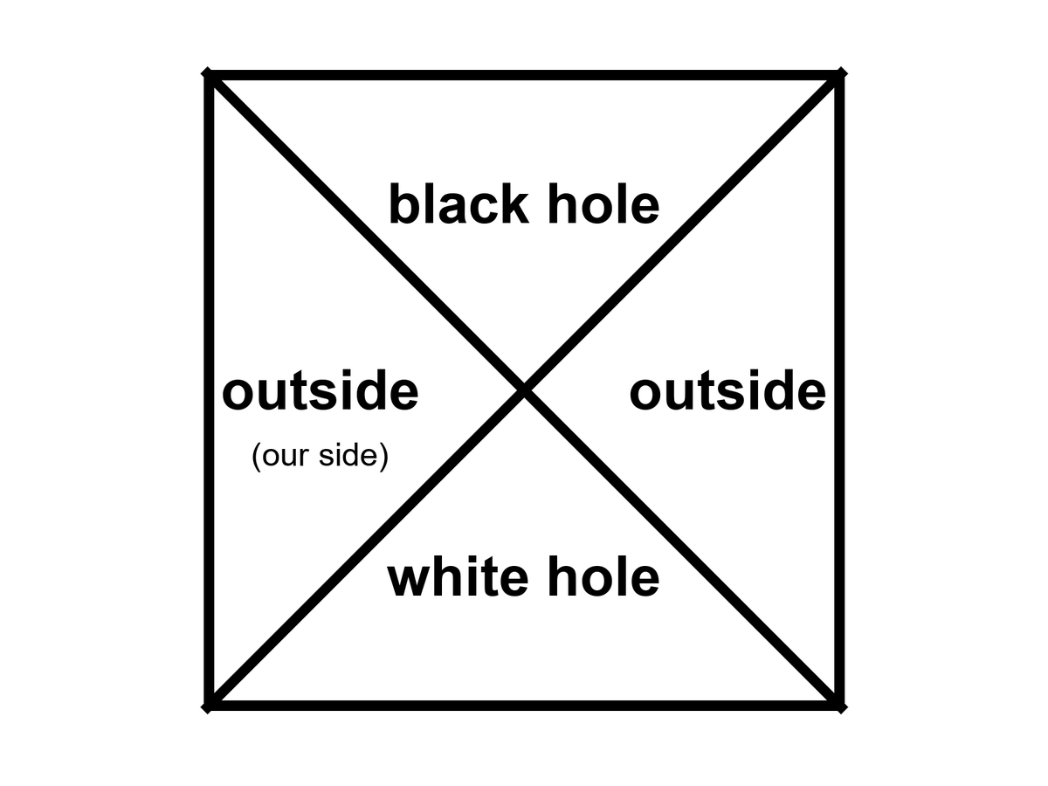
Figure 22. The Kruskal map as four rooms: two outsides, a black hole, a white hole. We live in one of the outsides.
No one has ever seen a white hole. They are allowed as mathematics and unwelcome as astrophysics. They are unstable the way a pencil on its point is unstable. A speck of dust, a photon, a rumor of mass falling toward the past horizon ruins the fountain. Any stuff that tries to enter from the exterior cannot; that is the definition. Any stuff that is already in the white room must leave, and once it has left the fountain is no longer the clean vacuum solution you drew. The universe, as far as we can tell, makes membranes in one direction: collapse, inward, one-way in. It does not spray matter out of ready-made white fountains.
Hot claim: black-hole horizons exist and we have weighed them, pictured their shadows, and heard them ring. Warm claim: the time-reverse solution sits in the same notebook and deserves a diagram. Cold claim: there is a white hole in the sky, or at the beginning of time, waiting to be photographed. There is not, on present evidence. There is a picture we can draw.
People like to say the Big Bang was a white hole. The analogy has a poetic muscle and a scientific limp. A white hole is a local object in a larger spacetime. The bang, as Chapter 7 insisted, was not a bomb in a warehouse. It was everywhere. You would not have stood outside a fountain and watched the universe come out. You would have been inside the soup, and so would every other direction. A hole is a place. The bang was a time — a hotter, smaller-spaced version of everywhere. You can draw pictures in which a bang looks, mathematically, like a time-reverse of a collapse. You can also draw pictures in which it does not. Oppenheimer and Snyder, in 1939, wrote the collapse of a ball of dust and got a black hole. Run that solution backward and you get an explosion out of a white membrane into a pre-existing space. That is not the Friedmann loaf. The Friedmann loaf has no outside, no pre-existing dark, no nozzle. The leftover glow is not a spray from a nozzle. It is a baby picture of a fog that filled the loaf.
Keep the nouns on their leashes. A white hole, if one existed, would have a mass, a location, a sky around it. The bang had a temperature, a leftover helium fraction, a glow in every direction. Those are different courtrooms. Mixing them is how a reader ends up asking what the universe exploded into, and then answering “a white hole,” and then feeling clever. The feeling is not a fossil.
Conformal cyclic cosmology — CCC, a cold idea — tries to glue a remote, empty future to a next bang with a conformal trick. When the universe is old and thin and almost empty of mass, the remaining massless stuff does not care about a scale. Photons, in a world with no massive clocks left, do not know how big the loaf is. Maybe that future can be rewritten as a beginning. Maybe bang follows bang, not by bouncing through a crunch, but by a rescaling that turns a dead, cold loaf into a new hot one. Its advocates have looked for rings in the leftover glow, scars of previous aeons. The claims are disputed. The idea is allowed to sit on the table. It is not a white hole in the sky. It is a maybe about the shape of the whole loaf. Call it cold and let it sit. Barrow would have walked you to the edge of the idea and then refused to sell it as a fossil. The fossils we have — the glow, the helium, the stretch — do not require a fountain and do not require a previous aeon. They require a hot, dense, expanding everywhere. Chapter 7 already held that courtroom. This chapter will not reopen it with a prettier noun.
Carroll’s work on the arrow, which this book already owes, sits here without being hired as a sermon. If the fundamental rules look the same with the tape reversed, the direction we call time is a fact about the loaf’s edges, not about a little arrow painted on each crumb. A white hole is what you get when you take that tape-reversal literally at a horizon. A smashed egg is what you get when you refuse to. Both lessons belong in the same kitchen. The first is a diagram. The second is breakfast.
Appendix A22 writes the four rooms and the pinch. Here, keep the fountain and the drain. If someone offers you a white hole as an exit, or as a birth, ask whether they have a photograph or a diagram. A diagram is allowed. A photograph would change the temperature of the claim. We have photographs of shadows and ripples. We have no photograph of a spray that cannot be entered. Until we do, the hole that runs backward is a teacher, not a destination. It teaches that the equations are more generous than the sky, and that the sky’s stinginess is information. Collapse happens. Uncollapse, as a local fountain, does not appear to. That is a fact about our loaf, and it is already stranger than a two-way pipe.

23. The Skin and the Leak
Jacob Bekenstein asked a rude question in the early 1970s: if you throw an encyclopedia into a black hole, where did the information go? If it vanishes, physics has lost its memory. If it stays, it has to stay somewhere that still counts.
The year was 1972, then 1973, papers that made respectable people itchy.⁴⁷ An encyclopedia is a useful kitchen object. It has a finite number of sentences. You can, in principle, count the bits. Drop it down a well and the well gets a little heavier. The horizon grows by a tiny area. If ordinary thermodynamics still applies — if you are not allowed to hide entropy by throwing it into a hole — then the hole itself must gain at least as much unread-ness as the encyclopedia lost to the outside world. Bekenstein argued that the hole’s entropy — its hidden information, its unread library — scales with the area of the horizon, not the volume inside. Hawking first thought the idea was wrong, and said so with the confidence of a man who had already proved that horizons only grow. Then, in 1974 and 1975, he found that the same calculation that fixed the coefficient also made the hole glow. A glowing hole has a temperature. A temperature and an energy give you an entropy. The coefficient came out four. The entropy is
S = kA / 4ℓ_{P}²
where A is the horizon area, k is Boltzmann’s constant, and ℓ_{P} is the Planck length, a ridiculously small ruler made from G, ħ, and c.
The Planck length is about 1.6 × 10⁻³⁵ meters. A square of that on a side is not a shelf. It is a pixel of the smallest bookkeeping the theory we have can write. One bit per few square Planck lengths on the skin. A solar-mass hole has a horizon area of a few thousand square kilometers and an entropy so large the number looks like a prank: on the order of 10⁷⁷ k, a library that would embarrass every warehouse on Earth and still fit, in the accounting, on a sphere thirty kilometers across. The inside, however deep it seems, does not get extra shelf space. This is the holographic idea in its first, stubborn form: the inventory of a region can be written on its boundary.
Hawking had already shown, classically, that the area of a horizon does not shrink. That area theorem is why he resisted Bekenstein: if area only grows, and if entropy is not area, then throwing the encyclopedia in looks like a way to cheat the second law. Once entropy is area, the theorem becomes a second law for holes. The encyclopedia’s unread sentences are not deleted from the universe’s books. They are charged to a lid that got a little wider. The glow, later, is the hole’s way of paying the bill in reverse — area shrinking, very slowly, as heat leaves. Classically the lid only grows. Quantum mechanically the lid can leak. Both statements can be true in their seasons.
Kitchen version, before the ambition starts. You throw an encyclopedia into a well. You want to know whether the universe still knows the encyclopedia. You do not get to climb in and check the basement. You get to watch the lid. The lid gets a little wider. The unread library, if it is still in the account, is written on the cover, not stacked in a volume you could walk. Count the lid. Do not count a warehouse that no letter can leave. The shock is Barrow’s kind of shock: the biggest object you can name — a billion-Sun hole — still files its secrets on a surface, at a density so fierce the numbers look like jokes until you remember that the jokes are the theory.
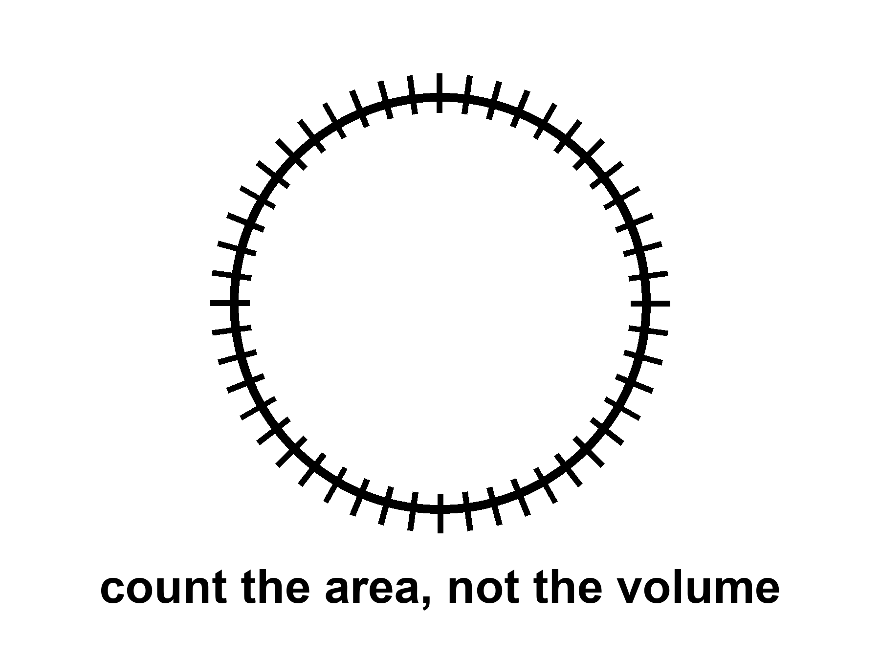
Figure 23. A sphere with hash marks on the skin only. A black hole’s entropy counts area, not volume.
People then got ambitious. Maybe the whole universe is a hologram. Maybe a gravity theory in a volume is secretly a quantum theory on a wall. In one special, negatively curved kind of space, this has been made precise enough to write papers that get jobs. Juan Maldacena’s AdS/CFT duality, from 1997, is the precise form: a gravitational theory in an Anti-de Sitter box, a space that caves in the way a saddle caves, matches a quantum field theory on the wall of the box. Calculations that look like black-hole thermodynamics on the inside look like ordinary quantum bookkeeping on the wall. That is a triumph of a model. That space is not our accelerating, leftover-glow space. We live with a shove, Chapter 18’s shove, that looks like a positive cosmological constant, a de Sitter mood, not an Anti-de Sitter box. A duality that works in a box we do not inhabit is not a photograph of the kitchen. It is a constraint on how ambitious you are allowed to be when you invent hiding places for bits. The leap from “black holes count on their skin” to “your kitchen is a projection” is a leap. Warm-to-cold. Useful as a constraint: you do not get to invent an infinitely roomy crunch-computer (Chapter 19) without saying where the bits sit. Tipler needed a loophole in a bound like this. The bound is not impressed.
Holography does not cancel events. It relocates the bookkeeping. The loaf may be a projection of something thinner. The events you care about — a last beep, a first helium nucleus, a woman saying good morning to a Thursday she will not have — still happen. They may have fewer hiding places than a volume would suggest. That is a change in the furniture of the account. It is not a vanishing. It is not a promise that a lost encyclopedia can be checked out later like a library book. It is a rule about how much unread stuff a region is allowed to hold.
The glow is a slow leak from the membrane.
In the kitchen version: near the horizon, the vacuum’s jitters get sorted. One part of a jitter falls in. The other part escapes. From far away, the hole is radiating, very slightly, as if it had a temperature. The formula, if you want the shape of it, is T_{H} = ħ c³ / (8π G M k): colder when heavier, hotter when lighter, Planck’s constant in the numerator so that a purely classical hole would not glow at all. Hawking’s temperature for a solar-mass hole is about 10⁻⁷ kelvin — ten millionths of a degree above absolute zero, a hundred million times colder than the leftover glow in your kitchen. Small holes are hotter. A hole the mass of a mountain would sizzle. A hole the mass of an asteroid would be a brief, rude oven. A hole the mass of a star is colder than the leftover glow and, today, gains weight from the sky faster than it leaks. Only in the unimaginably far future, after the leftover glow has thinned, would stellar holes begin to lose.
The leftover glow is 2.725 kelvin. A solar-mass hole, at about 60 billionths of a kelvin, is some forty million times colder than that.⁴⁸ The sky, for now, is a heat bath the hole sits in, and the bath wins. This is why “black holes evaporate” is a true sentence about a later season of the loaf and a false poster about Tuesday. Tuesday, the hole in Cygnus X-1 is getting slightly heavier from the microwave fog and from whatever gas it can steal. The leak is real in the derivation. The leak is not winning.
If nothing interrupts, the leak eventually takes all the mass. The evaporation time for a solar-mass hole is about 10⁶⁷ years — a one with sixty-seven zeros, a number that makes the 13.8 billion years of the stretch look like a blink in a blink. Barrow would have put that integer on a blackboard and let it sit until someone laughed. The laugh is allowed. The integer is the theory. The hole shrinks, heats, shrinks faster, and ends in a last, small violence. Whether the encyclopedia comes back in the last violence, or came out slowly in the glow, or is written on a remnant, is the information problem. It is unfinished.
The fight has a shape, even unfinished. Hawking’s first glow looked thermal, which is a polite word for “the radiation does not remember the encyclopedia’s sentences, only the hole’s mass, spin, and charge.” If the hole then vanishes, the sentences have nowhere to live. That is a quarrel with quantum mechanics, which prefers to keep its books unitary: information is shuffled, not shredded. Proposed peace treaties have names. Complementarity says the outside and the inside are two accounts of one book, and you are not allowed both at once. Firewalls say the membrane might be a violent place after all, a contradiction dressed as a heat bath. Islands in the recent math say the entropy of the glow can fall late in the evaporation, as if the sentences had been hiding in the radiation all along and only became countable later. None of these is a photograph. All of them are warmer than a shrug and colder than a settlement. It is not unfinished in a way that lets you use a hole as a filing cabinet for resurrection. A soul is not an encyclopedia. An encyclopedia is not a person. Neither one is stored in a basement you can open later by being patient, or pious, or good at grants.
Hawking radiation has not been seen from an astrophysical hole. It is a derived glow, as firm as a derivation can be without a photograph. Laboratory analogs — sound horizons in fluids, tricks with lasers, a Bose–Einstein condensate with a sonic membrane — have made related noises. Bill Unruh taught the field to listen for a sound that cannot climb out of a moving fluid: if the fluid runs faster than sound, there is a surface sound cannot recross, and the math of that surface is cousin to the math of Chapter 20. Jeff Steinhauer and others have built such membranes in the lab and reported a glow with the right family resemblance. They are encouraging and not the same as weighing a photon from Cygnus X-1. An analog horizon is a teacher. It is not the leak from M87*. You can poke the fluid. You cannot poke M87*. Keep the temperatures straight. The derivation is warm-to-hot. The photograph is missing. The analog is a cousin.
For the travel chapters, the leak is a timekeeper. It says black holes are not eternal furniture. They are long-lived, then gone, on clocks that make civilizations look like sparks. If you want a library to last, do not drop it in. Put it under ice, or in a vault, or in a machine that can wait. The membrane is a fact about events. It is not a basement.

24. Not a Door
The last mistake is the door.
A door has two sides you can use. A horizon has two sides you cannot trade. A kitchen door has two knobs. You go out for the mail. You come back for the casserole. The loaf of the house does not mind. You can stand in the yard and still be in the kitchen’s future, and stand in the kitchen and still be in the yard’s future. That is what two knobs are: two rooms that keep each other in their cones. A one-way membrane is not that door. Fall in and you do not come out “somewhere else” in this universe with a story to tell. There is no second knob. There is no mail. There is a sorting of events, and you have joined the set that cannot write home.
The flattering picture is always the same. The hole is a gate. The gate leads to a tunnel. The tunnel leads to another kitchen, or another century, or another you. The picture borrows its furniture from doors because doors are the one-way-looking objects we actually own, and because we have all, at least once, wanted a room that was not this one. Physics will not rent you that room at a horizon. The membrane does not open. It sorts. If you want a handle between two exteriors, that is a wormhole, and it is Chapter 34’s problem, and it is not this object. If you want a future in this universe with a story to tell, stay outside.
In the classical theory you come to a singularity, a ripped place in the loaf, and the theory stops. The geodesics — the straightest paths the geometry allows, the paths free clocks and free stones follow — do not come out. A geodesic that crosses r_{s} reaches r = 0 in a proper time you can write on a napkin: tens of microseconds for a stellar hole, hours for Sagittarius A*, the better part of a day for a giant like M87*. Those are not transit times to another station. They are the lengths of worldlines that end. They reach, in that finite proper time, a boundary the equations cannot extend through. That is what “singularity” means when it is being honest. It is not a glowing point with a brand name. It is geodesic incompleteness: the paths stop, and the theory that was telling you how they lean has nothing left to say. Appendix A24 writes the line. Here it is enough to refuse the hallway. A path that ends is not a path that arrives in another kitchen.
You can try to be clever. You can fire rockets inside. You can aim “sideways.” Inside a Schwarzschild hole there is no sideways that leads out. The radial direction has become timelike: “out” is as unavailable as “yesterday.” That sentence is the whole joke, dressed as a coordinate fact. The membrane is not a wall you bounced off. It is a date you cannot un-reach. The geodesics do not come out because “out” is no longer a direction in their future cones. Chapter 20’s last beep, heard from the ship, is the outside’s view of a crossing that, inside, is already a one-way season.
The singularity theorems, and Hawking’s cosmological versions, say that if gravity pulls in the ordinary way and energy behaves, collapse and bang-like expansions have boundaries the geodesics cannot extend through. Penrose’s 1965 result is the local one: a trapped surface — a sphere from which light is already being dragged inward, outgoing as well as incoming — plus ordinary energy conditions, and the loaf is incomplete. You do not need to assume a pretty symmetry. You need a trapped surface and a rule that energy is not too exotic, and the paths cannot be extended forever. That is why a collapsing star is not a special cartoon. It is a case of a general sentence. Hawking applied the same muscle to the early universe: if the past is a trapped place in the right sense, the bang, too, is incomplete as a geodesic story. Inflation and dark energy violate some of those energy assumptions, which is why the theorems are not a courtroom for “the universe began” in every model. A burst that repels, a shove that stretches, can dodge a hypothesis the 1960s treated as polite. They are still a courtroom for “you may not treat the inside of a hole as a hallway.” A stellar collapse still makes a trapped surface. Ordinary matter still obeys the energy conditions the theorems asked for. A trapped surface is not a doorframe. It is a proof that the paths do not return.
Hot claim: if you fall into a hole of the kind we have pictured and heard, classical general relativity does not give you an exit in this universe. Warm claim: a quantum theory of gravity will replace the ripped place with something that does not infinite-curve. Cold claim: that something is a door, a bounce you can steer, a baby cosmos with a forwarding address. The warm claim is a research program. The cold claim is a hope wearing a lab coat. This book will not rent the coat.
In speculative theory you might come to a bounce, a baby universe, a tangle of extra dimensions. Those are cold. They are also, even if true, not a transit system. A baby universe you cannot call is not a destination. A bounce that pinches off a new loaf, if such a pinch exists, is a maybe about the interior, not a ticket window. You do not steer it. You do not mail a letter through it. You do not retire there. The new loaf, in the sketches that allow one, is not “somewhere else” on a map you already own. It is a separate region of events, pinched off, causally unavailable to the ship that watched the last beep. Calling that a trip is like calling death a change of address because the nouns still exist in a dictionary.
Extra dimensions offered by string theory come with the standing rule: the framework cannot currently be tested. A hallway drawn in an untestable framework is a drawing. It is not a road. Loop-quantum sketches that replace the ripped place with a bounce are a different drawing, also unphotographed, also not a subway. This book will let the drawings sit. It will not sell tickets. A cold interior is allowed. A transit system is a different claim, and it fails even if the cold interior is true, because availability is the whole of what “destination” means. If you cannot call, you did not arrive. If no one can call you, you are not a station.
Wormholes, in Chapter 34, are a different object: a handle, not a membrane. People blur them because both are “holes” and both are associated with Einstein. Do not blur them. One is common and one-way. The other is unphotographed and probably expensive beyond engineering. A wormhole, if nature or a civilization ever held one open, would be a throat between two exteriors you could, in the optimistic diagrams, enter and leave. You would see two mouths, two skies, two knobs, if the metaphor will sit still that long. It needs exotic stress, a violation of the energy conditions the singularity theorems were using as police — a stuff that antigravitates in the throat so the pinch does not slam. The Kruskal throat of Chapter 22 is not that object. That throat pinches in finite proper time and cannot be traversed. The Morris–Thorne kind of handle is a different drawing, built to stay open, and it pays for the staying with matter no kitchen has ever weighed. It is a maybe about a handle on the block. A black hole is not that handle. A black hole is the membrane we have already pictured and heard. Confusing them is how a shadow in a ring becomes, in a careless paragraph, a subway. This book will not be careless. Chapter 34 can spend its own pages on the handle. This page is the refusal.
A short inventory, so the blur has nowhere to hide. Horizon: a fact about events, one-way, photographed as a shadow, heard as a ringdown. White hole: the time-reverse, undrawn in the sky, unstable. Kruskal throat: a pinch, not a tunnel you can walk. Wormhole: a proposed handle, two-way if it exists, not this chapter, not in the EHT image. Baby universe: a cold pinch-off, not a destination. Singularity: where the geodesics stop, not a station. If a paragraph uses two of those nouns as if they were one noun, the paragraph is a poster. Put it down.
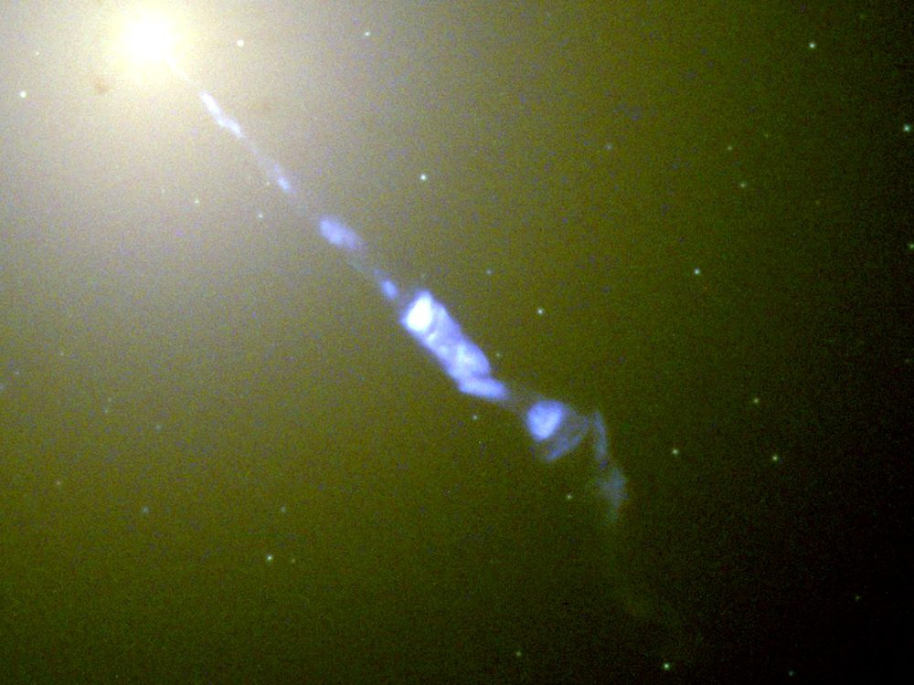
Figure 24. The bright host galaxy M87, with a jet thrown out from its center. A real black hole lives there. It is still not a door.
Look at Figure 24 and practice the sentence. A real hole lives in a real galaxy. Stars orbit. Gas glows. A shadow, if we had the baseline, would sit in the middle the way Figure 20 sits in M87. None of that is a door. The host is not a terminal. The dark is not an arrival hall. The honest nouns are still the ones Chapter 20 paid for: a fact about events, a last beep, a leak so slow it makes civilizations look like sparks.
So: no transit. No filing cabinet for souls. No steered crunch. No baby-universe bus. A shadow in a ring, a slow leak, a one-way fact about events. That is the honest hole. It is enough. It is already stranger than a door.
The part that began with Schwarzschild’s letter from the front ends here, on a galaxy that does not owe us an exit. The next part will try to go somewhere anyway — a greenhouse, a delay, a launch window — without once treating a membrane as a knob. If you wanted the hole to be a door, you wanted a different loaf. This one sorts events and does not give them back. Take the casserole out when your clock says so. Leave the well alone.
Continued in Book 2, Getting There Anyway. Part VI picks up exactly here: a greenhouse on a dead world, a delay, a launch window, and a crew that can wait. Parts VI to X follow it out to loops, copies, the filter, and the honest ending.

APPENDIX — The Scientific Detail

How to Read These Notes
Each note An twins popular chapter n. Units are SI unless stated. c is the speed of light, G Newton’s constant, ħ the reduced Planck constant, k Boltzmann’s constant. A scale factor a(t) is dimensionless; today a₀ = 1. Cosmological redshift z obeys 1 + z = 1/a for light emitted at a. A gravitational redshift, as in Pound–Rebka, is a different relation.
String theory, whenever it appears: a mathematical framework that cannot currently be tested. It has not produced a unique, risky prediction that would kill the whole idea if the experiment came out otherwise.
These notes are denser than the chapters they twin. They are still this book: short sentences, named measurements, temperatures on the claim. They are not a textbook. If a formula is numbered (1)–(17), the number is a handle, not a homework set. Row (18) is a standing rule, not a formula.

A0. Three Temperatures of Claim
Hot: repeated measurement, used to predict new ones. Warm: best model, real gaps. Cold: allowed by the equations, not selected by the data. A claim can change temperature. The oven is the sky, not the seminar.
Inflation is the cleanest change-of-temperature in this book. In 1981 Guth’s paper was a proposal: a brief early burst of repulsive stretch that could solve the horizon, flatness, and monopole problems the hot bang, taken alone, cannot. The first (“old”) inflation stalled on how to end the burst without emptying the universe of matter. In 1982 Albrecht–Steinhardt and Linde supplied slow-roll exits. That was still a model. What warmed the local burst was later data: a sky that is spatially flat to a percent; a primordial spectrum with n_{s} a few percent below 1 (A14); acoustic peaks in the leftover glow that match a nearly scale-invariant twitch stretched outside the Hubble radius and then brought back. Those are not proofs that a particular inflaton exists in a detector. They are reasons the local burst is no longer a 1981 maybe.
A claim can also cool. In March 2014 BICEP2 announced B-mode polarization at degree scales and offered a tensor-to-scalar ratio r ~ 0.2. Primordial gravitational waves from a high-scale burst would have been a trophy. Within a year Planck’s dust maps and the joint BICEP/Keck–Planck analyses showed that Galactic dust, not a primordial tensor background, carried the signal. The measurement was real. The interpretation was not. Current combinations (BICEP/Keck plus Planck) put r ≲ 0.03–0.04 at 95% confidence, depending on the data cut. High-scale inflation of the 2014 headline is colder than it was on announcement day. The local burst is still warm. Eternal inflation — self-reproducing pocket nucleations, a measure problem, no unique risky number — did not inherit the warming. It stays allowed and unselected.
Temperature is a discipline, not a mood. “We have a picture of a black-hole shadow” is hot. “The interior is a bounce into a baby universe” is cold. String landscapes, when named, inherit the standing rule (18). Use the labels in that spirit for the rest of these notes.

A1. Relativity of Simultaneity
Einstein synchronization: a clock at spatial coordinate x is set by a light signal from a master clock, assuming the one-way speed is c. That assumption is a convention that special relativity makes consistent. Observers with relative velocity v along x then disagree on which events with Δx ≠ 0 are simultaneous. The desynchronization is, to first order in v/c,
Δt = v Δx / c².
This is not a signal. Nothing travels from here to Andromeda in the instant you take a step. It is a fact about how two inertial frames slice the same loaf.
Worked numbers, Andromeda at Δx/c ≈ 2.5 × 10⁶ yr. Walking, v ≈ 1.4 m/s, so v/c ≈ 4.7 × 10⁻⁹. Then Δt ≈ 4.7 × 10⁻⁹ × 2.5 × 10⁶ yr ≈ 0.012 yr ≈ 4 days. The kitchen walker and the kitchen stander do not share a “now” on Andromeda to better than a long weekend. An airliner, v ≈ 250 m/s, tilts the same slice by ~2 yr. Earth’s orbital speed, v ≈ 30 km/s, tilts it by ~250 yr. None of those numbers is a photograph of Andromeda’s navy. Light from M31 is 2.5 million years late for everyone in the kitchen. The disagreement is about which events on that galaxy you label simultaneous with the casserole, not about which photons you receive.
At laboratory distances the same formula is tiny. Across a 10 m kitchen at walking speed, Δt ~ 5 × 10⁻¹⁷ s — below any clock you own. Relativity of simultaneity is therefore easy to miss and easy to oversell. The one-way speed used to set the clocks is the convention. Once both kitchens have adopted it, the disagreement about which distant events share a slice is not a convention. It is what the Lorentz transformation does to those clocks. Chapter 1’s lamps are that second fact. Calling the whole disagreement “only a convention” is the reading Chapter 1 refused. The disagreement becomes a plot point only when Δx is huge or v is not small. Chapter 1’s kitchen is the first case.

A2. Minkowski Coordinates and the Interval
An event is a point in a 4-manifold. In inertial coordinates the interval is
(1) ds² = −c² dt² + dx² + dy² + dz²
(signature convention −+++).
ds² < 0 timelike, = 0 lightlike, > 0 spacelike. ds² is invariant: every inertial observer computes the same number. The split into dt and dℓ is not. That is the entire content of “the loaf has a geometry; the slices are ours.”
Signature is a convention. Particle physicists often write +−−−, so the inequality for “timelike” flips. The physics does not. This book keeps −+++ so that spatial distances look like school geometry and proper time satisfies c² dτ² = −ds² along a worldline.
A number. Two sparks in a lab: Δt = 5.00 μs, Δx = 1.00 km, Δy = Δz = 0. Light would need 3.34 μs to cover that kilometer, so the pair is timelike. Equation (1) gives ds² / c² = −(5.00 × 10⁻⁶)² + (10³ / c)² ≈ −1.38 × 10⁻¹¹ s². The proper time between them, for the inertial traveler who visits both, is Δτ = √(−ds²)/c ≈ 3.72 μs. A different inertial frame can assign 6 μs and a shorter Δx; it cannot change Δτ. Swap the numbers to Δt = 2.00 μs and the same kilometer and ds² > 0: spacelike. No traveler visits both. Different frames can disagree on order.
Null intervals are the paths of light in vacuum. They are the boundary of A3’s cones. If you take nothing else from this note, take invariance: the interval is the thing the universe keeps. Your clock and your ruler are how you spend it.

A3. Light Cones and Lookback Time
(2) ds² = 0 ⇒ dℓ = c dt
The past light cone of an event p is the set of events that can signal to p. The future cone is the set p can signal to. Everything else is elsewhere: real, and unavailable as a cause or an effect of p. Equation (2) is the generators of those cones in inertial coordinates. In a curved, expanding cosmology the same idea survives: null geodesics still bound causal contact; the scale factor a(t) changes how far a null ray gets.
Lookback time to redshift z is the integral of dt = da / (a H(a)) from a = 1/(1+z) to a = 1. It is not “distance over c” except as a slogan. In a matter-plus-Λ fit with H₀ ≈ 67–73 km s⁻¹ Mpc⁻¹, light emitted at z = 1 has been traveling ~7.8 Gyr; at z = 2, ~10.5 Gyr; at last scattering z* ≈ 1090, the travel time is the age of the universe minus ~3.8 × 10⁵ yr. The leftover glow is a baby picture with the baby long gone. The Sun in your sky is eight minutes old; Jupiter tonight is ~30–50 min old depending on opposition; M31 is 2.5 Myr old in photons.
The night sky is the past cone, sampled. Astronomy is the only time travel we have: we receive news that already lies to our past. You cannot answer the news. You can wait for later news from a later event on the same worldline. Chapter 3’s lateness is geometry, not an instrument limit.

A4. Tilting the Simultaneity Slice
(3) t′ = γ (t − v x / c²)
where γ = 1 / √(1 − v²/c²).
A plane t′ = const is tilted in (t, x). The slope is v/c². At kitchen v the tilt is invisible on kitchen x and enormous on megaparsec x (A1). The Andromeda paradox is this tilt: two people who meet in a kitchen, one walking, assign different “present” events to a galaxy 2.5 million light-years away. They do not assign different photons in the eyepiece.
Reality-transfer arguments (Rietdijk 1966; Putnam 1967) take the tilt as a metaphysical conveyor: if event A is present-for-me and event B is present-for-you-when-you-share-A, then B is already real-for-me. The chain is then run around the loaf until every event is “already real.” The Lorentz transformation in (3) is not on trial. The extra premise is: “present ⇒ real,” plus transitivity of that privilege across observers who do not share a global plane. This book rejects the privilege of the plane. The manifold plus metric is the inventory. A slice is a bookkeeping surface. Calling the slice “the now” does not promote it to a moving spotlight.
At v not small, γ matters. Equation (3) is the exact boost, not the first-order slogan. For GPS satellites (v ≈ 3.9 km/s, γ − 1 ≈ 8.5 × 10⁻¹¹) the vx/c² term is a daily desynchronization you must correct or the navigation solution drifts by kilometers (A5). For a 0.1 c cruise, γ ≈ 1.005; for 0.9 c, γ ≈ 2.3. The twin effect (A5) is the integral of proper time along two different worldlines that meet twice. The Andromeda tilt is what those worldlines do to distant labels between the meetings.

A5. Proper Time and the Twin Effect
Proper time along a timelike worldline: c² dτ² = −ds². Between two meetings, the inertial path maximizes τ. That is the twin “paradox”: the accelerated twin has the smaller elapsed proper time. There is no paradox in the geometry. The worldlines are different lengths. The traveling twin is not inertial for the whole trip; the stay-at-home twin is (idealized). They meet twice and compare wristwatches. The comparison is a scalar. Everyone agrees.
Hafele–Keating (October 1971; Science 1972) flew commercial airliners around the world with cesium clocks and compared them to a ground set. Eastbound, Earth-rotation velocity adds to the jet; westbound it subtracts. Predicted: eastbound −40 ± 23 ns, westbound +275 ± 21 ns (special-relativistic plus gravitational pieces together). Measured: −59 ± 10 ns and +273 ± 7 ns. The signs and the hundreds of nanoseconds are the result. A classroom “clocks are metaphysical” speech does not survive that table.
Muons. Mean proper lifetime τ₀ ≈ 2.20 μs. Atmospheric muons are born ~10–20 km up at v so close to c that γ is typically ~10–20. Without dilation they would decay in a few hundred meters of flight; they reach the basement. Storage-ring measurements (CERN muon storage ring; later g−2 rings) hold γ ≈ 29.3 and find the lab lifetime γ τ₀ to parts in a thousand. That is the twin effect with a particle that does not file a flight plan.
GPS. Orbit v ≈ 3.9 km/s gives a special-relativistic slowing ~7 μs/day. The weaker gravitational potential at altitude gives a general-relativistic speeding ~46 μs/day. Net: the satellite clock runs ~38–39 μs/day fast versus a geoid clock if you do not correct. Light travels 11 km in 38 μs. Uncorrected, the navigation solution is junk in hours. Both corrections are tens of microseconds per day and opposite in sign, as the chapter said. The system is an industrial twin-plus-well clock.

A6. Causal Structure: Past, Future, Elsewhere
At an event p, I⁻(p) is the chronological past (events that can reach p on a future-timelike curve), I⁺(p) the chronological future, and the remainder of the manifold, minus the light-cone boundary, is spacelike-separated “elsewhere.” Causal past and future J±(p) include the null generators. These are the verbs the loaf actually has. “Now” is not among them.
A Cauchy surface is a spacelike 3-surface that intersects every inextendible causal curve exactly once. Data on a Cauchy surface determine the solution in the domain of dependence. Presentism, as a physics claim rather than a mood, wants a preferred Cauchy surface that is “the present,” advancing. General relativity does not supply a preferred one. Different foliations are different bookkeeping. In Minkowski space every inertial t = const is a Cauchy surface; none is privileged by the metric. In generic GR, global hyperbolicity may fail (Cauchy horizons; A36 (in Book 2)). Where it holds, you still have a stack of surfaces, not a glowing edge.
The block — the 4-manifold plus metric as the inventory — is the default reading once you accept (1) and the Einstein equation as the dynamics of that metric. It is not a proof that “the future is already filmed” in a fatalist sense. It is a refusal to add a moving spotlight the equations do not contain. Local becoming, if you want the word, is along a worldline: proper time (A5). It is not a cosmic weather front.

A7. FLRW: No Center, No Edge
The Friedmann–Lemaître–Robertson–Walker metric assumes homogeneity and isotropy on spatial slices: the same density and the same expansion rate at every comoving point, no preferred direction. In coordinates comoving with the cosmic fluid,
ds² = −c² dt² + a(t)² [dχ² + f_{K}(χ)² dΩ²],
where K = +1, 0, −1 labels spatial slices that are S³, E³, or H³ (closed, flat, open), and f_{K} is sin χ, χ, or sinh χ. There is no privileged center on those slices any more than there is a center of the Earth’s surface. Every galaxy can think of itself as at rest in the Hubble flow. “Expansion into what?” is a category error: a(t) rescales proper distances between comoving observers on the slices. The manifold is not required to sit in a higher-dimensional room with a spare radial direction labeled “outside.”
Observationally, the leftover glow is isotropic to ~10⁻⁵ after the dipole is removed (A9). Galaxy surveys (2dF, SDSS, DESI) find homogeneity on scales ≳ 100–300 Mpc, with the usual argument about whether a given catalog is large enough. Spatial curvature Ω_{k} is consistent with 0 at the percent level or better in Planck-like fits (A11). Flat and infinite is allowed. Flat and finite (a 3-torus) is allowed and not selected. Closed with a large radius is allowed. None of those options puts you at the middle of a bomb.
The “bang” is a hot, dense state of the slices in the past, not a point in a pre-existing box. At a → 0 the classical description fails (A45 (in Book 2)). That failure is not a location you can visit.

A8. Hubble–Lemaître Law and Redshift
(4) v = H₀ d (low z); 1 + z = 1/a_{emit}
H₀ is ȧ/a today. Equation (4)’s velocity form is a local linearization: recession v ≈ H₀ d for z ≪ 1, where d is proper distance now and v is not a rocket velocity through a box. The exact observable is redshift. Photons stretch with the slice: a feature emitted at wavelength λ_{em} when the scale factor was a_{emit} arrives at λ_{obs} = λ_{em} / a_{emit}, hence 1 + z = 1/a_{emit}. At z = 1 the universe was half its present scale. At z = 9 it was a tenth. At z* ≈ 1090 it was about a thousandth. Do not confuse z with lookback time; A3’s integral is the conversion, and it depends on the whole H(z) (A18).
Measured H₀ still tensions (status as of October 2026). Planck-like early-universe fits (CMB acoustic scale plus the working ΛCDM inventory) give H₀ ≈ 67.4 ± 0.5 km s⁻¹ Mpc⁻¹; DESI DR2 BAO with a BBN prior gives 68.5 ± 0.6. Late-universe distance ladders (Cepheids to Type Ia; SH0ES) give H₀ ≈ 73 ± 1, and the 2026 Local Distance Network combination gives 73.5 ± 0.8; the CCHP tip-of-the-red-giant-branch ladder gives 70.4 with wider errors (sources in the Notes, Chapter 8). The gap is several times the quoted errors and has persisted through independent rungs and through Gaia parallaxes. That is a real problem for the working model, not a reason to deny expansion. Tip-of-the-red-giant-branch ladders and some strong-lens time delays sit in between or on one side or the other; they have not closed the case. This book treats H₀ as measured twice, in tension, both measurements hot as measurements, the reconciliation warm-to-open.
Hubble’s original 1929 slope was ~500 km s⁻¹ Mpc⁻¹ and a universe too young for the rocks. The law was right; the calibration was not. The present tension is not that story again until someone shows which calibration, or which early-universe assumption, is the 1929 error. The law is not a center. It is a(t) made local.

A9. The CMB as a Blackbody
FIRAS on COBE (Mather et al.; Fixsen 2009 compilation) measured the sky-averaged spectrum as a blackbody at
T₀ = 2.72548 ± 0.00057 K.
Residuals from a Planck function are at the level of tens of parts per million. That is the most precise blackbody in nature we have ever taken apart. A blackbody needs a thermal history: the photons were in equilibrium with a charged plasma, then decoupled, then free-streamed while T ∝ 1/a (8). A “tired light” or “stars in a fog” story does not produce this spectrum plus the acoustic-peak pattern.
The dipole, ΔT ≈ 3.4 mK, is our motion relative to the rest frame of the glow: v ≈ 370 km/s toward Leo (more carefully, toward galactic coordinates near l ≈ 264°, b ≈ 48°). Subtract that and the intrinsic anisotropies are ΔT/T ~ 10⁻⁵ — tens to hundreds of microkelvin. Those are the seeds of A14, printed on the last-scattering surface.
Last scattering: hydrogen recombination drops the free-electron fraction and the Thomson optical depth τ falls through 1. Planck-like fits put the peak of the visibility function at z* ≈ 1090 (1089.80 ± 0.23 in the 2018 TT,TE,EE+lowE+lensing chain; the chapter’s 1090 is the right digit). The temperature then was T* = T₀ (1 + z*) ≈ 2970 K, which this book rounds to 3000 K. Age at last scattering: ≈ 380,000 yr. Helium recombination is earlier and less visible. Reionization at z ~ 6–9 puts a small extra τ on the large-scale polarization; it is not a second fireball.
Hot: the spectrum, the dipole as motion, the 10⁻⁵ map, last scattering at z ~ 10³. Warm: the detailed recombination code and the optical-depth tail. Cold: a craftsman who painted the blackbody (A35 (in Book 2)).

A10. Thermal History, Minute by Minute
(8) T ∝ 1/a (photon temperature after e⁺e⁻ annihilation)
Equation (8) is the leftover glow’s thermometer once electron–positron annihilation has dumped its entropy into the photons (a factor ~ (11/4)^{1/3} relative to the neutrinos). Before that, T still tracks 1/a up to g* changes when species drop out of the bath. A radiation-dominated clock reads t ~ 1 / T² in natural units: hotter is younger.
A prose timeline, not a wallpaper. t ~ 10⁻⁴³ s, T at the Planck energy ~10³² K: not a measurement; the classical metric is not to be trusted. A local inflationary burst, if it happened, ends somewhere around t ~ 10⁻³⁶–10⁻³² s in textbook sketches; T_{rh} after reheating is model-dependent (A13) and only required to sit above BBN. At t ~ 10⁻⁶ s, T ~ 10¹³ K ~ 1 GeV, the quark–gluon plasma hadronizes — inferred from heavy-ion experiments plus the cosmic expansion, not from a cosmic photograph. At t ~ 0.01 s, T ~ 10¹¹ K ~ 10 MeV: the chapter’s first rough mark; weak interactions still keep neutrinos and the n/p ratio in step. Neutrino decoupling: t ~ 1 s, T ~ 1 MeV. Electron–positron annihilation follows as T falls through ~0.5 MeV, reheating the photons relative to the already-decoupled neutrinos. Big-Bang nucleosynthesis: t ~ 1–3 min, T ~ 0.1–1 MeV (below). Recess. Then a long wait. Recombination and last scattering: t ~ 3.8 × 10⁵ yr, T ~ 3000 K, z* ≈ 1090 (A9). The glow has been free-streaming since. Reionization by the first stars and nuclei: z ~ 6–9, a few hundred million years. Today: T₀ = 2.725 K, t₀ ≈ 13.8 Gyr.
Those marks are the working thermal history. They are not a filmed minute log. The ones with spectral or abundance teeth (BBN; the CMB) are hotter than the ones that are interpolation plus accelerator physics.
Big-Bang Nucleosynthesis
Neutron-to-proton freeze-out n/p ≈ 1/6 when the weak rates fall behind the expansion at T ~ 0.8 MeV, then free decay (τ_{n} ≈ 880 s) toward ~1/7 by the time the deuterium bottleneck opens.
(9) Y_{p} ≈ 2 (n/p) / (1 + n/p) ≈ 0.25
(10) Deuterium bottleneck: D photodissociates until T ≲ 0.1 MeV.
Almost every neutron that survives is cooked into ⁴He. Equation (9) is why the helium mass fraction is a quarter and not a cosmic accident. Equation (10) is why the cooking waits three minutes: the bath is still full of gamma rays that break deuterium until T is low enough that η × exp(−B_{D} / T) drops, with baryon-to-photon ratio η ≈ 6 × 10⁻¹⁰ from the CMB.
Observed Y_{p} ≈ 0.24–0.25 (H II regions; primordial intercept). Deuterium, the most fragile useful thermometer, sits at D/H ≈ 2.5 × 10⁻⁵ in high-z quasar absorbers, matching CMB ω_{b} at the ~10% level or better. ³He is messier (stars both make and destroy it). Lithium-7 remains in tension: Spite-plateau Population II stars show A(Li) a factor ~2–3 below the CMB-plus-BBN prediction. That is a real gap — stellar depletion, new physics, or both — not a reason to throw out Y_{p} and D/H. No detector has photographed the third minute. The abundances plus the expansion plus the weak rates are the courtroom.

A11. Critical Density and the Cosmic Inventory
(5) ρ_{c} = 3 H₀² / (8π G)
Ω_{i} = ρ_{i} / ρ_{c}. For H₀ = 67.4 km s⁻¹ Mpc⁻¹, ρ_{c} ≈ 8.5 × 10⁻²⁷ kg m⁻³ — a few hydrogen atoms per cubic meter if it were all hydrogen, which it is not. For H₀ = 73 the critical density is ~17% higher; Ω values quoted from the CMB are usually reported in combinations like Ω_{i} h² that do not care which H₀ you prefer until you convert.
Planck-like inventory (round numbers this book uses): Ω_{b} ≈ 0.05, Ω_{c} ≈ 0.27, Ω_{Λ} ≈ 0.68, Ω_{k} ≈ 0, photons Ω_γ ~ 5 × 10⁻⁵, neutrinos a comparable few × 10⁻⁵ if masses are small. Mean baryon number density n_{b} ~ 0.2 m⁻³ (one proton in a box a bit more than a meter on a side). Stars and the gas you can photograph are a fraction of Ω_{b}; most baryons are in the warm–hot intergalactic medium and other faint phases. Dark matter Ω_{c} is the extra pull (A17). Dark energy Ω_{Λ} is the shove (A18). They do not trade costumes.
Spatial curvature: |Ω_{k}| ≲ 0.01 in standard fits, tighter if you assume the working model. That is “flat for practical purposes,” not a proof the 3-space is infinite (A39 (in Book 2)). Critical density is the density that would make a matter-only universe spatially flat. With Λ, the Friedmann equation still uses (5) as the unit; the geometry is Ω_{k} = 1 − Σ Ω_{i}.

A12. Horizon, Flatness, and Relic Problems
Particle horizon in a radiation-dominated era grows as ~ ct, more carefully χ_{p} ~ 2ct / a in comoving coordinates for a ∝ t^{1/2}. Opposite patches on the last-scattering surface, separated by ~1° or more on the sky today, had not been in causal contact in a pure hot-bang history. Yet the leftover glow agrees in temperature to ~10⁻⁵. That is the horizon problem: a thermal agreement without a prior chance to thermalize.
Flatness: |Ω − 1| ∝ 1/(a² H²). In decelerating eras (radiation, matter) this quantity grows toward the past, so Ω ≈ 1 today to a percent requires |Ω − 1| ≲ 10⁻¹⁶ at BBN and ~10⁻⁶⁰ near the Planck scale if you run the clock that far. That is a tuning if the bang is just a bang. It is automatic if a prior burst drives aH up exponentially and parks Ω near 1.
GUT-scale monopoles, if produced at a phase transition with T ~ 10¹⁶ GeV, freeze out with n_{M} / s large enough to overclose the universe by many orders unless they are never produced after a burst or are diluted by ≳ 10²⁵ in entropy. Other relics (domain walls, some moduli) tell similar stories. Inflation’s original sale was these three puzzles. The sale does not identify the inflaton (A13). It explains why a local burst was proposed, and why a burst that lasts N ~ 50–60 e-folds (11) is the size of the proposal.

A13. Slow-Roll and E-Folds
(11) N = ∫ H dt ≈ 50–60 needed to solve A12.
An e-fold is a factor e in a. Fifty e-folds is a stretch of e⁵⁰ ~ 5 × 10²¹; sixty is ~10²⁶. That is the dilution that flattens, homogenizes, and hides relics. Exact N depends on the reheating temperature and the scales you care about; 50–60 is the working window, not a sacred integer.
Slow-roll parameters ε = −Ḣ/H², η = ε̇/(Hε) ≪ 1 (or the potential versions ε_{V} = (M_{Pl}²/2)(V′/V)², η_{V} = M_{Pl}² V″/V). While they stay small the burst continues; when ε reaches 1, inflation ends. Reheating converts vacuum-like energy (w ≈ −1) into a radiation bath. T_{rh} can sit anywhere from a few MeV (below that, BBN is wrecked) up toward GUT scales in optimistic models. No inflaton has been identified in a detector. No laboratory field has been shown to be the one.
What warmed the idea is A14’s spectrum plus A9’s flatness, not a named particle. High-scale models that predicted r large enough for BICEP2’s first claim cooled when the dust was subtracted (A0). Starobinsky-like R² and a range of plateau potentials remain compatible with n_{s} ≈ 0.96–0.97 and r below present bounds. The Lyth bound roughly says r ~ 0.01 already implies a super-Planckian field range; that is a theoretical discomfort, not a kill-shot. Compatibility is not a detection. String theory sometimes offers inflatons as a catalog. The catalog cannot currently be tested.

A14. The Primordial Spectrum
(12) P_{R}(k) ∝ k^{n}_{s} ⁻ ¹
(13) n_{s} ≈ 0.965 (Planck 2018 central value; the error bar, not a second answer, is what later combinations move)
Amplitude A_{s} ≈ 2.1 × 10⁻⁹ at the pivot k = 0.05 Mpc⁻¹. A scale-invariant Harrison–Zeldovich spectrum is n_{s} = 1. The measured tilt a few percent below 1 is a slow-roll success: n_{s} − 1 ≈ −2ε − η (sign conventions as usual). Planck 2018: n_{s} = 0.9649 ± 0.0042 in the baseline combination; later ACT/SPT/Planck combinations move the digit inside 0.96–0.97. Tensor-to-scalar ratio r = P_{T} / P_{R} is bounded: r ≲ 0.036 (95%) from BICEP/Keck 2018 plus Planck, with the exact ceiling depending on the likelihood. That kills the 2014 r ~ 0.2 headline. It does not kill a local burst.
The Mukhanov–Sasaki variable v = z ℛ quantizes the curvature twitch ℛ on a rigid expanding background. Modes freeze when they exit the Hubble radius (k = aH) and re-enter later as density seeds δρ/ρ ~ 10⁻⁵ — the same order as ΔT/T on the leftover glow. Acoustic peaks in the CMB and the baryon acoustic feature in galaxy surveys (A18) are that twitch, oscillated and projected. Non-Gaussianity f_{NL} is consistent with 0 at the level slow-roll predicts (f_{NL} ~ n_{s} − 1). A large local f_{NL} would have been a different, colder story.
Hot: A_{s}, n_{s} < 1, acoustic physics. Warm: a slow-roll burst as the source. Cold: a named inflaton, a detected tensor background.

A15. Eternal Inflation and the Measure Problem
If the quantum kick δφ ~ H/2π per Hubble time exceeds the classical roll down the potential, inflation self-reproduces: volume that is still inflating grows faster than volume that has exited. Pocket nucleations in a false-vacuum sea (Coleman–De Luccia) are a related picture with bubbles instead of a slowly rolling field. Both produce a multiverse of the Level II kind (A38 (in Book 2)). Neither is a detection.
The measure problem is that “most” is not defined. Volume-weighted measures favor pockets that inflate longest. Pocket-weighted measures count nucleations. Observer-weighted measures try to condition on galaxies or on Boltzmann brains. They disagree, sometimes by infinite factors. Anthropic cuts on Λ (A42 (in Book 2)) inherit this fog: Weinberg’s upper bound is a real inequality; turning it into a probability needs a measure you do not have.
Borde–Guth–Vilenkin (BGV): if the average Hubble rate along a past-directed geodesic is positive, that geodesic is past-incomplete. Eternal inflation, on this theorem, is not a past-eternal block. It does not prove a kitchen-time “before.” It proves that the inflating congruence cannot be extended indefinitely into the past as a regular, expanding spacetime. What replaces the incompleteness is A45 (in Book 2)’s problem, not a filmed first tick.
Temperature: local burst, warm (A13–A14). Eternal froth and a predictive measure, cold-to-warm at best. A landscape of string vacua as the menu, untestable by (18).

A16. Sensitivity: From Quantum Noise to BKL Chaos
Inflationary δφ is chaotic in the colloquial sense: a 10⁻⁵ twitch, stretched across the sky, becomes the difference between a void and a cluster. It is not always chaotic in the formal attractor sense. Slow-roll backgrounds are often attractors in field space; the noise on top of them is what gets amplified into δρ/ρ. Do not sell “chaos” as a single noun for both.
BKL (Belinski–Khalatnikov–Lifshitz): generic spacelike singularities in classical GR show Mixmaster behavior — chaotic Bianchi IX oscillations, a sequence of Kasner epochs with exponents that bounce in a deterministic but exponentially sensitive map. Nearby spatial points lose correlation as t → 0 (or toward a crunch). That is a theorem-level expectation of the classical theory, not a photograph of the bang.
A steered crunch — the Omega Point demand that intelligence control the geometry all the way to a single c-boundary point — requires control of that chaos. Barrow-type results make the demand measure-zero unless extra structure is imposed: you would need to fine-tune the approach on successively smaller scales without a horizon-free handle (A23, A43 (in Book 2)). Lyapunov exponents of the Mixmaster map are positive; each Kasner epoch shrinks the set of successful steerings. Sensitivity is an engine for structure in the expanding era. It is a veto on a required final mind in a recollapse.

A17. What “Non-Baryonic” Means
Baryons: protons and neutrons (plus electrons when the popular chapters say “ordinary matter”). CMB acoustic peaks plus BBN fix Ω_{b} ≈ 0.05 (ω_{b} = Ω_{b} h² ≈ 0.0224). Dynamical masses (clusters; large-scale flows), weak lensing, and the CMB peak positions give Ω_{m} ≈ 0.3. The difference Ω_{c} ≈ 0.26–0.27 does not couple electromagnetically at the level that would have shown up as extra light, extra damping, or extra BBN catalysts. Collisionless cold dark matter (CDM) is the working fluid: it clumps, it does not shine, it does not collide with itself or with baryons at rates that would erase A17’s offsets. WIMP, axion, sterile neutrino, primordial black hole (in a narrow mass window) are candidate nouns, not detections.
Rotation curves: v² ≈ G M(<r)/r in a disk. Flat v(r) at tens to hundreds of km/s implies M ∝ r well outside the starlight. That is the original “missing mass” in spirals (Rubin; Bosma). It is not, by itself, a proof of a new particle — MOND still has friends here — but it is the everyday face of the extra pull.
Weak and strong lensing map surface density Σ. The Bullet Cluster, 1E 0657−56 at z ≈ 0.3 (Clowe, Markevitch, et al., 2006), is a merger in which the X-ray gas (Chandra) lagged the collisionless mass reconstructed from weak lensing. The offset is the point: collisional baryons were stripped; the majority of the gravitating mass was not. Modified-gravity stories that tie the extra pull strictly to the visible gas have to work around that photograph. They have not done so in a way this book treats as competitive.
CMB acoustic peaks: the odd/even peak-height ratio is sensitive to Ω_{b}; the spacing and the third-peak height help fix Ω_{m} h² and the late-time inventory. That is why the leftover glow, not only the Bullet, is a dark-matter courtroom.
Direct detection: LZ, XENON1T/nT, PandaX, and predecessors have not found a WIMP. Spin-independent cross-section limits sit near 10⁻⁴⁷–10⁻⁴⁸ cm² at ~30–40 GeV/c², with neutrino fog approaching. Axion haloscopes (ADMX and cousins) have closed slices of g_{aγγ}–m_{a} space, not the whole QCD-axion band. Nulls are data. They are not a proof CDM is a mistake. They are a proof the first popular noun was not sitting on the first shelf.

A18. Vacuum Energy and the Cosmological Constant
(6) ρ_{Λ} = Λ c² / (8π G) (constant)
Naive QFT zero-point ~ M⁴ with M at the Planck scale (~10¹⁹ GeV) overshoots ρ_{Λ},obs by ~120 orders of magnitude; even a TeV cutoff overshoots by ~60. Observed ρ_{Λ} ~ (2.3 × 10⁻³ eV)⁴, or about 6 × 10⁻²⁷ kg m⁻³ — the same order as ρ_{c} today, which is the coincidence problem. Weinberg 1987: if ρ_{Λ} is too large and positive, galaxies do not form before the shove wins; that anthropic upper bound sits within one or two decades of the measured value. A bound is not a derivation. It becomes an explanation only if an ensemble of vacua exists and a measure can be defined (A15, A42 (in Book 2)). String landscapes offered as that ensemble inherit (18).
Supernovae, BAO, and H(z)
(7) H²(z)/H₀² = Ω_{m} (1+z)³ + Ω_{r} (1+z)⁴ + Ω_{Λ} + Ω_{k} (1+z)²
(for w = −1). Type Ia supernovae as standardizable candles (Riess et al. 1998; Perlmutter et al. 1999; Schmidt’s team sharing the 2011 Nobel) showed that luminosity distance at z ~ 0.5–1 is too large for a matter-only decelerating universe. The leftover glow and a baryon acoustic oscillation standard ruler together prefer the same fit. BAO: the sound horizon at the drag epoch is r_{d} ≈ 147 Mpc comoving in Planck-like physics; galaxy and Lyman-α surveys (SDSS, BOSS, eBOSS, DESI) recover a feature at ~150 Mpc comoving. That is a meter stick, not a metaphor.
Equation (7) with Ω_{m} ≈ 0.3, Ω_{Λ} ≈ 0.7, Ω_{k} ≈ 0 is the working H(z). Acceleration (q₀ < 0) begins near z ~ 0.6 in that fit — a few billion years ago, not at the bang. As of October 2026, DESI DR2 BAO with the CMB prefers an evolving w(z) (parametrized w = w₀ + wₐ z/(1+z)) over Λ at about 3σ, about 2.8–4.2σ when supernova samples are added; the full Dark Energy Survey result gives w₀ ≈ −0.82 today; a Bayesian reanalysis finds the evidence not decisive. That is a possible warming of “not exactly Λ.” It is not a detection of a Big Rip, a bounce, or a required recollapse (A19, A44 (in Book 2)). w ≈ −1 remains the working number until a survey reaches discovery strength.
Hot: acceleration; Ω_{Λ} ~ 0.7; BAO ruler. Warm: Λ as a true constant rather than a slow field. Cold: we know why the zero-point is small.

A19. Why Recollapse Is Not in the Data
Closed matter-only recollapse needs Ω_{m} > 1 and no lasting shove. Observed Ω_{m} ≈ 0.3, Ω_{Λ} ≈ 0.7, q₀ < 0. The working Friedmann equation (7) expands forever. The expansion accelerates. A recollapse remains possible in a different vacuum or a w(z) that turns around later — a cold option, not the fit.
FAP and the Omega Point, as a requirement of the laws plus data, fail here first: they need a crunch. They fail again on horizons (A23, A26 (in Book 2)): a de Sitter-like late phase has an event horizon and a finite entropy budget, not an infinite computational resource in a vanishing 3-volume. They fail a third time on BKL chaos (A16) if you grant a crunch anyway. This book keeps that failure. A poetic crunch is not a measurement.
What would reopen recollapse: a measured w(z) that climbs through −1/3 and stays there with Ω_{m} high enough, or a vacuum decay (A44 (in Book 2)) into a negative-Λ phase on a timescale shorter than the remaining expansion. Neither is in the data. The first is a research program. The second is a lifetime Γ that is not measured (and, in the Standard Model metastability calculation, is usually quoted as vastly longer than t₀, with large theoretical fog). A closed universe with Ω_{k} slightly negative and Ω_{Λ} ≈ 0.7 still expands forever in the working fit; curvature does not buy you a crunch once the shove is on.

A20. The Schwarzschild Radius
(14) r_{s} = 2 G M / c²
The horizon is the null surface r = r_{s} in Schwarzschild coordinates. That coordinate is bad at the surface: g_{tt} → 0, g_{rr} → ∞. Curvature invariants (Kretschmann scalar ~ M²/r⁶) are finite at r_{s} and blow up at r = 0. The horizon is a fact about events — which worldlines can still reach future null infinity — not a painted brick wall.
Numbers. Sun: r_{s} ≈ 2.95 km. Earth: ≈ 8.9 mm. A 10 M_⊙ stellar hole: ≈ 30 km. Sagittarius A*: M ≈ 4.3 × 10⁶ M_⊙ (stellar orbits; GRAVITY; S0-2 periapsis), r_{s} ≈ 1.3 × 10¹⁰ m ≈ 0.08 AU. M87*: M ≈ 6.5 × 10⁹ M_⊙, r_{s} ≈ 1.9 × 10¹³ m ≈ 130 AU. The Event Horizon Telescope’s 2019 M87* ring and 2022 Sgr A* ring are images of photon-orbit scale (~2.5–5.5 r_{s} depending on spin and inclination), not snapshots of r = 0. The 1.3 mm M87* ring diameter is ~42 μas, matching a 6.5-billion-solar-mass hole at 16.8 Mpc. LIGO/Virgo/KAGRA hear mergers: GW150914 was 36 + 29 → 62 M_⊙ with ~3 M_⊙ c² in gravitational waves, peak strain ~10⁻²¹, ringdown frequencies matching Kerr quasi-normals at the masses implied by the inspiral. Thousands of solar-mass events later, the catalog is a population, not a one-off. Hot: horizons of this kind exist. Warm: the interior continues as classical GR until a singularity. Cold: we know what replaces r = 0.

A21. Gravitational Time Dilation and Kerr Orbits
(15) dτ = dt √(1 − r_{s}/r) (static observer, Schwarzschild)
A clock at rest at radius r runs slow versus a clock at infinity by that factor. On Earth’s geoid versus a GPS orbit the gravitational piece is ~+46 μs/day for the higher clock (A5). At the surface of a neutron star (r ~ 3–5 r_{s}) the factor is tens of percent. At a static station hovering near r_{s} the factor goes to 0 — and the station needs a rocket that goes to infinity. Hovering is not free.
Kerr: spin parameter a/M between 0 and 1 in geometric units. The innermost stable circular orbit (ISCO) sits at 6 GM/c² for Schwarzschild and moves in to GM/c² for prograde extremal spin. That is why thin-disk efficiency can reach ~40% of rest mass for high spin versus ~6% for a non-spinning hole. Extreme “hour versus years” ratios for a person beside a supermassive hole need a station near ISCO and a/M within ~10⁻¹⁴ of extremal so that the redshift factor is huge while the orbit remains stable. Allowed by the metric. Not generic. Astrophysical spins measured from iron lines and continuum fitting are high (a/M ~ 0.7–0.98 for some AGN) and nowhere near that engineering tolerance.
Frame dragging (Lense–Thirring) is measured around Earth (Gravity Probe B; LAGEOS) at the milliarcsecond-per-year level. Around a hole it is the reason the ergosphere exists (r < 2GM/c² at the equator for Kerr). Penrose processes and Blandford–Znajek jets can tap spin. They are not time machines (A36 (in Book 2)).

A22. White Holes and the Kruskal Diagram
Maximal analytic extension of Schwarzschild (Kruskal–Szekeres coordinates): two exterior regions, a black-hole region (r < r_{s}, future), a white-hole region (r < r_{s}, past), and an Einstein–Rosen throat connecting the exteriors. A white hole is a past horizon: matter can exit, not enter. The time-reverse of collapse is not the same as a film of a hole run backward in an astrophysical sky. Forming a white hole from regular initial data in our exterior is not what stars do. The white-hole region in the eternal diagram is as eternal and as unphysical as the second exterior: a boundary condition, not a collapse.
Unstable: any infalling perturbation (and the quantum flux) destroys the idealized extension. No astrophysical candidate has been named that survived a measurement. Fast radio bursts, gamma-ray bursts, and odd transients have all been offered and re-offered; none is a white hole in the data.
A white hole is not the FLRW bang. The bang is a hot, dense spatial slice in the past of every comoving worldline. A white hole is a local causal structure with an exterior. Confusing them is a diagram accident (both have a past singularity in some drawings). It is not a theory of the leftover glow. Planck’s blackbody plus z* ≈ 1090 last scattering (A9) is the bang’s photograph. No analogous spectrum has been offered for an astrophysical white hole.

A23. The Bekenstein–Hawking Bound
(16) S = k A / (4 ℓ_{P}²) ℓ_{P} = √(ħ G / c³)
Entropy scales with area, not with the 3-volume inside. For a solar-mass hole, A = 4π r_{s}² gives S/k ~ 10⁷⁷, enormous compared with a star of the same mass. This is the seed of holography: the number of states a region can hold is bounded by the area of a surrounding lightsheet (Bousso’s covariant version of Bekenstein). AdS/CFT makes a precise dual in negatively curved space with a conformal boundary. That dual is not a tested description of our cosmology. We do not live in AdS. String theory’s most precise holography inherits (18) when offered as a fact about the leftover glow.
Tipler-style infinite information in a vanishing 3-volume fights this counting. Unless horizons are removed by hand and the area theorem is evaded, a crunch does not give you infinite bits. The late universe we have, with Λ > 0, gives you a cosmological horizon of radius ~16 Gly (A26 (in Book 2)) and a finite Gibbons–Hawking entropy ~ 10¹²² k. That is a budget, not an infinity.
Hawking Temperature and Evaporation Time
T_{H} = ħ c³ / (8π G M k). Solar-mass hole: T_{H} ≈ 6 × 10⁻⁸ K, far below T_{CMB} = 2.725 K, so a stellar hole in today’s sky accretes more from the leftover glow (and from the interstellar medium) than it evaporates. A hole lighter than ~10¹¹ kg would be hotter than the CMB and could be losing mass now; none is observed. Evaporation time t_{ev} ~ 5120 π G² M³ / (ħ c⁴) ~ 10⁶⁷ (M/M_⊙)³ yr. For M = 10¹² kg (a sometimes-quoted primordial window), t_{ev} can sit near the age of the universe; Fermi and cousins have not confirmed a Hawking photosphere. Information paradox: a thermal Hawking spectrum versus unitary evaporation. Unfinished. Not a door (A24).

A24. Geodesics, Singularities, and Why You Do Not Come Out
In classical GR, timelike geodesics that cross r_{s} reach r = 0 in finite proper time. For Schwarzschild, τ ~ π GM/c³ from horizon to crunch — about 10 μs for a 10 M_⊙ hole, about 20 s for Sgr A*, about 9 h for M87*. They cannot return to the exterior. The horizon is not a hallway. Outgoing light at r = r_{s} stays at r = r_{s}; inside, the r coordinate is timelike and decreasing r is as compulsory as tomorrow. The photon sphere (r = 1.5 r_{s} for Schwarzschild; the EHT ring sits near that projected scale) is still outside. Orbiting there is not visiting the interior.
The singularity theorems (Penrose 1965; Hawking–Penrose) give geodesic incompleteness under energy conditions plus a trapped surface, not a map of what the incomplete edge “is.” Tidal forces at the horizon of a supermassive hole can be small (the curvature scale is GM/c²); at r → 0 they are not. No-hair: a classical hole is characterized by M, J, and Q. That is a statement about the exterior, not a door code.
Inflation and Λ violate the strong energy condition. That is why a burst and a late shove can exist without recollapse. They do not violate the null energy condition in the working stress-energy, and they do not turn a trapped surface into a transit system. Quantum replacements (bounces, fuzzballs, firewalls, baby universes) are research programs. String replacements, when offered, cannot currently be tested. A baby universe you cannot call is not a destination. You do not come out.

A46. Inventory of Claims, by Temperature
Hot: expansion, including the Hubble–Lemaître linearization at low z; CMB blackbody at T₀ = 2.72548 K plus ΔT/T ~ 10⁻⁵ anisotropies and acoustic peaks; BBN light elements (Y_{p}, D/H) at the order the third minute predicts; Ω_{b}, Ω_{c}, Ω_{Λ} to tens of percent; horizons of the Schwarzschild/Kerr kind (orbits, shadows, ringdowns); no universal now (Hafele–Keating; GPS; muon γ); accelerating expansion (Type Ia; BAO; CMB).
Warm: a local inflationary burst as the source of the tilt and the flatness; CDM as a collisionless fluid whose particle is unspecified (LZ/XENON nulls); Λ as the shove rather than a slow field; Hawking radiation as a calculation not yet photographed; WAP as a cut if an ensemble exists; tidal oceans on icy moons (Europa/Enceladus evidence strong for oceans, not for life); H₀ tension as a real discrepancy without a named winner; chronology protection as a conjecture that keeps edits dead.
Cold: required Omega Point; SAP/FAP as physics; traversable wormholes or Alcubierre bubbles as engineering; hops between Everett branches; string landscape as an explanation (18); a proven beginning “before” which there was kitchen-time; BICEP2’s r ~ 0.2 as primordial tensors; a white hole in the catalog of the sky; a craftsman in the leftover glow.
A claim can change temperature (A0). This list is the book’s oven reading on publication day, not a creed. New digits — a tensor background, a WIMP, a w(z) that refuses −1, a vacuum-decay product — would move lines. They would not restore a universal now, a required final mind, or a hallway through a horizon.

Equations at a Glance
Rows (1)–(17) are formulas. The last row is a rule this book refuses to disguise as one.
# | Relation | Role
(1) | ds² = −c² dt² + dℓ² | Interval
(2) | ds² = 0 | Light
(3) | t′ = γ (t − v x/c²) | Slice tilt
(4) | v = H₀ d, 1+z = 1/a | Stretch
(5) | ρ_{c} = 3H₀²/8πG | Critical density
(6) | ρ_{Λ} = Λ c²/8πG | Shove as constant
(7) | H(z) Friedmann | History of the stretch
(8) | T ∝ 1/a | Cooling
(9) | Y_{p} ≈ 2(n/p)/(1+n/p) | Helium mass fraction
(10) | D bottleneck T ≲ 0.1 MeV | Why three minutes
(11) | N = ∫ H dt ~ 50–60 | E-folds
(12)–(13) | P_{R}(k), n_{s} ≈ 0.965 | Seeds
(14) | r_{s} = 2GM/c² | Horizon scale
(15) | dτ = dt √(1−r_{s}/r) | Well clocks
(16) | S = kA/4ℓ_{P}² | Area counting
(17) | NEC; ρ + p_{r} < 0 at throat | Wormhole bill
(18) | Standing rule, not a formula: a string-theory test would be a unique, risky, framework-level prediction that experiment could kill. None is in hand. | Untestable

Further Reading (tiered)
Years and publishers are here so a shelf can be fetched. The notes cite papers in place, with the year and the venue, and that citation is the bibliography entry. This list is the next reading, not a second copy of those notes. Together they are the shelf.
Named in the text: Albert A. Michelson and Edward W. Morley, “On the Relative Motion of the Earth and the Luminiferous Ether,” American Journal of Science 34 (1887): 333–345. Henri Poincaré, “La mesure du temps,” Revue de métaphysique et de morale 6 (1898): 1–13. Albert Einstein, “On the Electrodynamics of Moving Bodies,” Annalen der Physik 17 (1905): 891–921. Hermann Minkowski, “Space and Time,” lecture, Cologne, 21 September 1908, Physikalische Zeitschrift 10 (1909): 104–111. J. C. Hafele and Richard E. Keating, “Around-the-World Atomic Clocks,” Science 177 (1972): 166–170. C. W. Rietdijk, “A Rigorous Proof of Determinism Derived from the Special Theory of Relativity,” Philosophy of Science 33 (1966): 341–344. Hilary Putnam, “Time and Physical Geometry,” Journal of Philosophy 64 (1967): 240–247. Neil Ashby, “Relativity in the Global Positioning System,” Living Reviews in Relativity 6 (2003): 1. The Andromeda walk is in Roger Penrose, The Emperor’s New Mind (Oxford University Press, 1989), also on the loops shelf below. Adam G. Riess and colleagues, “Observational Evidence from Supernovae for an Accelerating Universe and a Cosmological Constant,” Astronomical Journal 116 (1998): 1009–1038. S. Perlmutter and colleagues, “Measurements of Omega and Lambda from 42 High-Redshift Supernovae,” Astrophysical Journal 517 (1999): 565–586. Steven Weinberg, “Anthropic Bound on the Cosmological Constant,” Physical Review Letters 59 (1987): 2607–2610. Planck Collaboration, “Planck 2018 results. VI. Cosmological parameters,” Astronomy & Astrophysics 641 (2020): A6. J. B. Hartle and S. W. Hawking, “Wave function of the Universe,” Physical Review D 28 (1983): 2960–2975. Alexander Vilenkin, “Creation of Universes from Nothing,” Physics Letters B 117 (1982): 25–28. DESI Collaboration, “DESI 2024 VI: Cosmological Constraints from the Measurements of Baryon Acoustic Oscillations,” arXiv:2404.03002 (2024), where the drifting-w conversation began; superseded by DESI DR2 (arXiv:2503.14738, 2025) and the 2026 analyses listed in the Notes and Sources for Chapter 18 and A44 (in Book 2).
Start here: Steven Weinberg, The First Three Minutes (Basic Books, 1977; updated edition 1993). John D. Barrow, The Origin of the Universe (Basic Books / Science Masters, 1994). Barbara Ryden, Introduction to Cosmology, 2nd ed. (Cambridge University Press, 2017). Katie Mack, The End of Everything (Astrophysically Speaking) (Scribner, 2020).
Next: Alan Guth, The Inflationary Universe (Addison-Wesley, 1997). Sean Carroll, From Eternity to Here (Dutton, 2010). Simon Singh, Big Bang (Fourth Estate, 2004). Andrew Liddle, An Introduction to Modern Cosmology, 3rd ed. (Wiley, 2015).
Heavier: P. J. E. Peebles, Principles of Physical Cosmology (Princeton University Press, 1993). Viatcheslav Mukhanov, Physical Foundations of Cosmology (Cambridge University Press, 2005). Edward W. Kolb and Michael S. Turner, The Early Universe (Addison-Wesley, 1990). Steven Weinberg, Cosmology (Oxford University Press, 2008). Roger Penrose, The Road to Reality (Jonathan Cape, 2004), for the singularity theorems in a heavier key.
Icy worlds: F. Nimmo and R. T. Pappalardo, “Ocean Worlds in the Outer Solar System,” Journal of Geophysical Research: Planets 121 (2016): 1378–1399. J. R. Spencer and colleagues, “Cassini Encounters Enceladus: Background and the Discovery of a South Polar Hot Spot,” Science 311 (2006): 1401–1405. COSPAR Panel on Planetary Protection, “Policy on Planetary Protection,” Space Research Today, January 2026 edition (Bureau approval 7 November 2025); the Panel’s page is cosparhq.cnes.fr/cospar-policy-on-planetary-protection/.
Second origins: Stephen Jay Gould, Wonderful Life: The Burgess Shale and the Nature of History (W. W. Norton, 1989). Francis Crick, “The Origin of the Genetic Code,” Journal of Molecular Biology 38 (1968): 367–379. A. G. Cairns-Smith, Genetic Takeover and the Mineral Origins of Life (Cambridge University Press, 1982).
Loops, selves, and the two incompleteness morals: Douglas Hofstadter, Gödel, Escher, Bach (Basic Books, 1979) and I Am a Strange Loop (Basic Books, 2007) — tangled hierarchies, the nest as a mind, incompleteness as self-reference. The opposite moral, mind as not a program, is Roger Penrose, The Emperor’s New Mind (Oxford University Press, 1989) and Shadows of the Mind (Oxford University Press, 1994). This book’s own statement of both morals is Appendix A41 (in Book 2). Hugh Everett III, “Relative State Formulation of Quantum Mechanics,” Reviews of Modern Physics 29 (1957): 454–462. John S. Bell, “On the Einstein Podolsky Rosen Paradox,” Physics 1 (1964): 195–200.
Avoid as physics: Tipler’s Omega Point as required law; any string text that forgets the standing rule numbered (18), which is not a formula.

Glossary
Event. A happening with a location in spacetime.
Worldline. An object’s chain of events.
Block. All the events, with no moving edge called now. The loaf is the picture of the block used in this book.
Loaf. The block, drawn as bread: events are the crumb, a life is a thread through it, “now” is a slice you draw.
Leftover glow. The microwave background, a blackbody near 2.725 K, light from when the fog lifted.
Bombs. Type Ia supernovae used as standard candles. Chapter 18 names them. Later chapters keep the word.
Proper time. Length of a timelike worldline.
Interval. Invariant ds² in (1). The split into space and time is not invariant.
Simultaneity. Two events called the same time. Observers in relative motion do not share the distant ones. Chapter 1. The one-way speed used to set the clocks is a convention. The disagreement, once both kitchens use that convention, is not.
Ether. The resting stuff nineteenth-century optics wanted light to wave in. The 1887 Cleveland experiment did not find it.
Timelike. A separation a slower-than-light signal can cross. Everyone agrees on the order.
Lightlike. The edge of that permission. Only light makes the trip.
Spacelike. Too far apart for light. Order is not agreed. Elsewhere.
Light cone. Past cone: events that can affect you. Future cone: events you can affect. The rest is elsewhere. Chapter 3.
Geodesic. The straightest path the geometry allows. Free stones and free clocks follow one.
Singularity. A boundary where those paths stop and the equations stop describing what happens next. Geodesic incompleteness, not a glowing point with a brand name.
Horizon (black hole). One-way null surface. Events inside do not reach the outside.
Particle horizon. The past edge: how far light has had time to travel to you since the hot early universe. Patches outside each other’s particle horizon have not exchanged a signal yet.
Cosmic event horizon. The future edge: galaxies that will never receive a letter you send now, if the shove keeps winning. Not the same edge as the particle horizon, and not a black-hole horizon.
FLRW. The smooth, expanding geometry this book uses for the hot past and the leftover glow: Friedmann, Lemaître, Robertson, Walker. The scale factor a lives on its slices.
Scale factor a. Dimensionless stretch of those slices; a₀ = 1 today.
Redshift z. For cosmological stretch, with a₀ = 1, 1 + z = 1/a at emission. A photon climbing out of a well (Chapter 5, Pound–Rebka) also loses energy; that is a gravitational redshift, not this formula.
Inflaton. The unnamed field whose temporary repulsive stretch is the working preface to the hot bang. Not a particle in a tank.
Inflation. That brief early stretch. Local burst: warm. Eternal froth: colder.
E-fold. One factor of e (about 2.7) in a. Some 50–60 e-folds are the working burst. A doubling is a different count.
Past Hypothesis. The boundary fact that the early universe was absurdly ordered. David Albert’s name; Sean Carroll popularized it. It is why there is an arrow.
Dark matter. Extra pull; not atoms; not the shove.
Dark energy. Extra shove; not the pull. The working fit looks like a cosmological constant.
w. Pressure over density. Λ sits at w = −1.
Decoherence. Entanglement with an environment that makes interference go away on a calculable time. No mind required.
Everett / branch. The reading that keeps every outcome the equation allows, after decoherence, as a term you do not occupy. Warm. Not a destination. Elsehow, not elsewhere.
Elsehow. This book’s word for a branch: not a place you could point at.
Omega Point. A hoped-for final crunch in which life computes forever. Cold as required law.
Bekenstein bound. Entropy of a region scales with area, not volume. Chapter 23 and equation (16).
Chronology protection. Hawking’s conjecture that a would-be time machine destroys itself. Not a theorem. Appendix A36 (in Book 2).
NEC. Null energy condition. Traversable throats need it violated. Equation (17).
Habitable zone (stellar). Band where starlight permits surface liquid water.
Tidal habitable environment. Liquid water under ice, heated by flex or trapped heat.
WAP. Weak anthropic principle: a selection effect, not a purpose.
SAP / FAP. Strong and final anthropic claims. Not hired.
CTC. Closed timelike curve. A loop in the block, not an edit.
FIRAS. COBE spectrometer that made the leftover glow a blackbody to parts in 10⁵.
Shove. This book’s name for the accelerated stretch, the working fit being a cosmological constant. Not the pull.
Pull. This book’s name for the extra gravity that does not shine. Not the shove.
Permit. A world you can weigh, close enough that delay, dirt, and a date are the invoice. Chapter 25. Not a downtown, and not a handle.
Look first. Taste the plume, or melt the hole, before you open the library. Seed later. Chapter 33.
Pattern engine. A machine that completes a phrase, folds a protein, or aims a tool. Not, by that talent, a century-stable crew. Chapter 32.
Azotosome. A proposed membrane for a cold methane lake. The case that those skins would hold has gone against them. Cold. Chapter 31.
Technosignature. A leak a civilization did not mean as a letter: waste heat, a gas out of balance, a radio we already know how to make. Not a hello.
Exotic matter. Stuff that, in some frames, has negative energy density, so a throat can stay open. We can write it. We have not stacked it. Equation (17).
Kruskal. The diagram in which the Einstein–Rosen throat pinches before anything useful crosses. A drain you cannot climb. Appendix A22.
LUCA. Last universal common ancestor. The bottleneck every cultured lineage on Earth still shares. One grandmother on this rock, not a cosmic typesetter.
Biosignature. A disequilibrium that wants a story: two gases that should have eaten each other and have not. “It looks green” is not one.
Panspermia. A seed that traveled, sloppy or on purpose. Our exact dictionary under someone else’s ice would be this, or contamination. Chapter 33.
Frozen accident. Crick’s name for a working code that later edits would break all at once, because every protein in the house depends on the dictionary.

NOTES AND SOURCES
Notes are numbered in reading order. Each number in the text links here, and each note links back to its first place in the text. Where a source is cited again later, the same number is reused. Every link was checked on 3 October 2026; claims marked “as of October 2026” describe a field that is still moving.

Notes
1. GPS satellite clocks run fast by about 45.7 µs/day from weaker gravity and slow by about 7.1 µs/day from orbital speed, net about +38.6 µs/day; the factory frequency offset and receiver corrections handle both. Neil Ashby, “Relativity in the Global Positioning System,” Living Reviews in Relativity 6, 1 (2003).
2. The SI defines the metre by fixing the speed of light at exactly 299,792,458 m/s and the second by the caesium-133 hyperfine frequency. BIPM, The International System of Units (SI Brochure), 9th edition (2019).
3. The train-and-embankment thought experiment appears in Einstein’s popular book, first published in German in 1916 (English translation 1920). Albert Einstein, Relativity: The Special and General Theory (Project Gutenberg edition).
4. Minkowski’s address to the 80th Assembly of German Natural Scientists and Physicians, Cologne, 21 September 1908. Hermann Minkowski, “Space and Time” (1908), English translation on Wikisource.
5. Distance and the light-day date are NASA’s; Voyager 1’s distance grows by about 3.6 AU a year. NASA Science, “Voyager 1: What Is a Light-Day?”.
6. Muons circulating in the CERN storage ring at γ ≈ 29.3 lived longer by the predicted factor, to about 0.1%. J. Bailey et al., “Measurements of relativistic time dilatation for positive and negative muons in a circular orbit,” Nature 268, 301–305 (1977).
7. Flights in October 1971; predicted and measured offsets are tabulated in Appendix A2. J. C. Hafele and R. E. Keating, “Around-the-World Atomic Clocks: Predicted Relativistic Time Gains,” Science 177, 166–168 (1972).
8. Gravity Probe A (June 1976) carried a hydrogen maser to about 10,000 km; the gravitational frequency shift matched general relativity to about 70 parts per million. R. F. C. Vessot et al., “Test of Relativistic Gravitation with a Space-Borne Hydrogen Maser,” Physical Review Letters 45, 2081–2084 (1980).
9. Harvard’s Jefferson Laboratory tower, 22.5 m: the gravitational shift of gamma rays measured to about 10%. R. V. Pound and G. A. Rebka Jr., “Apparent Weight of Photons,” Physical Review Letters 4, 337–341 (1960).
10. Aluminium-ion optical clocks at NIST resolved time dilation at speeds under 10 m/s and gravitational shift over a height change of 33 cm. C. W. Chou et al., “Optical Clocks and Relativity,” Science 329, 1630–1633 (2010).
11. The May 1919 eclipse expeditions to Sobral and Príncipe; the starlight deflection favoured Einstein’s value over the Newtonian half-value. F. W. Dyson, A. S. Eddington, and C. Davidson, “A Determination of the Deflection of Light by the Sun’s Gravitational Field,” Philosophical Transactions of the Royal Society A 220, 291–333 (1920).
12. The relativity of simultaneity is section 2 of the 1905 paper. Albert Einstein, “Zur Elektrodynamik bewegter Körper,” Annalen der Physik 17 (322), 891–921 (1905).
13. The classic argument from relativity to the block; for the debate since, see the SEP entry cited next. Hilary Putnam, “Time and Physical Geometry,” Journal of Philosophy 64, 240–247 (1967).
14. A survey of the arguments for and against reading relativity as a block, including the Rietdijk–Putnam argument and its critics. Stanford Encyclopedia of Philosophy, “Being and Becoming in Modern Physics”.
15. Fermi observations of GRB 090510 bounded energy-dependent light speed beyond the Planck scale for linear effects. A. A. Abdo et al., “A limit on the variation of the speed of light arising from quantum gravity effects,” Nature 462, 331–334 (2009).
16. The best current defences of presentism and the replies to the relativity objection. Stanford Encyclopedia of Philosophy, “Presentism”.
17. Ellis’s evolving (crystallizing) block universe. George F. R. Ellis, “Physics in the Real Universe: Time and Spacetime,” General Relativity and Gravitation 38, 1797–1824 (2006); arXiv:gr-qc/0605049.
18. Bell’s theorem. J. S. Bell, “On the Einstein Podolsky Rosen Paradox,” Physics Physique Fizika 1, 195–200 (1964).
19. Settings switched while the photons were in flight. A. Aspect, J. Dalibard, and G. Roger, “Experimental Test of Bell’s Inequalities Using Time-Varying Analyzers,” Physical Review Letters 49, 1804–1807 (1982).
20. Delft, 2015: electron spins 1.3 km apart, detection and locality loopholes closed together. The 2022 Nobel Prize went to Aspect, Clauser, and Zeilinger for this line of work. B. Hensen et al., “Loophole-free Bell inequality violation using electron spins separated by 1.3 kilometres,” Nature 526, 682–686 (2015).
21. Planck 2018 base ΛCDM: age 13.787 ± 0.020 Gyr, H₀ = 67.4 ± 0.5 km/s/Mpc, nₛ = 0.965 ± 0.004. Planck Collaboration, “Planck 2018 results. VI. Cosmological parameters,” Astronomy & Astrophysics 641, A6 (2020).
22. Twenty-four nebulae with distances; the slope was about 500 km/s/Mpc, too high because of calibration errors later corrected. Edwin Hubble, “A relation between distance and radial velocity among extra-galactic nebulae,” PNAS 15, 168–173 (1929).
23. SH0ES, JWST Cepheids. Status as of October 2026. A. G. Riess et al., “The Perfect Host: JWST Cepheid Observations in a Background-free Type Ia Supernova Host Confirm No Bias in Hubble-constant Measurements,” Astrophysical Journal Letters 992, L34 (2025).
24. DESI Data Release 2 baryon acoustic oscillations and the evolving-dark-energy fits (w₀wₐ); significance 2.8–4.2σ depending on the supernova sample. Status as of October 2026. DESI Collaboration, “DESI DR2 Results II: Measurements of Baryon Acoustic Oscillations and Cosmological Constraints” (2025), arXiv:2503.14738.
25. A community combination of local distance-ladder methods. Status as of October 2026. H0DN Collaboration (S. Casertano et al.), “The Local Distance Network: A community consensus report on the measurement of the Hubble constant at ∼1% precision,” Astronomy & Astrophysics 708, A166 (2026).
26. Tip-of-the-red-giant-branch and JAGB ladder from JWST. Status as of October 2026. W. L. Freedman et al., “Status Report on the Chicago-Carnegie Hubble Program (CCHP): Measurement of the Hubble Constant Using the Hubble and James Webb Space Telescopes,” Astrophysical Journal 985, 203 (2025).
27. The excess 3.5 K antenna temperature at 4080 MHz; the 1978 Nobel Prize. A. A. Penzias and R. W. Wilson, “A Measurement of Excess Antenna Temperature at 4080 Mc/s,” Astrophysical Journal 142, 419–421 (1965).
28. T = 2.72548 ± 0.00057 K. D. J. Fixsen, “The Temperature of the Cosmic Microwave Background,” Astrophysical Journal 707, 916–920 (2009).
29. The “αβγ” paper, dated 1 April 1948. R. A. Alpher, H. Bethe, and G. Gamow, “The Origin of Chemical Elements,” Physical Review 73, 803–804 (1948).
30. Big-bang nucleosynthesis review: helium-4 mass fraction about 0.245, deuterium about 2.5 × 10⁻⁵ of hydrogen. Particle Data Group, “Big-Bang Nucleosynthesis,” Review of Particle Physics (2025).
31. The anthropic bound on Λ, published eleven years before the supernova discovery. Steven Weinberg, “Anthropic Bound on the Cosmological Constant,” Physical Review Letters 59, 2607–2610 (1987).
32. Guth’s original inflation paper. Tensor-to-scalar ratio r < 0.036 (BICEP/Keck 2021) remains the headline B-mode limit. Alan H. Guth, “Inflationary universe: A possible solution to the horizon and flatness problems,” Physical Review D 23, 347–356 (1981).
33. A search of WMAP data for bubble-collision signatures; no significant detection. S. M. Feeney, M. C. Johnson, D. J. Mortlock, and H. V. Peiris, “First Observational Tests of Eternal Inflation,” Physical Review Letters 107, 071301 (2011).
34. LZ, 4.2 tonne-year exposure, no WIMP signal. Status as of October 2026. LZ Collaboration, “Dark Matter Search Results from 4.2 Tonne-Years of Exposure of the LUX-ZEPLIN (LZ) Experiment,” Physical Review Letters 135, 011802 (2025).
35. XENONnT, 3.1 tonne-year exposure, no WIMP signal. XENON Collaboration, “WIMP Dark Matter Search using a 3.1 Tonne-Year Exposure of the XENONnT Experiment” (2025), arXiv:2502.18005.
36. Flat rotation in Andromeda’s outer regions. V. C. Rubin and W. K. Ford Jr., “Rotation of the Andromeda Nebula from a Spectroscopic Survey of Emission Regions,” Astrophysical Journal 159, 379 (1970).
37. The Bullet Cluster: lensing mass offset from the hot gas. D. Clowe et al., “A Direct Empirical Proof of the Existence of Dark Matter,” Astrophysical Journal Letters 648, L109–L113 (2006).
38. The September 2026 extended-energy-window analysis reported an excess at about 2.6σ global significance. Status as of October 2026. LZ Collaboration, “Search for dark matter particle interactions in an extended nuclear recoil energy window” (2026), arXiv:2609.02823.
39. High-z Supernova Search Team; with the paper cited next, the 2011 Nobel Prize (Perlmutter, Schmidt, Riess). A. G. Riess et al., “Observational Evidence from Supernovae for an Accelerating Universe and a Cosmological Constant,” Astronomical Journal 116, 1009–1038 (1998).
40. Supernova Cosmology Project. S. Perlmutter et al., “Measurements of Ω and Λ from 42 High-Redshift Supernovae,” Astrophysical Journal 517, 565–586 (1999).
41. DESI DR2 Lyman-alpha forest analysis, July 2026. Status as of October 2026. DESI Collaboration, “DESI DR2 Results IV: Alcock-Paczyński Measurements from the Lyman Alpha Forest and Cosmological Constraints” (2026), arXiv:2607.27410.
42. Dark Energy Survey six-year multi-probe dynamical-dark-energy constraints. Status as of October 2026. DES Collaboration, “Constraints on Dynamical Dark Energy from Multiple Probes in the Full Dark Energy Survey” (2026), arXiv:2605.27221.
43. A Bayesian-evidence reanalysis finding the preference for evolving dark energy not decisive. D. D. Y. Ong, D. Yallup, and W. Handley, “A Bayesian Perspective on Evidence for Evolving Dark Energy” (2025), arXiv:2511.10631.
44. M87*: mass about 6.5 billion Suns, ring diameter about 42 microarcseconds. Event Horizon Telescope Collaboration, “First M87 Event Horizon Telescope Results. I. The Shadow of the Supermassive Black Hole,” Astrophysical Journal Letters 875, L1 (2019).
45. Sgr A*: about 4 million Suns; variability on minute timescales. Event Horizon Telescope Collaboration, “First Sagittarius A Event Horizon Telescope Results. I. The Shadow of the Supermassive Black Hole in the Center of the Milky Way,” Astrophysical Journal Letters 930, L12 (2022).
46. GW150914, detected 14 September 2015. LIGO Scientific and Virgo Collaborations, “Observation of Gravitational Waves from a Binary Black Hole Merger,” Physical Review Letters 116, 061102 (2016).
47. Black-hole entropy proportional to horizon area. J. D. Bekenstein, “Black Holes and Entropy,” Physical Review D 7, 2333–2346 (1973).
48. Hawking temperature T = ħc³/(8πGMk), with k the Boltzmann constant, about 6 × 10⁻⁸ K for one solar mass, against 2.725 K for the cosmic background. S. W. Hawking, “Particle creation by black holes,” Communications in Mathematical Physics 43, 199–220 (1975).

Bibliography by Chapter
Sources are listed under every chapter that cites them, in order of first citation.
Front matter and Prologue
• Neil Ashby, “Relativity in the Global Positioning System,” Living Reviews in Relativity 6, 1 (2003) — note 1
Chapter 1. The Argument in the Kitchen
• BIPM, The International System of Units (SI Brochure), 9th edition (2019) — note 2
• Albert Einstein, Relativity: The Special and General Theory (Project Gutenberg edition) — note 3
Chapter 2. An Event Is a Happening, Not a Thing
• Hermann Minkowski, “Space and Time” (1908), English translation on Wikisource — note 4
Chapter 3. Light Is Late on Purpose
• NASA Science, “Voyager 1: What Is a Light-Day?” — note 5
Chapter 4. Andromeda’s Navy
• Neil Ashby, “Relativity in the Global Positioning System,” Living Reviews in Relativity 6, 1 (2003) — note 1
Chapter 5. You Are a Path
• J. Bailey et al., “Measurements of relativistic time dilatation for positive and negative muons in a circular orbit,” Nature 268, 301–305 (1977) — note 6
• J. C. Hafele and R. E. Keating, “Around-the-World Atomic Clocks: Predicted Relativistic Time Gains,” Science 177, 166–168 (1972) — note 7
• R. F. C. Vessot et al., “Test of Relativistic Gravitation with a Space-Borne Hydrogen Maser,” Physical Review Letters 45, 2081–2084 (1980) — note 8
• R. V. Pound and G. A. Rebka Jr., “Apparent Weight of Photons,” Physical Review Letters 4, 337–341 (1960) — note 9
• C. W. Chou et al., “Optical Clocks and Relativity,” Science 329, 1630–1633 (2010) — note 10
• Neil Ashby, “Relativity in the Global Positioning System,” Living Reviews in Relativity 6, 1 (2003) — note 1
Chapter 6. The Block
• F. W. Dyson, A. S. Eddington, and C. Davidson, “A Determination of the Deflection of Light by the Sun’s Gravitational Field,” Philosophical Transactions of the Royal Society A 220, 291–333 (1920) — note 11
• J. C. Hafele and R. E. Keating, “Around-the-World Atomic Clocks: Predicted Relativistic Time Gains,” Science 177, 166–168 (1972) — note 7
• R. V. Pound and G. A. Rebka Jr., “Apparent Weight of Photons,” Physical Review Letters 4, 337–341 (1960) — note 9
• C. W. Chou et al., “Optical Clocks and Relativity,” Science 329, 1630–1633 (2010) — note 10
• Neil Ashby, “Relativity in the Global Positioning System,” Living Reviews in Relativity 6, 1 (2003) — note 1
• Albert Einstein, “Zur Elektrodynamik bewegter Körper,” Annalen der Physik 17 (322), 891–921 (1905) — note 12
• Hilary Putnam, “Time and Physical Geometry,” Journal of Philosophy 64, 240–247 (1967) — note 13
• Stanford Encyclopedia of Philosophy, “Being and Becoming in Modern Physics” — note 14
• A. A. Abdo et al., “A limit on the variation of the speed of light arising from quantum gravity effects,” Nature 462, 331–334 (2009) — note 15
• Stanford Encyclopedia of Philosophy, “Presentism” — note 16
• George F. R. Ellis, “Physics in the Real Universe: Time and Spacetime,” General Relativity and Gravitation 38, 1797–1824 (2006); arXiv:gr-qc/0605049 — note 17
• J. S. Bell, “On the Einstein Podolsky Rosen Paradox,” Physics Physique Fizika 1, 195–200 (1964) — note 18
• A. Aspect, J. Dalibard, and G. Roger, “Experimental Test of Bell’s Inequalities Using Time-Varying Analyzers,” Physical Review Letters 49, 1804–1807 (1982) — note 19
• B. Hensen et al., “Loophole-free Bell inequality violation using electron spins separated by 1.3 kilometres,” Nature 526, 682–686 (2015) — note 20
Chapter 7. The Explosion That Happened Everywhere
• Planck Collaboration, “Planck 2018 results. VI. Cosmological parameters,” Astronomy & Astrophysics 641, A6 (2020) — note 21
Chapter 8. Everything Is Stretching
• Edwin Hubble, “A relation between distance and radial velocity among extra-galactic nebulae,” PNAS 15, 168–173 (1929) — note 22
• Planck Collaboration, “Planck 2018 results. VI. Cosmological parameters,” Astronomy & Astrophysics 641, A6 (2020) — note 21
• A. G. Riess et al., “The Perfect Host: JWST Cepheid Observations in a Background-free Type Ia Supernova Host Confirm No Bias in Hubble-constant Measurements,” Astrophysical Journal Letters 992, L34 (2025) — note 23
• DESI Collaboration, “DESI DR2 Results II: Measurements of Baryon Acoustic Oscillations and Cosmological Constraints” (2025), arXiv:2503.14738 — note 24
• H0DN Collaboration (S. Casertano et al.), “The Local Distance Network: A community consensus report on the measurement of the Hubble constant at ∼1% precision,” Astronomy & Astrophysics 708, A166 (2026) — note 25
• W. L. Freedman et al., “Status Report on the Chicago-Carnegie Hubble Program (CCHP): Measurement of the Hubble Constant Using the Hubble and James Webb Space Telescopes,” Astrophysical Journal 985, 203 (2025) — note 26
Chapter 9. A Baby Picture in Microwaves
• A. A. Penzias and R. W. Wilson, “A Measurement of Excess Antenna Temperature at 4080 Mc/s,” Astrophysical Journal 142, 419–421 (1965) — note 27
• D. J. Fixsen, “The Temperature of the Cosmic Microwave Background,” Astrophysical Journal 707, 916–920 (2009) — note 28
• Planck Collaboration, “Planck 2018 results. VI. Cosmological parameters,” Astronomy & Astrophysics 641, A6 (2020) — note 21
Chapter 10. The First Three Minutes
• R. A. Alpher, H. Bethe, and G. Gamow, “The Origin of Chemical Elements,” Physical Review 73, 803–804 (1948) — note 29
• Particle Data Group, “Big-Bang Nucleosynthesis,” Review of Particle Physics (2025) — note 30
Chapter 15. Bubbles That May Never Stop
• Steven Weinberg, “Anthropic Bound on the Cosmological Constant,” Physical Review Letters 59, 2607–2610 (1987) — note 31
• Planck Collaboration, “Planck 2018 results. VI. Cosmological parameters,” Astronomy & Astrophysics 641, A6 (2020) — note 21
• Alan H. Guth, “Inflationary universe: A possible solution to the horizon and flatness problems,” Physical Review D 23, 347–356 (1981) — note 32
• S. M. Feeney, M. C. Johnson, D. J. Mortlock, and H. V. Peiris, “First Observational Tests of Eternal Inflation,” Physical Review Letters 107, 071301 (2011) — note 33
Chapter 17. The Extra Pull
• LZ Collaboration, “Dark Matter Search Results from 4.2 Tonne-Years of Exposure of the LUX-ZEPLIN (LZ) Experiment,” Physical Review Letters 135, 011802 (2025) — note 34
• XENON Collaboration, “WIMP Dark Matter Search using a 3.1 Tonne-Year Exposure of the XENONnT Experiment” (2025), arXiv:2502.18005 — note 35
• V. C. Rubin and W. K. Ford Jr., “Rotation of the Andromeda Nebula from a Spectroscopic Survey of Emission Regions,” Astrophysical Journal 159, 379 (1970) — note 36
• D. Clowe et al., “A Direct Empirical Proof of the Existence of Dark Matter,” Astrophysical Journal Letters 648, L109–L113 (2006) — note 37
• Planck Collaboration, “Planck 2018 results. VI. Cosmological parameters,” Astronomy & Astrophysics 641, A6 (2020) — note 21
• LZ Collaboration, “Search for dark matter particle interactions in an extended nuclear recoil energy window” (2026), arXiv:2609.02823 — note 38
Chapter 18. The Shove
• A. G. Riess et al., “Observational Evidence from Supernovae for an Accelerating Universe and a Cosmological Constant,” Astronomical Journal 116, 1009–1038 (1998) — note 39
• S. Perlmutter et al., “Measurements of Ω and Λ from 42 High-Redshift Supernovae,” Astrophysical Journal 517, 565–586 (1999) — note 40
• Planck Collaboration, “Planck 2018 results. VI. Cosmological parameters,” Astronomy & Astrophysics 641, A6 (2020) — note 21
• DESI Collaboration, “DESI DR2 Results II: Measurements of Baryon Acoustic Oscillations and Cosmological Constraints” (2025), arXiv:2503.14738 — note 24
• DESI Collaboration, “DESI DR2 Results IV: Alcock-Paczyński Measurements from the Lyman Alpha Forest and Cosmological Constraints” (2026), arXiv:2607.27410 — note 41
• DES Collaboration, “Constraints on Dynamical Dark Energy from Multiple Probes in the Full Dark Energy Survey” (2026), arXiv:2605.27221 — note 42
• D. D. Y. Ong, D. Yallup, and W. Handley, “A Bayesian Perspective on Evidence for Evolving Dark Energy” (2025), arXiv:2511.10631 — note 43
Chapter 20. A Horizon Is a Fact About Events
• Event Horizon Telescope Collaboration, “First M87 Event Horizon Telescope Results. I. The Shadow of the Supermassive Black Hole,” Astrophysical Journal Letters 875, L1 (2019) — note 44
• Event Horizon Telescope Collaboration, “First Sagittarius A Event Horizon Telescope Results. I. The Shadow of the Supermassive Black Hole in the Center of the Milky Way,” Astrophysical Journal Letters 930, L12 (2022) — note 45
• LIGO Scientific and Virgo Collaborations, “Observation of Gravitational Waves from a Binary Black Hole Merger,” Physical Review Letters 116, 061102 (2016) — note 46
Chapter 21. An Hour Beside the Edge
• Neil Ashby, “Relativity in the Global Positioning System,” Living Reviews in Relativity 6, 1 (2003) — note 1
Chapter 23. The Skin and the Leak
• J. D. Bekenstein, “Black Holes and Entropy,” Physical Review D 7, 2333–2346 (1973) — note 47
• S. W. Hawking, “Particle creation by black holes,” Communications in Mathematical Physics 43, 199–220 (1975) — note 48
If this book gave you something, a laugh, an idea, or a better question, I’d love to hear about it. A short review on Amazon, even a sentence or two, helps other curious readers find it, and I read every one.

ABOUT THE AUTHOR
Lothar J. Musiol is a graduate of Munich University of Applied Sciences who spent more than forty years in the semiconductor industry, first at Germany’s largest company in the field, then at a string of American start-ups. He studied physics alongside all of it, seriously enough to know exactly how much he is simplifying. Dual citizenship, put to its most sensible use, lets him split his time between San Clemente, California, and Passau, Bavaria, where Austria begins at the garden fence. The household includes one married daughter, one grumpy Teacup Pomeranian named Gucci, and eleven chickens, listed in order of seniority rather than volume.
He writes to make complex ideas clearer and more engaging than most treatments manage, without ever pretending they are simpler than they actually are.

ALSO BY LOTHAR J. MUSIOL
Physics, Actually
• Physics, Actually, Volume 1: Motion, Forces, Time, and Relativity
• Physics, Actually, Volume 2: Gravity, Cosmology, and the Limits of Spacetime
• Physics, Actually, Volume 3: The Standard Model, Chaos, and the Edge of Knowledge
• Life, Actually: From the First Cell to the Edited Genome and the Search for Life Elsewhere
More Actually Books
• Gravitation, Actually: A Short Book on Gravity
• The Universe, Actually: What Humanity Currently Understands About Reality
Math, Actually
• Math, Actually, Volume 1: From Arithmetic to Calculus
• Math, Actually, Volume 2: From Multivariable Calculus to Set Theory & Logic
• Math, Actually, Volume 3: From Differential Equations to Abstract Algebra
• Math, Actually, Volume 4: From Category Theory to the Frontier
Quantum, Actually
• Quantum, Actually, Volume 1: Questions and Answers from the Double Slit to the Superconducting Wire
• Quantum, Actually, Volume 2, Part 1: A QED Course — From Light to Classical Fields
• Quantum, Actually, Volume 2, Part 2: A QED Course — From Quantum Fields to Deep QED
Science Sparks
• Science Sparks: Physics, Life, and Mathematics — The Same Few Rules, Told in Highlights
Look First
• Look First, Volume 1, Book 2: The Universe Has No Now — Getting There Anyway
• Look First, Volume 2: A Trip Is Not a New Life
Electrical Engineering Series
• Foundations of Electronics (Book 1)
• Circuits, Components, and Control (Book 2)
• Semiconductor Physics and Devices (Book 3)
• RF, Microwave, and Transceivers (Book 4)
• Communications, Wireless, and SDR (Book 5)
• Power and Energy (Book 6)
• Packaging, Layout, EMC, and Test (Book 7)
History
• The Dolphins' View of History
Fiction
• The Murder That Hadn't Happened Yet (The Relativistic Investigation Bureau, Book 1), Lothar J. Musiol writing as Spezala Genara Relavi (S.G.R.)
• The Warning That Was Sent Too Late (The Relativistic Investigation Bureau, Book 2), Lothar J. Musiol writing as Spezala Genara Relavi (S.G.R.)
• Schrödinger's Paperwork (Lolly Wren's Curious Science Adventures, Book 1), Lothar J. Musiol writing as Quentin Edmund Darling (Q.E.D.)
• The Permitted Options (Lolly Wren's Curious Science Adventures, Book 2), Lothar J. Musiol writing as Quentin Edmund Darling (Q.E.D.)
• Protocol Flamingo (The Invasion Storybooks, Book 1), Lothar J. Musiol writing as George Herbert Fontaine
• In Love with Murder, Actually: A Comic Mystery, Lothar J. Musiol writing as Romuald Livingston
In German
• Auswandern – Ab in die USA, Kanada, Australien oder Neuseeland?

